New Research on Climate Change Projections for the Baltic Sea Region until 2100
Ole B. Christensen, Erik Kjellström, Christian Dieterich, Matthias Gröger, H.E. Markus Meier

Abstract
The Baltic Sea Region is expected to be very sensitive to climate change; it is a region with a diverse climate and a very rich ecosystem, but also stressed due to high population in the area. Climate change impacts could easily exacerbate other anthropogenic stressors such as biodiversity stress from society and eutrophication of the Baltic Sea considerably. Therefore, there has been a focus on estimations of climate change and its impacts in recent research. In this review paper, we will concentrate on a presentation of recent results from both atmosphere-only and coupled atmosphere-ocean regional climate models.

Background
For many years, hundreds of global climate change simulations have been produced according to various greenhouse gas emission scenarios. This has been coordinated through the years in model intercomparison projects (CMIPs), often in connection with the work on the Intergovernmental Panel on Climate Change (IPCC) Working Group I assessment reports (IPCC 2001, 2007, 2013). The fifth IPCC assessment report (IPCC 2013; AR5) built on the World Climate Research Programme’s (WCRP) Coupled Model Intercomparison Project phase 5 (CMIP5) multi-model data (Taylor et al., 2012) with the participation of many general circulation models (GCMs) and use of several Representative Concentration Pathway (RCP) scenarios (van Vuuren et al., 2011).
The Baltic Sea Region is very diverse with considerable changes happening over rather small distances compared to typical GCM resolutions. At the European level, efforts have therefore been done to downscale GCM simulations to a higher horizontal resolution allowing for detailed analysis of climate change on a local to regional scale. The history of coordinated Regional climate model (RCM) simulations started in the PRUDENCE project (Christensen and Christensen 2007), continued with the ENSEMBLES project (van der Linden and Mitchell 2009;. Hanel and Buishand 2011; Kyselý et al. 2011; Räisänen and Eklund 2011; Déqué et al. 2012; Kjellström et al. 2013) and now continued in the unfunded Euro-CORDEX initiative, which forms part of CORDEX (www.cordex.org; e.g. Kjellström et al., 2016; Jacob et al., 2013; Kotlarski et al., 2014; Keuler et al., 2016; Kjellström et al., 2017). Most recently, the EU-funded COPERNICUS project PRINCIPLES has provided funding for an extension of the available CMIP5-driven RCM downscalings in the Euro-CORDEX setup with around 12km spatial resolution. This has led to the availability of almost 100 different simulations following RCP scenarions RCP2.6, RCP4.5, and RCP8.5. All these data are publicly available and can be downloaded by any interested party.
During the past decade a number of coupled atmosphere ocean sea ice models with focus on the Baltic Sea and adjacent marginal seas have been developed for climate studies (e.g. Wang et al., 2015; Dieterich et al., 2019; Primo et al., 2019; Kelemen et al., 2019; Akhtar et al., 2019; Sein et al., 2020). In these models prescribed boundary conditions (sea ice, SST) were replaced by online coupled ocean GCMs allowing for a realistic representation of air sea thermal feedbacks (see review by Gröger et al., this thematic issue). These models exhibit a different model solution for many climate variables especially over the coupled region (Gröger et al., 2015; Ho-Hagemann et al., 2017; Primo et al., 2019; Gröger et al., 2019; Gröger et al., 2020). The first ensemble of regional coupled climate change simuations was recently provided by Dieterich et al. (2019) and Gröger et al. (2019, 2020) and are based on the regional moel RCA4 coupled interactively to the ocean GCM NEMO.
Available RCM studies have resulted in extensive analyses of possible climatic futures for areas including the Baltic Sea basin (e.g. Lind and Kjellström 2008; Kjellström and Lind 2009; Benestad 2011; Kjellström et al. 2011a; Nikulin et al. 2011). Probabilistic climate change information has been derived from the GCM scenarios (Räisänen 2010) and RCM scenarios (Buser et al. 2010; Donat et al. 2011). In addition, the wider range of GCM scenarios has been used to set regional scenarios in a broader context (Lind and Kjellström 2008; Kjellström et al., 2016 and 2017).
Recently, several institutions have started employing convection permitting regional models (CPMs). Such models are able to run in much higher resolution, since they avoid the possible double counting, where traditional hydrostatic RCMs with fully parameterized convective precipitation release may produce convective precipitation explicitly as well as parameterized. With CPMs grid distances below the “grey zone” of 3-5 km are possible. In Lind et al. (2020) results are presented with the CPM HARMONIE-Climate (HCLIM), produced in a common Nordic model collaboration (NorCP) with participation from Sweden, Norway, Denmark, and Finland. Comparing a CPM version of HCLIM in 3 km resolution with a non-CPM version in 12 km, it was concluded that the high-resolution model showed better results for precipitation intensity distribution, including extreme precipitation, for the summer precipitation diurnal cycle, and for snow in mountains.
Most RCMs do not include a dynamic ocean model, implying that the surface properties for the Baltic Sea (sea-surface temperatures – SSTs – and sea ice) are taken directly from the driving GCM. As the GCMs have only a very crude representation of the Baltic Sea, this constitutes an additional source of uncertainty for the regional scenarios. In this paper we will show uncoupled RCM results regarding projected climate change according to Euro-CORDEX 12km for the very large multi-GCM/multi-RCM ensemble. These will be compared to an existing ensemble with the atmospheric regional model RCA4 coupled to the NEMO ocean model. The latter has a dynamic ocean, but the resolution is lower, and the ensemble is smaller.
In order to estimate model uncertainties, this work will concentrate on the large Euro-CORDEX ensemble in spite of the imperfections of atmosphere-only convection-parameterizing models.
Downscaling of GCM results to the regional scale has been pursued for a number of years. Systematic collaboration among modelling institutes has taken places in the context of EU-financed projects (e.g. PRUDENCE, ENSEMBLES), other international projects (Climate and Energy Systems in the Nordic region; Kjellström et al. 2011b. CORDEX; Giorgi et al. 2006, http://cordex.org/)) and national efforts (e.g. Iversen 2008; Kjellström et al. 2011a). Through the years, spatial resolution has increased from 50km grid distance to a currently common 12km.
In addition to downscaling of climate change scenarios, observation-based reanalysis datasets have also been extensively downscaled, particularly in recent years (e.g. Feser et al. 2001; Hagemann et al. 2004; Christensen et al. 2010; Samuelsson et al. 2011; Kotlarski et al., 2014; Prein et al., 2015). These experiments allow a comparison of RCM results and observational data for the most recent decades and thereby an evaluation of the RCMs. The RCMs are found to capture many features of the climate in a realistic way but despite this there are systematic errors and biases. As a remedy to this, bias-correction is sometimes applied to the results (e.g. Dosio et al., 2016).

Data and methods
The main results of this study build on seasonal means from the publicly available EURO-CORDEX data, which at present consist of the simulations listed in Tab. 1.
For the median changes (mid panels in the figures) we only show results if at least 75% of the models show a coherent sign of change, elsewhere we indicate by white color that the changes are not robust. The plots below show climate change according to the three emission scenario and for the periods 2041-2070 and 2071-2100 compared to 1981-2010. All simulations, where data were available through the ESGF network at the time of writing (Sep. 2020) were used.
For RCP8.5, the global temperature change averaged over the simulations is 3.49 degrees. The corresponding global change for RCP4.5 is 1.92 degrees, and for RCP2.6 it is 0.96 degrees; to a high extent maps of climate change in the Baltic area for the weaker emission scenarios correspond to the same patterns as the RCP8.5 climate change normalized by global temperature change; maps are available in supplement.
Scenario | GCM ensemble member | RCM | Missing
rcp85 | NCC-NorESM1-M r1i1p1 | SMHI-RCA4
rcp85 | NCC-NorESM1-M r1i1p1 | KNMI-RACMO22E
rcp85 | NCC-NorESM1-M r1i1p1 | GERICS-REMO2015
rcp85 | NCC-NorESM1-M r1i1p1 | DMI-HIRHAM5
rcp85 | NCC-NorESM1-M r1i1p1 | ETH-COSMO-crCLIM | sic
rcp85 | MPI-M-MPI-ESM-LR r1i1p1 | UHOH-WRF361H
rcp85 | MPI-M-MPI-ESM-LR r1i1p1 | KNMI-RACMO22E
rcp85 | MPI-M-MPI-ESM-LR r1i1p1 | DMI-HIRHAM5
rcp85 | MPI-M-MPI-ESM-LR r1i1p1 | MOHC-HadREM3-GA7-05 | sic,snw,pr,rsds
rcp85 | MPI-M-MPI-ESM-LR r3i1p1 | SMHI-RCA4
rcp85 | MPI-M-MPI-ESM-LR r3i1p1 | GERICS-REMO2015
rcp85 | MPI-M-MPI-ESM-LR r3i1p1 | ETH-COSMO-crCLIM
rcp85 | MPI-M-MPI-ESM-LR r2i1p1 | SMHI-RCA4
rcp85 | MPI-M-MPI-ESM-LR r2i1p1 | MPI-CSC-REMO2009
rcp85 | MPI-M-MPI-ESM-LR r2i1p1 | ETH-COSMO-crCLIM | sic
rcp85 | MPI-M-MPI-ESM-LR r1i1p1 | SMHI-RCA4 | snw
rcp85 | MPI-M-MPI-ESM-LR r1i1p1 | MPI-CSC-REMO2009
rcp85 | MPI-M-MPI-ESM-LR r1i1p1 | ETH-COSMO-crCLIM | sic
rcp85 | MPI-M-MPI-ESM-LR r1i1p1 | CLMcom-CCLM4-8-17 | sic
rcp85 | MOHC-HadGEM2-ES r1i1p1 | UHOH-WRF361H
rcp85 | MOHC-HadGEM2-ES r1i1p1 | SMHI-RCA4 | snw
rcp85 | MOHC-HadGEM2-ES r1i1p1 | MOHC-HadREM3-GA7-05
rcp85 | MOHC-HadGEM2-ES r1i1p1 | KNMI-RACMO22E
rcp85 | MOHC-HadGEM2-ES r1i1p1 | GERICS-REMO2015
rcp85 | MOHC-HadGEM2-ES r1i1p1 | DMI-HIRHAM5
rcp85 | MOHC-HadGEM2-ES r1i1p1 | CLMcom-CCLM4-8-17 | sic
rcp85 | MOHC-HadGEM2-ES r1i1p1 | ETH-COSMO-crCLIM | sic,snw,pr,rsds
rcp85 | MIROC-MIROC5 r1i1p1 | UHOH-WRF361H
rcp85 | MIROC-MIROC5 r1i1p1 | GERICS-REMO2015
rcp85 | MIROC-MIROC5 r1i1p1 | CLMcom-CCLM4-8-17 | sic
rcp85 | IPSL-IPSL-CM5A-MR r1i1p1 | SMHI-RCA4 | snw
rcp85 | IPSL-IPSL-CM5A-MR r1i1p1 | KNMI-RACMO22E
rcp85 | IPSL-IPSL-CM5A-MR r1i1p1 | GERICS-REMO2015
rcp85 | ICHEC-EC-EARTH r12i1p1 | UHOH-WRF361H
rcp85 | ICHEC-EC-EARTH r12i1p1 | GERICS-REMO2015
rcp85 | ICHEC-EC-EARTH r12i1p1 | ETH-COSMO-crCLIM | sic
rcp85 | ICHEC-EC-EARTH r12i1p1 | MOHC-HadREM3-GA7-05
rcp85 | ICHEC-EC-EARTH r12i1p1 | CLMcom-CCLM4-8-17 | sic
rcp85 | ICHEC-EC-EARTH r3i1p1 | SMHI-RCA4
rcp85 | ICHEC-EC-EARTH r3i1p1 | KNMI-RACMO22E
rcp85 | ICHEC-EC-EARTH r3i1p1 | DMI-HIRHAM5
rcp85 | ICHEC-EC-EARTH r1i1p1 | SMHI-RCA4
rcp85 | ICHEC-EC-EARTH r1i1p1 | KNMI-RACMO22E
rcp85 | ICHEC-EC-EARTH r1i1p1 | DMI-HIRHAM5
rcp85 | ICHEC-EC-EARTH r12i1p1 | SMHI-RCA4 | snw
rcp85 | ICHEC-EC-EARTH r12i1p1 | KNMI-RACMO22E
rcp85 | ICHEC-EC-EARTH r12i1p1 | DMI-HIRHAM5
rcp85 | CNRM-CERFACS-CNRM-CM5 r1i1p1 | SMHI-RCA4 | snw
rcp85 | CNRM-CERFACS-CNRM-CM5 r1i1p1 | KNMI-RACMO22E
rcp85 | CNRM-CERFACS-CNRM-CM5 r1i1p1 | GERICS-REMO2015
rcp85 | CNRM-CERFACS-CNRM-CM5 r1i1p1 | DMI-HIRHAM5
rcp85 | CNRM-CERFACS-CNRM-CM5 r1i1p1 | CLMcom-CCLM4-8-17 | sic
rcp85 | CCCma-CanESM2 r1i1p1 | GERICS-REMO2015
rcp85 | CCCma-CanESM2 r1i1p1 | CLMcom-CCLM4-8-17 | sic
rcp45 | NCC-NorESM1-M r1i1p1 | SMHI-RCA4
rcp45 | NCC-NorESM1-M r1i1p1 | GERICS-REMO2015
rcp45 | NCC-NorESM1-M r1i1p1 | DMI-HIRHAM5
rcp45 | MPI-M-MPI-ESM-LR r2i1p1 | MPI-CSC-REMO2009
rcp45 | MPI-M-MPI-ESM-LR r1i1p1 | SMHI-RCA4 | snw
rcp45 | MPI-M-MPI-ESM-LR r1i1p1 | MPI-CSC-REMO2009
rcp45 | MPI-M-MPI-ESM-LR r1i1p1 | CLMcom-CCLM4-8-17 | sic
rcp45 | MOHC-HadGEM2-ES r1i1p1 | SMHI-RCA4 | snw
rcp45 | MOHC-HadGEM2-ES r1i1p1 | KNMI-RACMO22E
rcp45 | MOHC-HadGEM2-ES r1i1p1 | GERICS-REMO2015
rcp45 | MOHC-HadGEM2-ES r1i1p1 | DMI-HIRHAM5
rcp45 | MOHC-HadGEM2-ES r1i1p1 | CLMcom-CCLM4-8-17 | sic
rcp45 | IPSL-IPSL-CM5A-MR r1i1p1 | SMHI-RCA4 | snw
rcp45 | ICHEC-EC-EARTH r3i1p1 | DMI-HIRHAM5
rcp45 | ICHEC-EC-EARTH r1i1p1 | KNMI-RACMO22E
rcp45 | ICHEC-EC-EARTH r12i1p1 | SMHI-RCA4 | snw
rcp45 | ICHEC-EC-EARTH r12i1p1 | KNMI-RACMO22E
rcp45 | ICHEC-EC-EARTH r12i1p1 | CLMcom-CCLM4-8-17 | sic
rcp45 | CNRM-CERFACS-CNRM-CM5 r1i1p1 | SMHI-RCA4 | snw
rcp45 | CNRM-CERFACS-CNRM-CM5 r1i1p1 | KNMI-RACMO22E
rcp45 | CNRM-CERFACS-CNRM-CM5 r1i1p1 | CLMcom-CCLM4-8-17 | sic
rcp26 | NOAA-GFDL-GFDL-ESM2G r1i1p1 | GERICS-REMO2015
rcp26 | NCC-NorESM1-M r1i1p1 | SMHI-RCA4
rcp26 | NCC-NorESM1-M r1i1p1 | KNMI-RACMO22E
rcp26 | NCC-NorESM1-M r1i1p1 | GERICS-REMO2015
rcp26 | MPI-M-MPI-ESM-LR r2i1p1 | MPI-CSC-REMO2009
rcp26 | MPI-M-MPI-ESM-LR r1i1p1 | UHOH-WRF361H
rcp26 | MPI-M-MPI-ESM-LR r1i1p1 | SMHI-RCA4 | snw
rcp26 | MPI-M-MPI-ESM-LR r1i1p1 | MPI-CSC-REMO2009
rcp26 | MPI-M-MPI-ESM-LR r1i1p1 | KNMI-RACMO22E
rcp26 | MOHC-HadGEM2-ES r1i1p1 | SMHI-RCA4 | snw
rcp26 | MOHC-HadGEM2-ES r1i1p1 | KNMI-RACMO22E
rcp26 | MOHC-HadGEM2-ES r1i1p1 | GERICS-REMO2015
rcp26 | MOHC-HadGEM2-ES r1i1p1 | DMI-HIRHAM5
rcp26 | MIROC-MIROC5 r1i1p1 | GERICS-REMO2015
rcp26 | MIROC-MIROC5 r1i1p1 | CLMcom-CCLM4-8-17 | sic
rcp26 | IPSL-IPSL-CM5A-LR r1i1p1 | GERICS-REMO2015
rcp26 | ICHEC-EC-EARTH r3i1p1 | DMI-HIRHAM5
rcp26 | ICHEC-EC-EARTH r12i1p1 | SMHI-RCA4 | snw
rcp26 | ICHEC-EC-EARTH r12i1p1 | KNMI-RACMO22E
rcp26 | ICHEC-EC-EARTH r12i1p1 | GERICS-REMO2015
rcp26 | ICHEC-EC-EARTH r12i1p1 | CLMcom-CCLM4-8-17 | sic
rcp26 | CNRM-CERFACS-CNRM-CM5 r1i1p1 | KNMI-RACMO22E
Table 1. Model simulations used. These constitute the entire set of seasonal-average fields available from the ESGF archive in September 2020. There are 54 ensemble members following RCP8.5, 21 following RCP4.5, and 22 following RCP2.6. In the rightmost column missing fields are indicated. Some simulations are missing DJF 2005-2006 due to the transition between historical and scenario simulations; we have repeated DJF 2004-2005 in its place. All simulations driven by HadGEM2-ES are missing the year 2100; here we have included 2070 in the analysed period.
In this study we will concentrate on the warmer RCP8.5 scenario. The figures below show results based on 54 regional climate change simulations from the RCP8.5 EURO-CORDEX simulations listed in Table 1. Corresponding plots for other scenarios and periods can be found in Supplementary Material. For each point, the two quartiles and the median among ensemble members of the change is shown. In the plot of the median we only show points where 75% of models agree on the sign, i.e., where both quartile plots show the same sign. We will discuss only winter (DJF) and summer (JJA) in this study.
We will also investigate the coupled model ensemble with RCA4-NEMO. RCA4 is set up for the EURO-Cordex domain with a horizontal resolution of ~24 km and 40 vertical levels. NEMO simulates the hydrodynamics of the Baltic Sea as well as the North Sea at ~3.7 km resolution and 56 vertical levels (Gröger et al., 2015, Dieterich et al., 2019). Air-sea fluxes are exchanged every 3 hours between the ocean and the atmosphere GCM. The ensemble consists of 33 downscaled global model climate simulations based on 9 different global models as well as a reanalysis for the historical period and the RCP26, RCP45, and RCP85 scenarios.
These results will be compared to the corresponding RCA4 atmosphere-only simulations, which can be found in the EURO-CORDEX archive.

Temperature
According to the EURO-CORDEX ensemble, air temperatures in the Baltic Sea area will increase with time during the present century. This happens everywhere according to models and is a robust result for this ensemble and area for all seasons, locations, simulations and scenarios.
We will discuss RCP8.5 results in the following. For weaker scenarios and closer periods we generally see the same patterns with correspondingly lower amplitude (see Sup. Mat.).
For both seasons analysed, the temperature change shows spatial gradients with the highest positive values in the north-east. Winter warming is larger than summer warming, and larger than the global average warming of about 3.5 degrees; in the north-east it approaches twice the global average warming. Higher warming than the global average is generally expected for land areas, which warm more quickly than sea areas. The strong winter increase is also influenced by the snow-ice albedo feedback. The north-south gradient of greatest warming in the north in winter is general, but there is a spread in the magnitude of the change. This spread is illustrated in the columns of the figures below. As only 9 GCMs have been used for these RCM experiments the spread between quartiles will be lower than what would have come from an exhaustive downscaling of all CMIP5 global simulations.
The warming in the Baltic Sea region is above the global average, largely due to the strong winter increase (Fig. 1). This increase in winter mean temperature is most pronounced for the coldest episodes (Kjellström 2004). This is also the case for the most extreme daily maximum and minimum temperatures (Kjellström et al. 2007; Nikulin et al. 2011) with a significant decrease in probabilities of cold temperatures (Benestad 2011). In summer, warm extremes are projected to become more pronounced. For example, Nikulin et al. (2011) showed that warm extremes in today’s climate (1961–1990) with a 20-yr return value (defined as the temperature that will be exceeded once every 20 years as a statistical average) will occur around once every five years in Scandinavia by 2071–2100 according to an ensemble of six RCM simulations, all downscaling GCMs under the SRES A1B scenario.
Summer warming in the Baltic Sea basin is smaller than the winter warming and is relatively homogeneous across the area. A tendency for larger warming over land areas in the most northern parts of the Baltic Sea basin is seen. These areas are closest to the northern rim of Scandinavia and the Kola Peninsula where warming in summer is as high as in parts of southernmost Europe (Kjellström et al., 2018). The above-average warming over the Baltic Sea basin may be due to a poor representation of the sea-surface temperatures in the coarse-scale GCMs that only crudely resolve the Baltic Sea. Coupled atmosphere-ocean RCMs may give different, possibly more physically consistent, results here (e.g. Kjellström and Ruosteenoja, 2007).The highest-percentile summer warming is comparatively larger than the median in the southeast of the region. This can be related to the large-scale pattern of warming in Europe with the strongest summer warming in southern Europe. In the very northeast of the region there is a large warming, probably connected to ice-albedo feedback. Similar results also exist for other GCM/RCM combinations (Christensen and Christensen 2007; Kjellström et al. 2011a; Vautard et al. 2014). The results are consistent with the results for an earlier period (2021–2050) based on a larger ensemble of RCM-GCMs as presented by Déqué et al. (2012). They found that even though the total uncertainty related to the choice of model combination (GCM/RCM) and sampling (natural variability) is large, it is still not enough to mask the temperature response, not even for the relatively short-term 2021–2050 time frame.
Corresponding changes in the daily minimum temperature and daily maximum temperature (not shown) have the same patterns as the average temperature change, with the expected larger magnitude of warming for minimum temperature. This is a direct consequence of the fact that the greenhouse effect acts by reducing outgoing long-wave radiation, which acts to cool the surface particularly when the ground is warmer than the air, e.g., during winter and during nights.
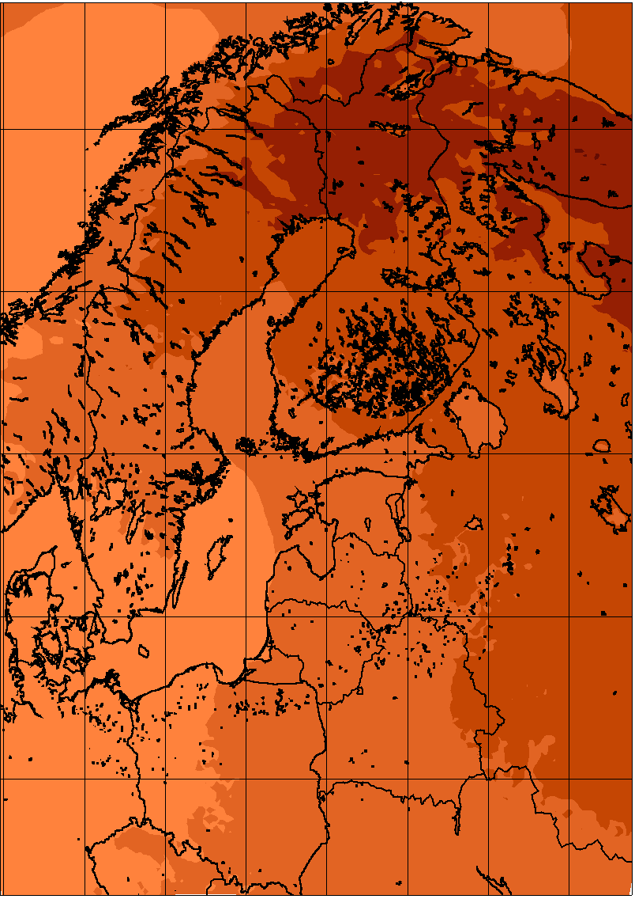 | 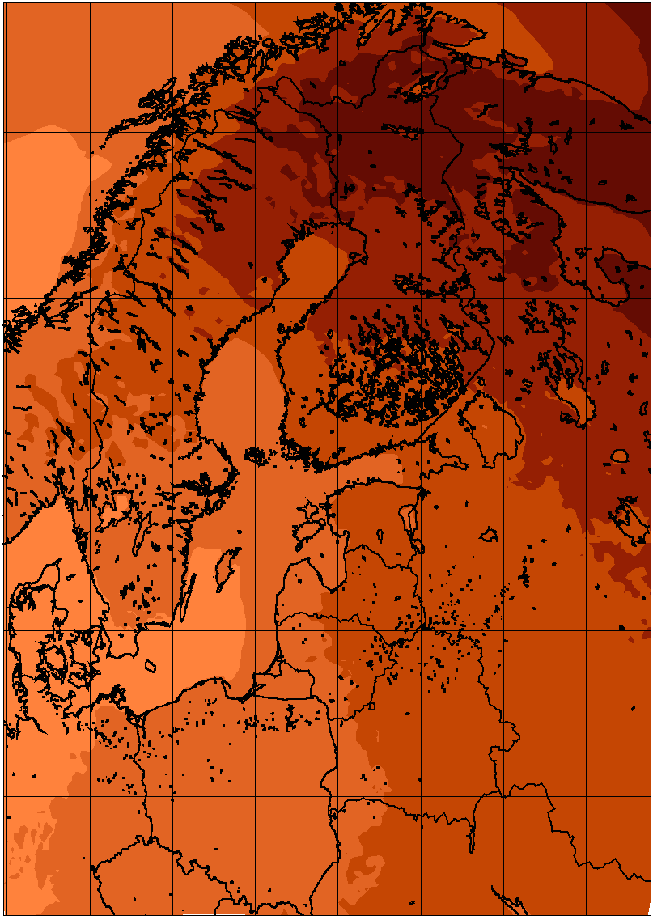 | 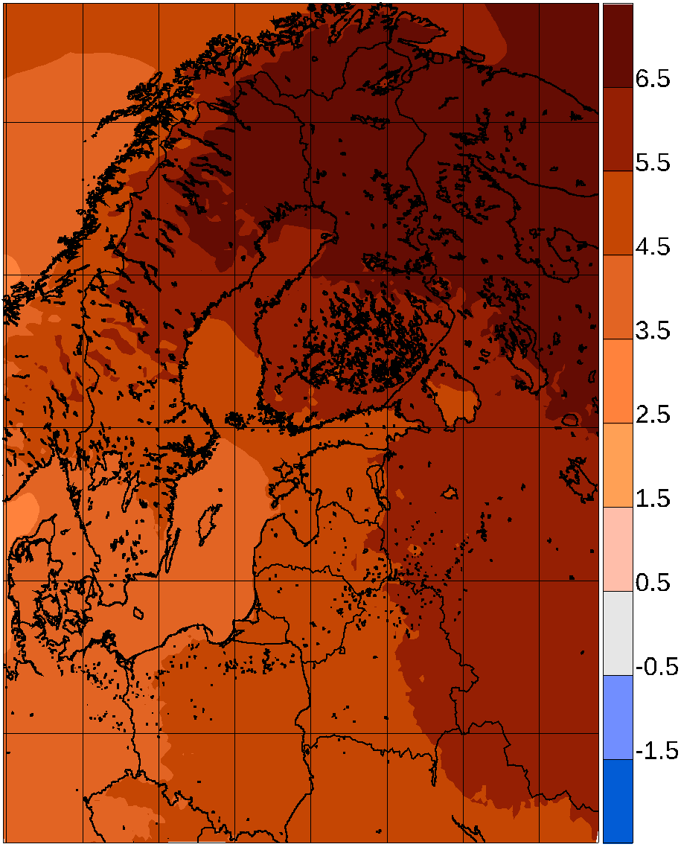
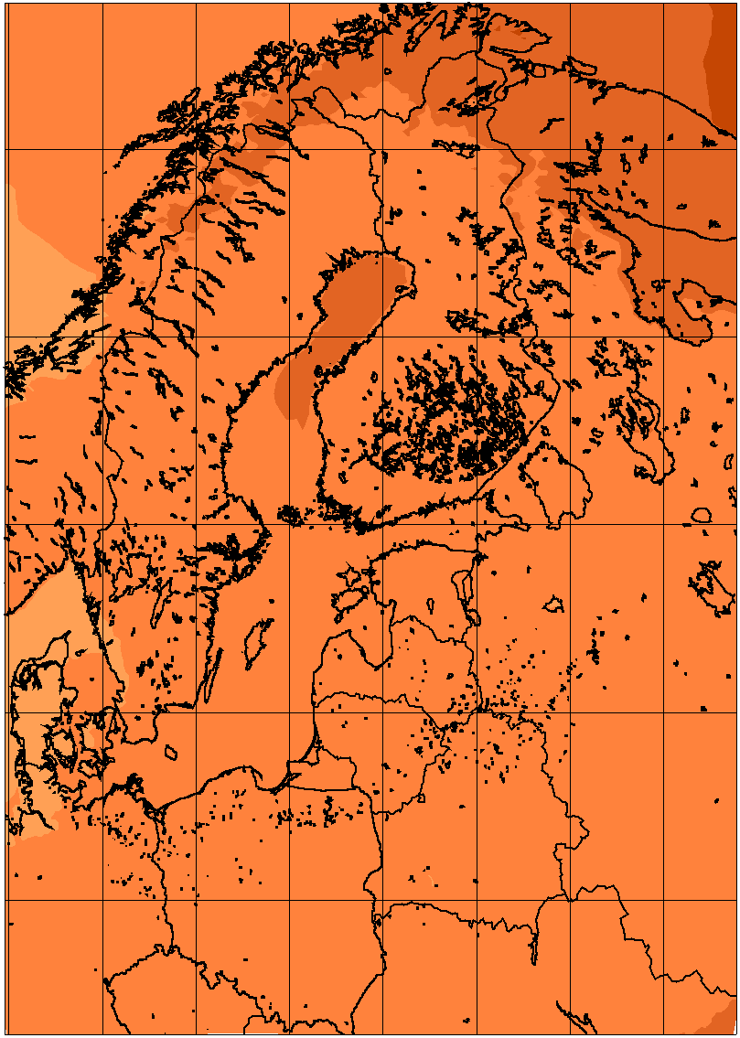 | 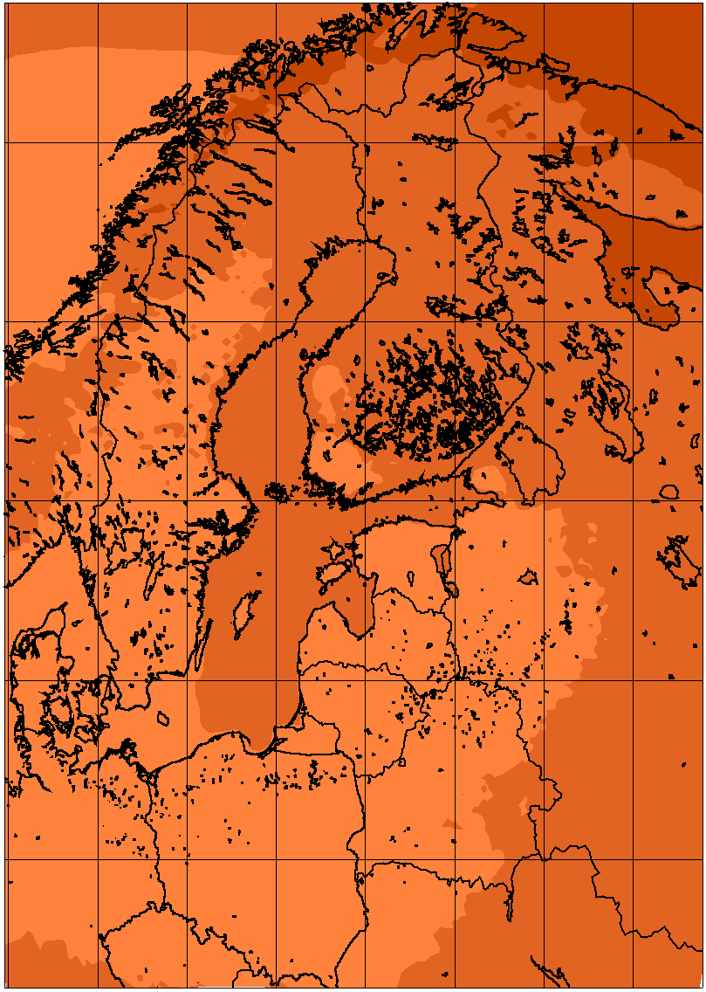 | 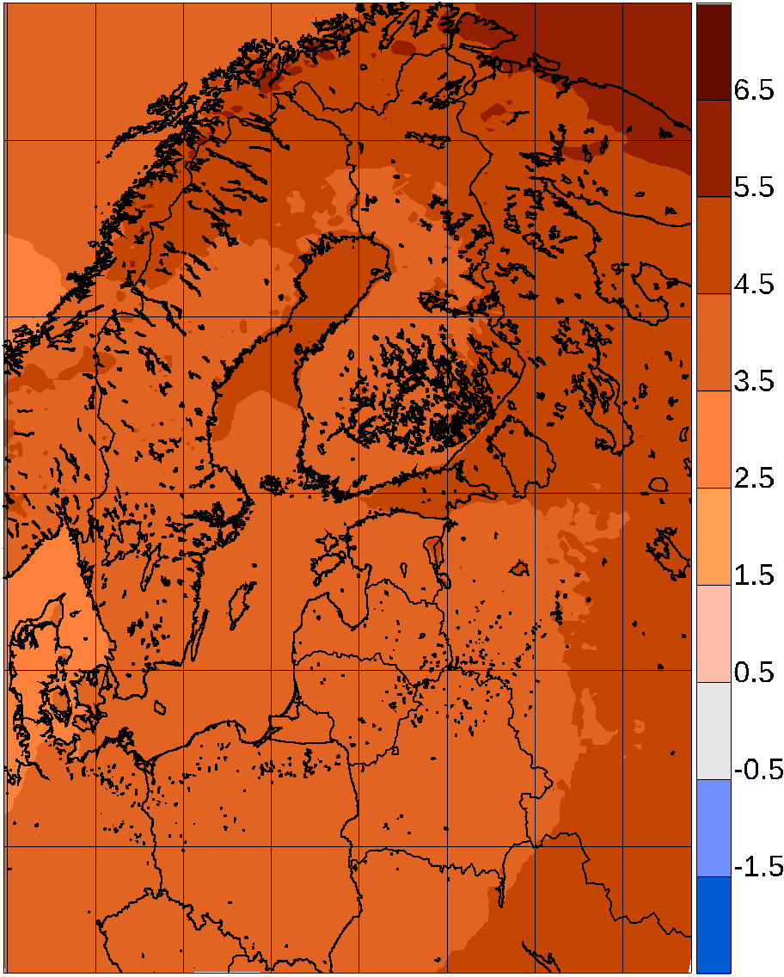
Figure 1. Temperature change between 1981-2010 and 2071-2100 for 51 simulations from Euro-CORDEX according to the RCP8.5 scenario. Top row: winter; bottom row: summer. Left column: lowest quartile; mid column: median value; right column: higher quartile. In all following figures, the mid column depicting pointwise median values is only coloured when 75% of simulations agree on the sign of the change.

Precipitation
Climate models project a general intensification of the global hydrological cycle (e.g. Held and Soden 2006). On a European scale, this implies more precipitation in northern Europe and less in southern Europe, both in winter and summer (Christensen et al. 2007). Between these areas of projected increase and projected decrease there is a broad zone where only small changes or changes in different directions are projected (see e.g. Kjellström et al. 2011a). This transition zone shifts with the seasons and is located farther to the south in winter and to the north in summer. In summer, this zone shifts into the Baltic Basin. This picture is also seen for the large ensemble of global simulations entering the AR5 Climate Atlas. As a consequence, precipitation is projected to increase over the entire Baltic Sea catchment in winter, while in summer increased precipitation is mostly projected for the northern half of the basin only. In the south, precipitation is projected to change very little, although with a large spread between different models including both increases and decreases. Basically, both increases and decreases are possible in the future.
The AR5 Climate Change Atlas depicts global model results for the RCP4.5 emission scenario for the half-year seasons October-March and April-September. The GCM results show general increases in the winter half-year, between 0 and 20% for the 2-3 degrees’ global warming of the RCP4.5 simulations between 1985-2005 and 2085-2100. For the summer half-year only the northern half of the catchment exhibits significant change, which is positive but smaller than winter.
As for temperature, the regional climate simulations here confirm the large-scale picture painted in AR5. Figure 2 shows relative precipitation change for winter and summer for the same EURO-CORDEX models as in Fig 1. During winter, the relative increases are quite homogeneous, although there are large differences between the lower and upper quartile in what changes are seen just to the west of the Baltic Sea catchment (Norway) as a result of different changes in the large-scale circulation. For summer there is a clear north-south gradient: the further north, the more positive the change. As expected, there are greater projected increases in winter than in summer. Roughly, the winter increase is 25-35% over most of the area in the median, and the summer increase 15-25% for the northern part of the area. This is consistent with the AR5 Climate Atlas, where median increases of precipitation in the area are 10-20% for the winter half year and 5-10% for summer, as these results correspond to the RCP4.5 scenario with around 2.5 degrees of warming for the periods mapped, whereas the Euro-CORDEX results correspond to a global warming of 3.8 degrees. For the summer season there is disagreement on the sign of climate change for most of the southern half of the area, indicated by the masked-out area defined as regions where at least 4 of the 16 models disagree on the sign with the majority. Since the period mapped here consists of the 3 summer months June-August, whereas the AR5 Climate Atlas maps April-September, a comparison of the position of the no-change area is difficult. In an analysis of the older ENSEMBLES simulations Déqué et al. (2012) found significantly positive summer precipitation signals for almost all land points in the Baltic Sea catchment.
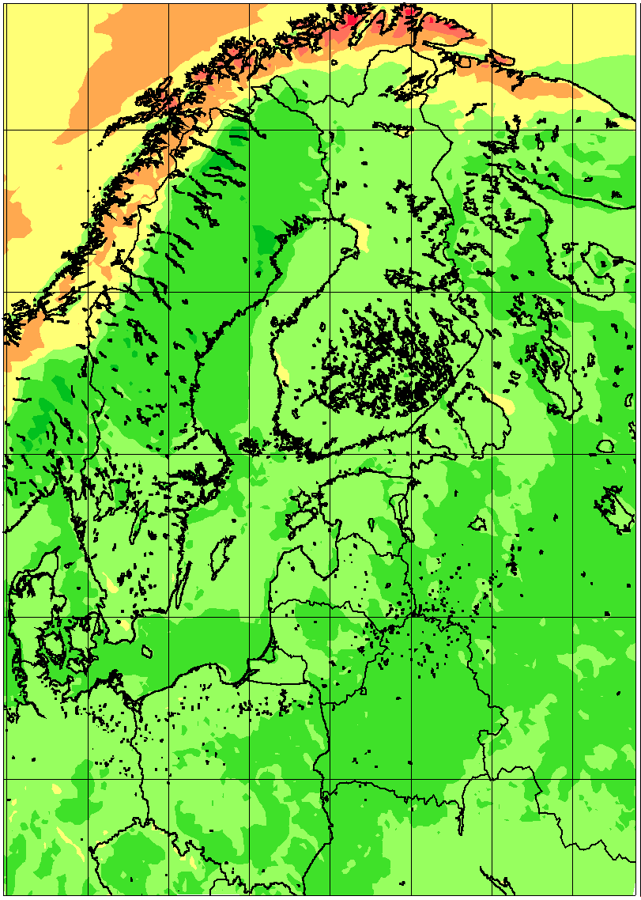 | 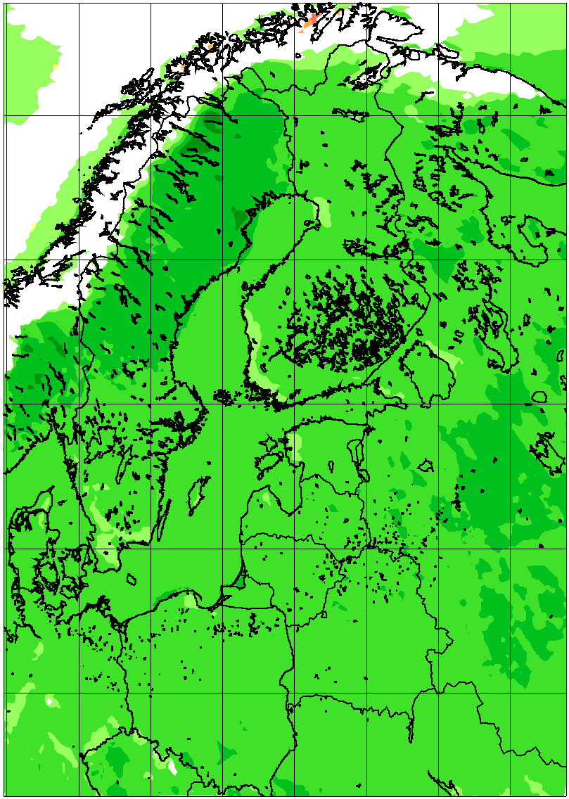 | 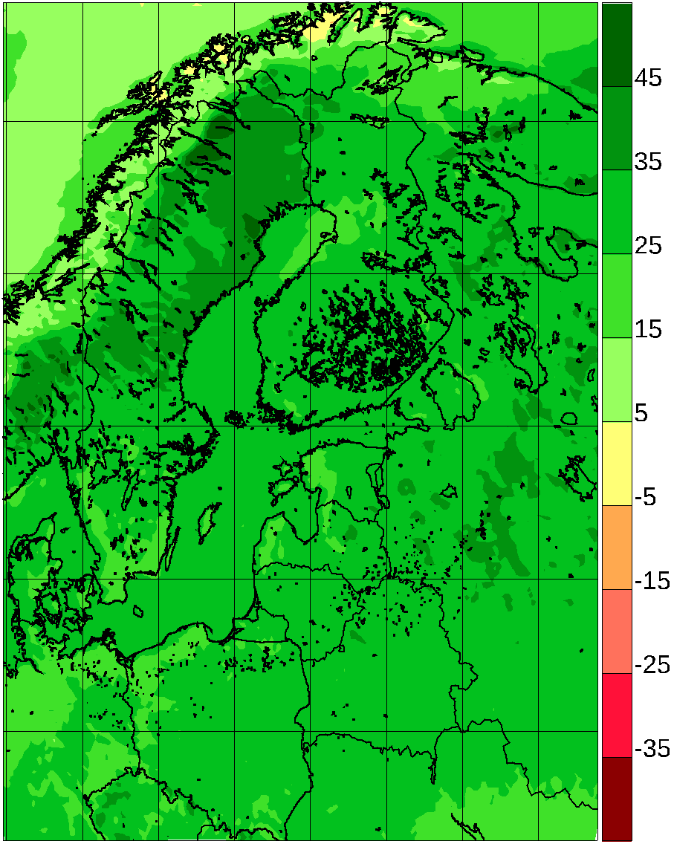
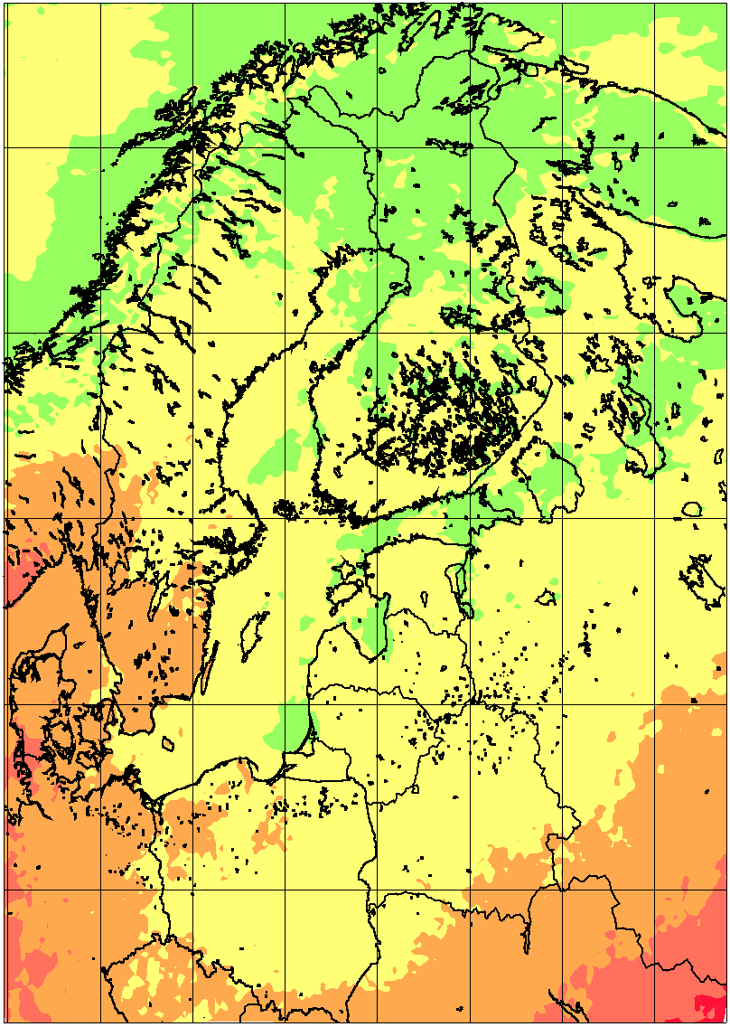 | 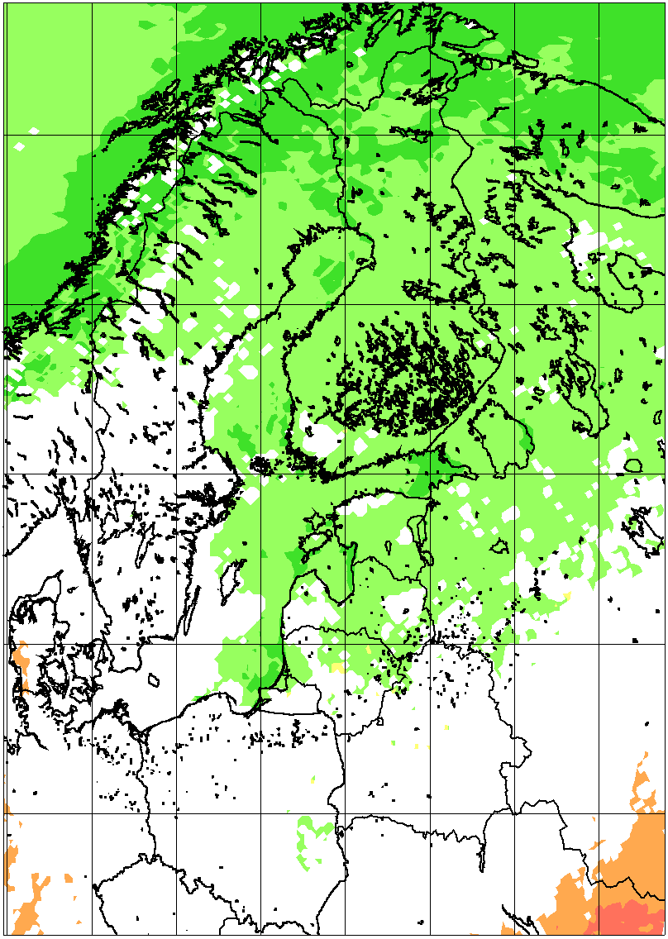 | 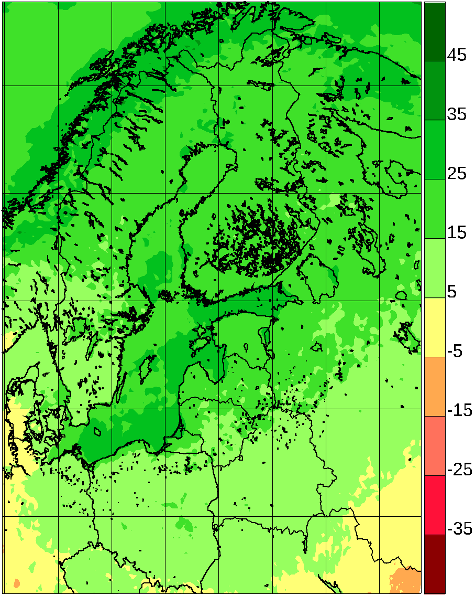
Figure 2. Precipitation relative change (%) between 1981-2010 and 2071-2100 for 54 simulations from Euro-CORDEX according to the RCP8.5 scenario. Top row: winter; bottom row: summer. Left column: lowest quartile; mid column: median value; right column: higher quartile. In all following figures, the mid column depicting pointwise median values is only coloured when 75% of simulations agree on the sign of the change.
Extreme weather events are very important for many aspects of society. Extreme precipitation is responsible for flooding and this aspect of anthropogenic climate change has received considerable attention. As the water-holding capacity of the atmosphere increases under a warmer climate, precipitation extremes are also projected to increase (e.g. Lenderink and van Meijgaard 2010). Several studies, some of which are described in the following, indicate that extreme precipitation is likely to increase in the future, even in areas and seasons, where the average precipitation does not increase. One example is the SREX report (Seneviratne et al., 2012) where it was shown that higher extremes of precipitation consistently show larger increases than lower, and than averages.
Building on the PRUDENCE project, Christensen and Christensen (2003) reported that even projections showing a considerable decrease in average summer precipitation in large parts of southern Europe also showed an increased likelihood of very extreme precipitation in that area as well as in the north where average precipitation was not projected to decrease. More intense precipitation can be expected on time scales ranging from single rain showers to long-lasting synoptic scale precipitation.
It has been argued that changes in precipitation extremes of a shorter duration may exceed those for longer time scales, as indicated by e.g. Kendon et al. (2014), Lenderink and van Meijgaard (2010). However, other results indicate (Ban et al., 2014) that convection-permitting models may give roughly the same increase also for shorter durations, consistent with the Clausius-Clapeyron scaling of around 6-7% per degree of warming.
As an example of changes in daily precipitation, Nikulin et al. (2011) investigated an ensemble of RCM simulations with the RCA model and showed that the 20-yr return value of precipitation extremes in the 1961–1990 period was projected to decrease to 6–10 years in 2071–2100 for summer over northern Europe and to 2–4 years in winter in Scandinavia for the SRES A1B scenario. Similarly, Larsen et al. (2009) reported that the return period for 20-yr rainfall events on a 1-hour basis decreased to 4 years over Sweden based on a high-resolution RCM integration.
For the Rhine catchment, Hanel and Buishand (2011) investigated annual maxima of daily precipitation in 15 RCM simulations from the ENSEMBLES project and found an overestimation of the amount of these extremes, particularly in summer, when compared to a gridded observation set; this was partly attributed to a low density of observations used in constructing the gridded data set. The RCM models all projected increases of extreme precipitation with long return periods.
Collected results from 54 of the models from the Euro-CORDEX project are illustrated in Fig. 3. The change in extreme precipitation is shown calculated as 10-yr return values (the daily precipitation amount so large that it will be exceeded only once every 10 years on average). The median signal is consistently positive across the domain for the areas where more than 75% of the model results have the same sign. The increase in the Baltic Sea basin is roughly similar for both summer and winter, but the inter-model spread is larger in summer, corresponding to the greater influence of local processes in this season; it should be noted that the increase in the number of models analysed, compared to Christensen and Kjellström (2018) from 19 to 54 results in a considerably more robust positive signal in the summer 10-year return value.
It is apparent that the relative change of the extreme precipitation in winter (Fig. 3 upper panel) looks very much like the relative change in average precipitation (Fig. 2), indicating no change in the shape of the intensity distribution function. The situation is different for summer, where the projected change in extreme precipitation is consistently more positive than the change in average precipitation. This feature is, however, less apparent in the Euro-CORDEX results than in the PRUDENCE results of BACC (2008) and the ENSEMBLES results described in BACC2 (2013). It is not clear if this difference is due to the fact that the RCMs are run at different horizontal resolutions in the three projects (i.e. 50, 25 and 12.5 km) or if it is a consequence of different model formulations or on the large-scale climate change signal as imposed by the underlying GCMs that also differs between the experiments.
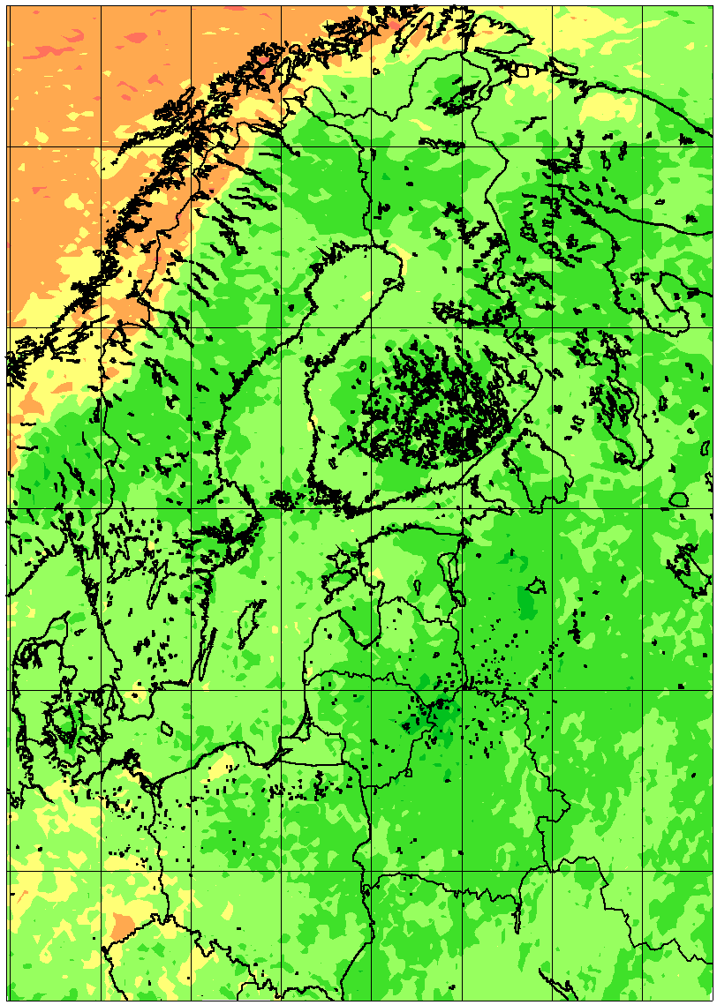 | 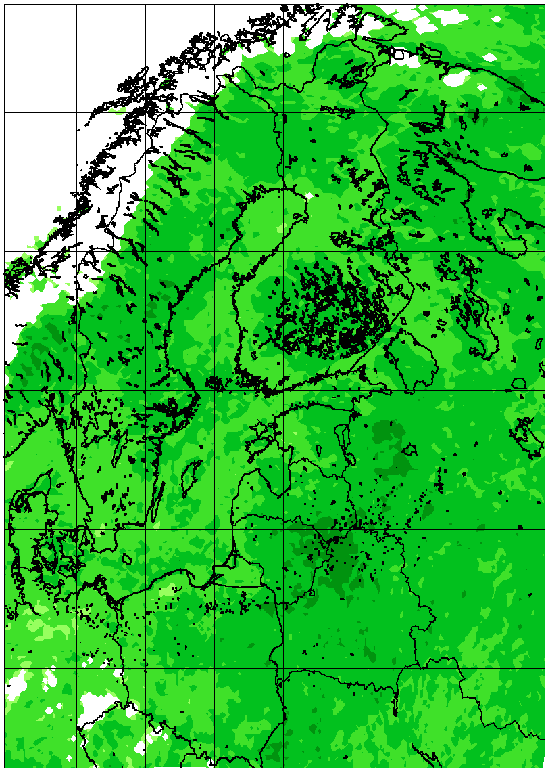 | 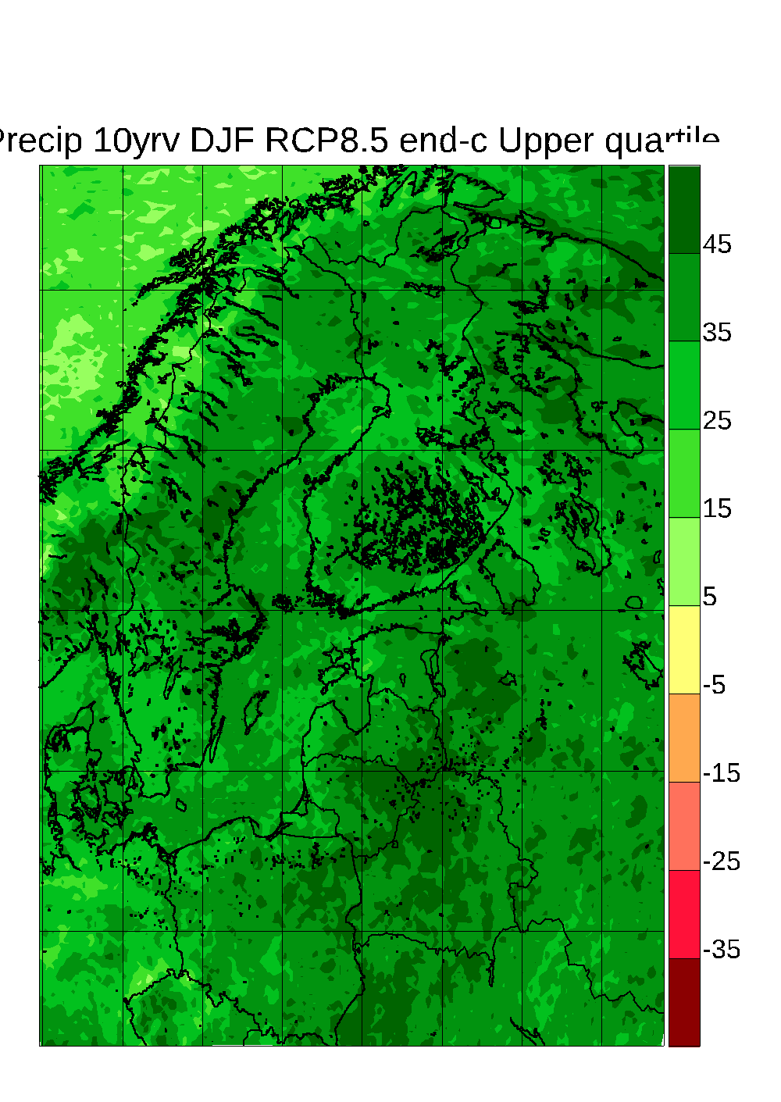
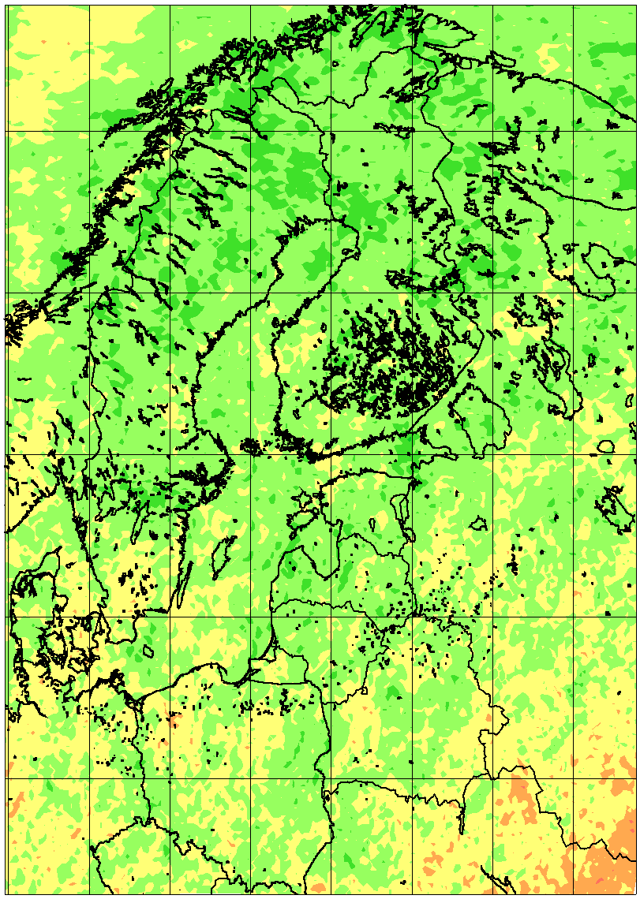 | 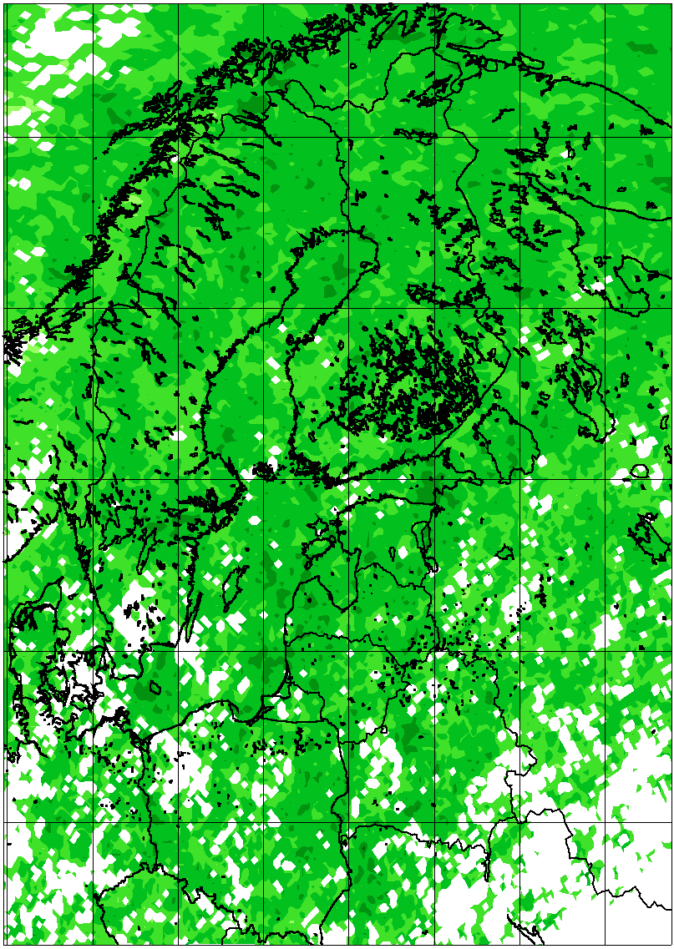 | 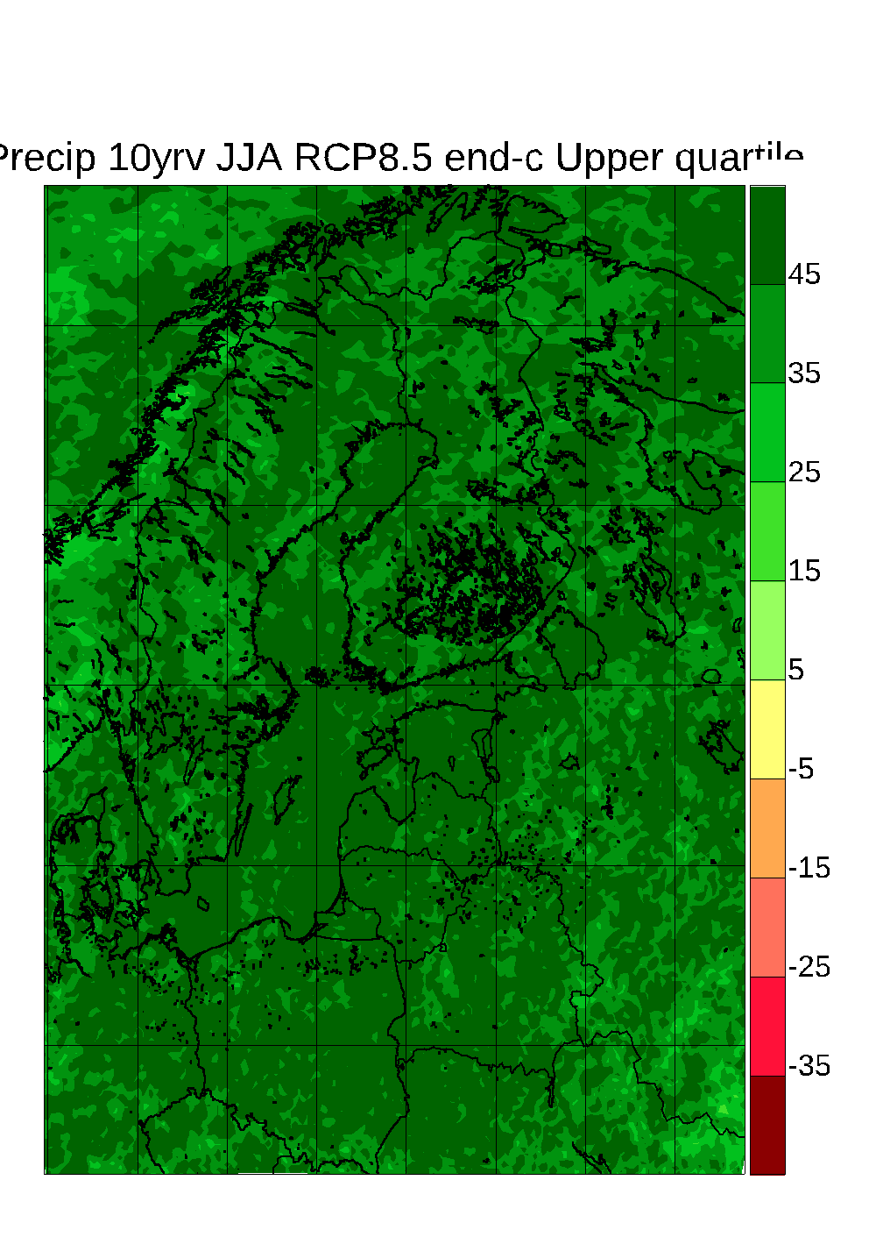
Figure 3. Change in 10-year return value of daily precipitation change between 1971-2000 and 2071-2100 for 54 simulations from Euro-CORDEX according to the RCP8.5 scenario. Top row: Winter; bottom row: Summer. Left column: lowest quartile; mid column: median value; right column: higher quartile. For the medians, only points where 75% of models agree on the sign are shown.

Wind speed
Changes in the wind climate are even more uncertain than is the case for the precipitation climate, both for seasonal mean conditions and for extremes on shorter time scales (e.g. Kjellström et al. 2011a; Nikulin et al. 2011).
Donat et al. (2011) investigated mid-century as well as end-of-century changes in the annual 98th percentile daily maximum wind in 14 ENSEMBLES RCM simulations for 2021–2050 and 11 models for 2070–2099 of which nine are part of the 13-member ensemble employed for the present analyses. The ensemble average, like the driving GCMs, showed a tendency to increase in a belt from the British Isles to the Baltic Sea, and a tendency to reduce in the Mediterranean area. Nikulin et al. (2011), based on an ensemble of one RCM downscaling six different GCMs under the A1B scenario, found increasing wind speed expressed as 20-year return periods of annual maximum wind speed over the Baltic Sea in five out of six simulations.
In BACC2 (2013) an analysis of 13 ENSEMBLES simulations showed a very slight and insignificant median increase in the southern part of the Baltic area, consistent with the findings by Donat et al. (2011), but with a large spread between models.
Figure 4 shows average changes over the Baltic Sea for the 51 Euro-CORDEX RCP8.5 simulations, which are used (Tab. 1). There is very little agreement between the models about even the direction of change for winter in the Baltic Sea area unlike the tendency for reduced average wind speed outside of the area over the North Atlantic (northwest corner in Figure 4 panels). Over the northernmost parts of the Baltic Sea basin, the Bothnian Bay, there is an indication of larger wind speed increase (or less decrease) over the sea than over surrounding land areas. This feature has previously been pointed out by Kjellström et al. (2011a), Meier et al. (2011) and Tobin et al (2016) and has been related to decreases in sea-ice in the future warmer climate leading to consequent changes in stability conditions of the lower atmosphere. Summer results show consistent but small reductions of wind over land of about 2-6%. Again, in summer, there are differences between land and ocean areas with generally larger increases or smaller decreases over the Baltic Sea than its surrounding land areas. See also the comparison between regional coupled and uncoupled simulations in Fig. 12 where probably the more consistent treatment of ice-albedo feedback leads to a larger increase.
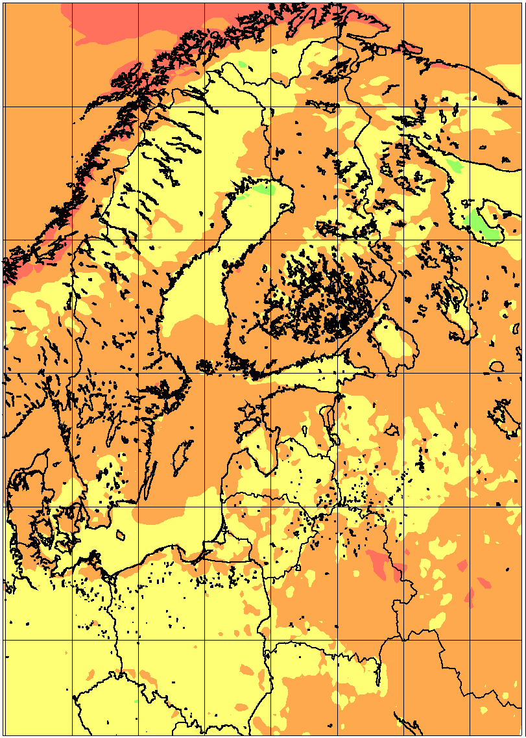 | 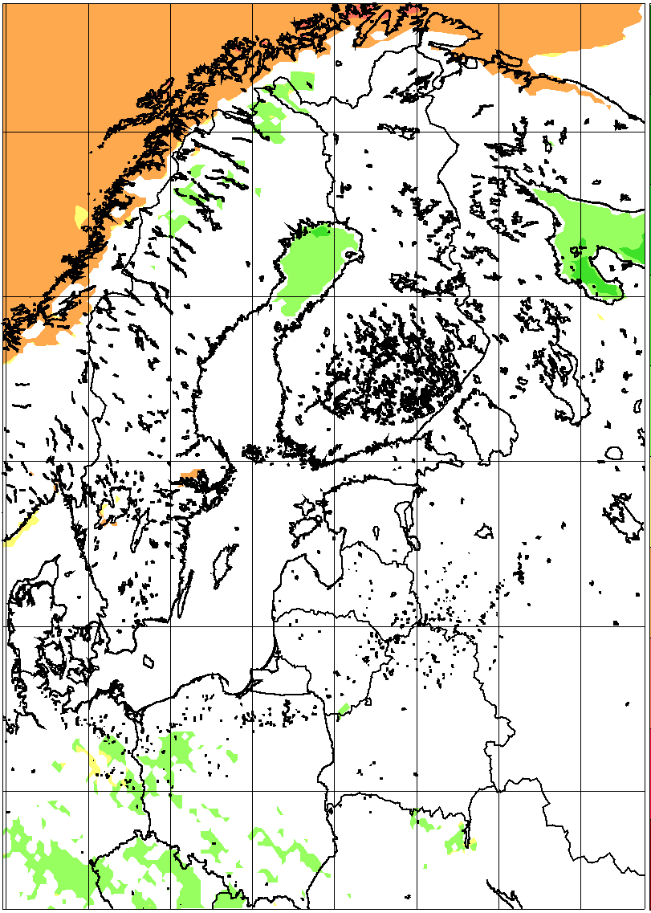 | 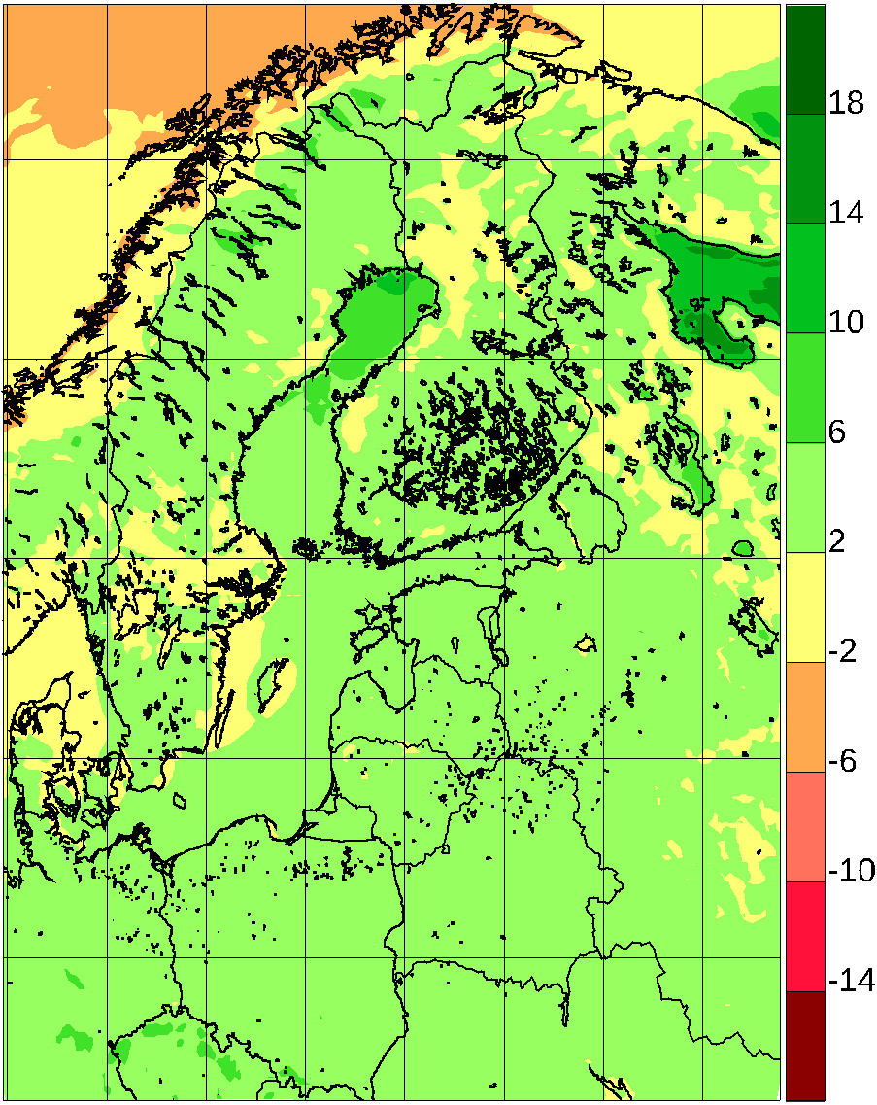
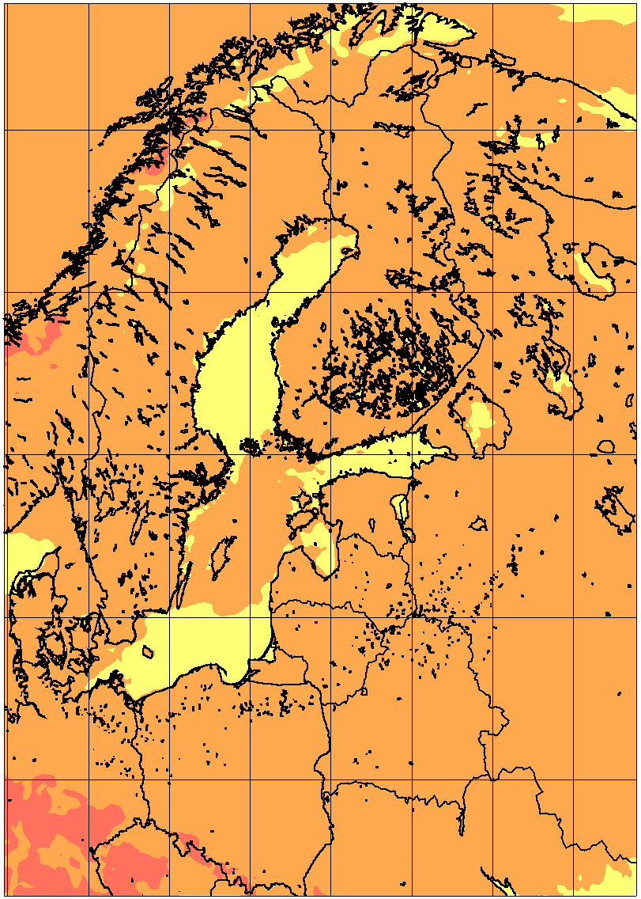 | 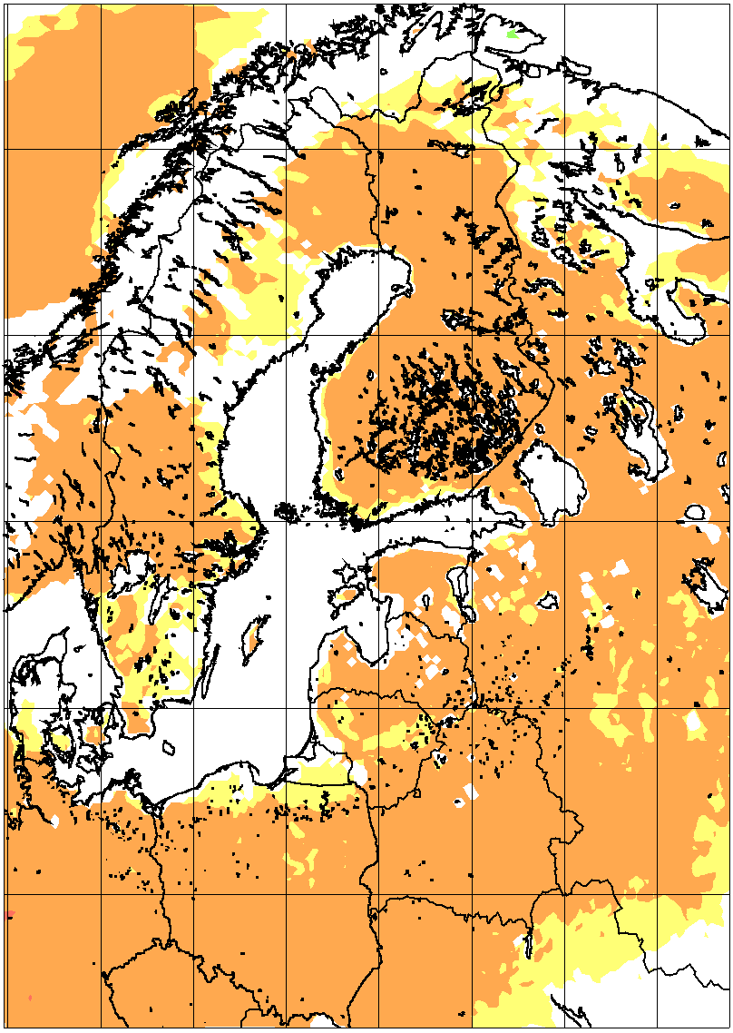 | 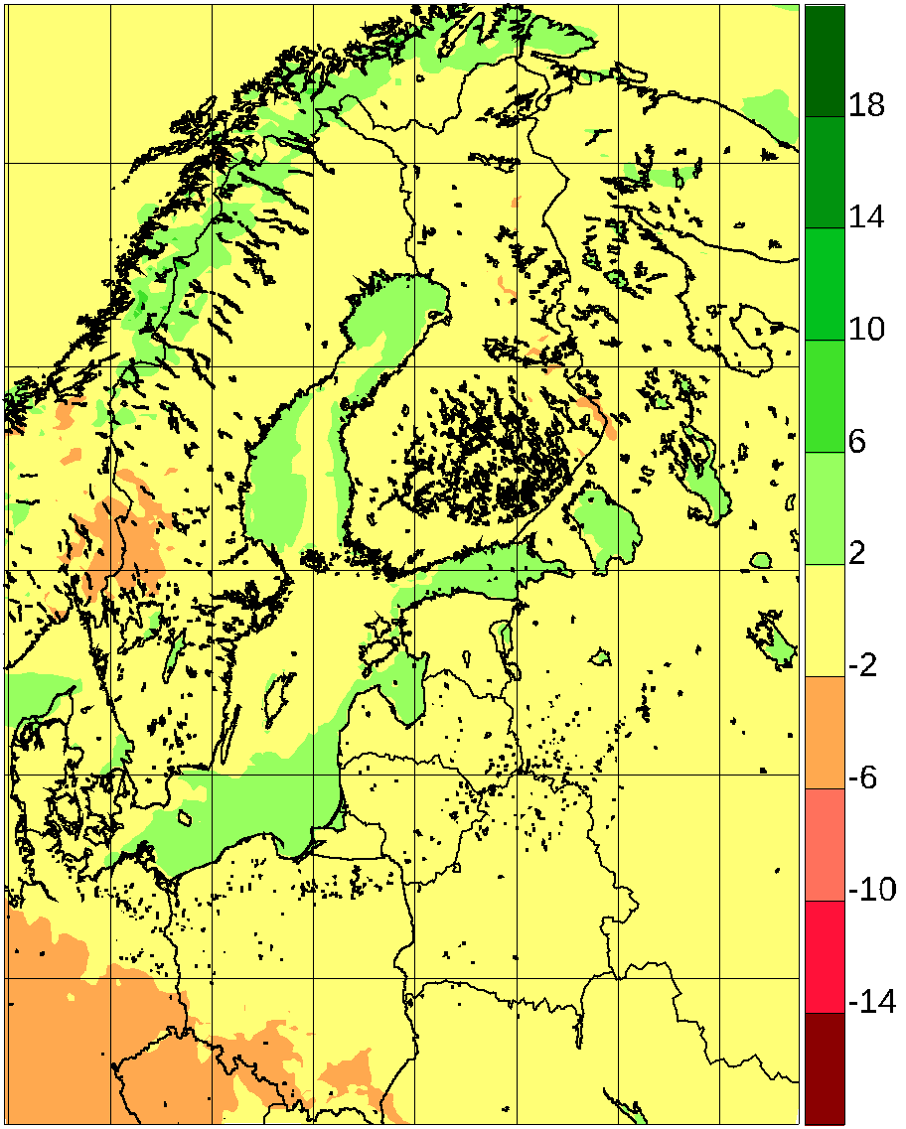
Figure 4. Average wind speed relative change (%) between 1981-2010 and 2071-2100 for 50 simulations from Euro-CORDEX according to the RCP8.5 scenario. Top row: winter; bottom row: summer. Left column: lowest quartile; mid column: median value; right column: higher quartile. In all following figures, the mid column depicting pointwise median values is only coloured when 75% of simulations agree on the sign of the change.
The relative change in extreme wind speed is shown in Fig. 5 as the relative change of the 10-year return value of daily maximum wind speed for the 46 of the Euro-CORDEX simulations considered. Basically nowhere do more than 75% of the models agree on the sign of the pointwise change. It is noteworthy that the interquartile spread is much smaller than in Christensen and Kjellström (2018); this indicates that the models agree that there is no signal, and not just that there are too few models present to overcome natural variability.
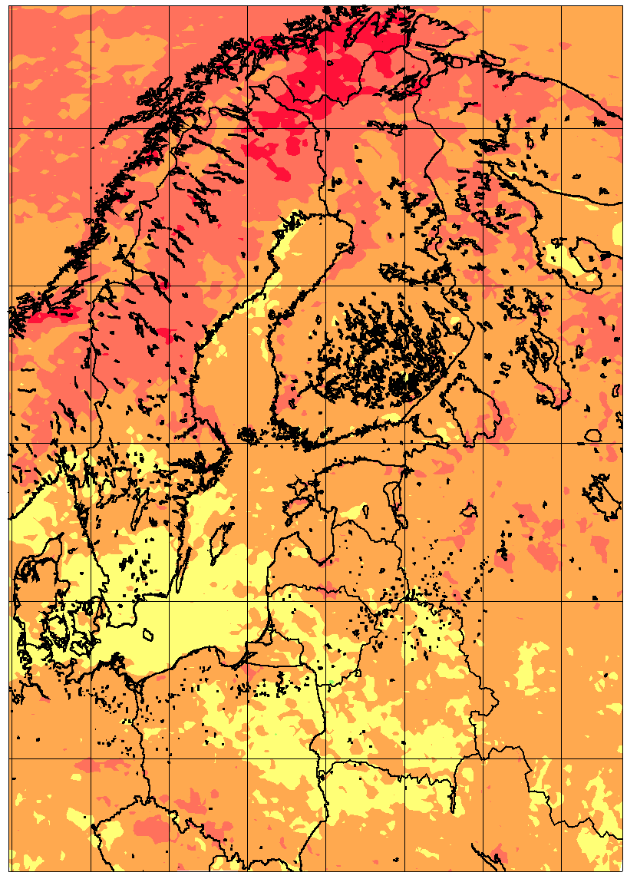 | 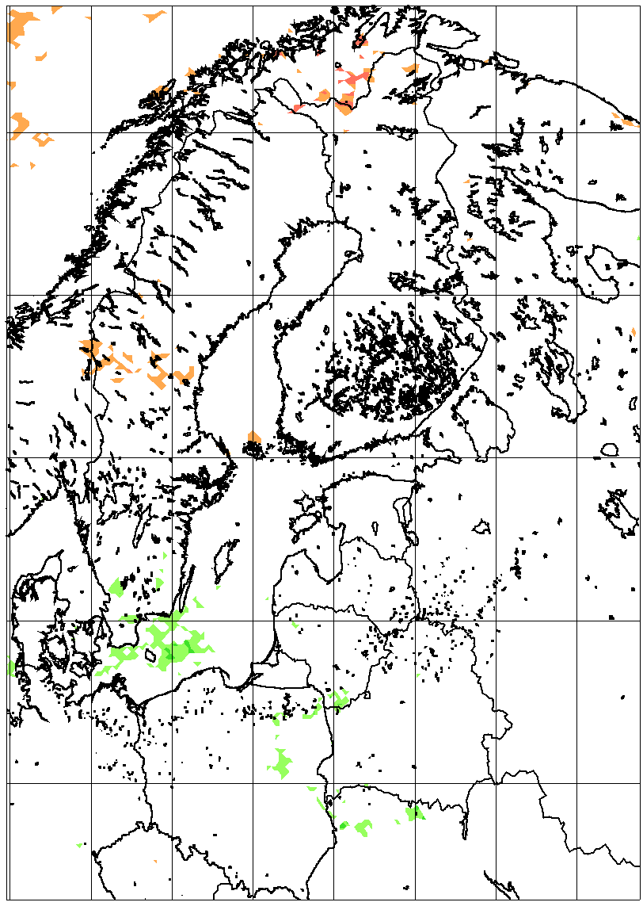 | 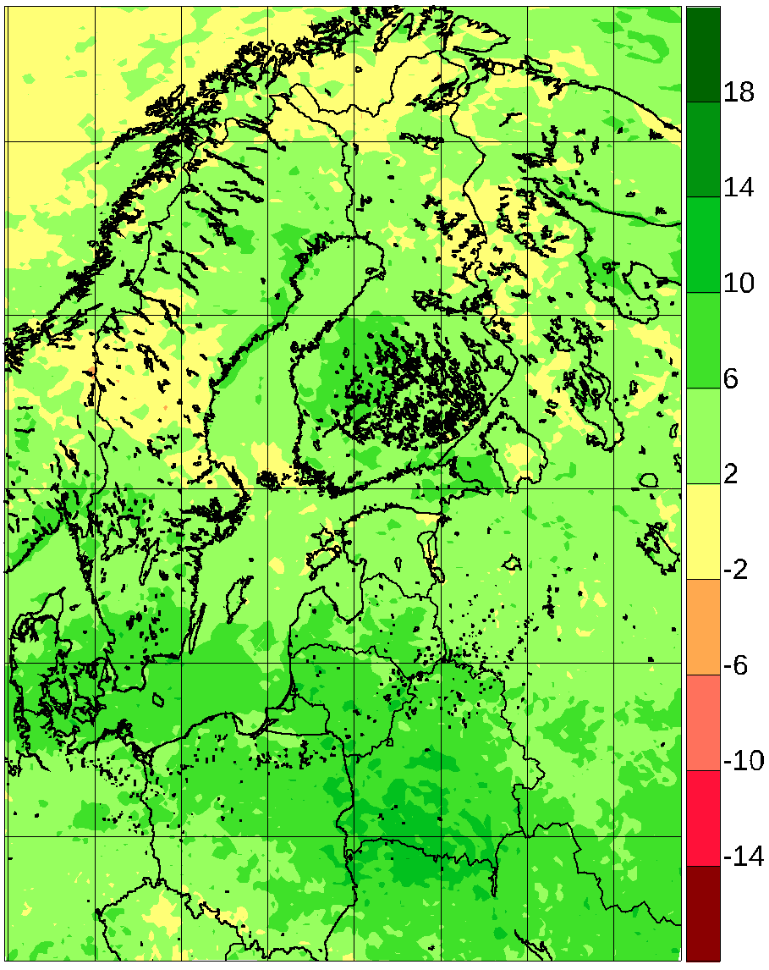
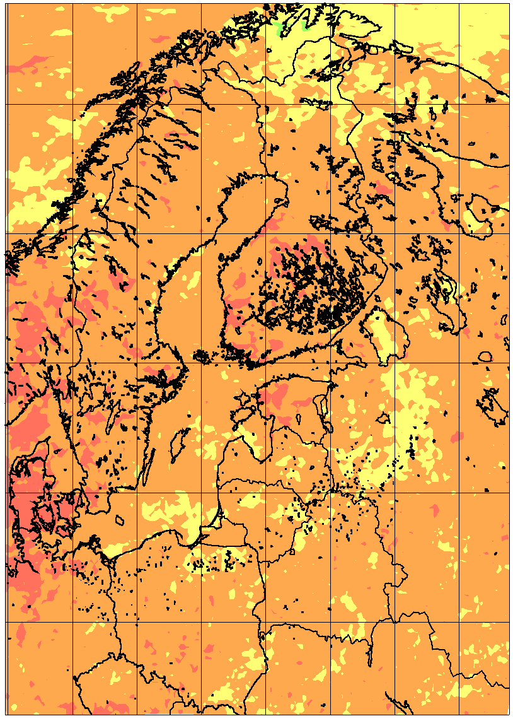 | 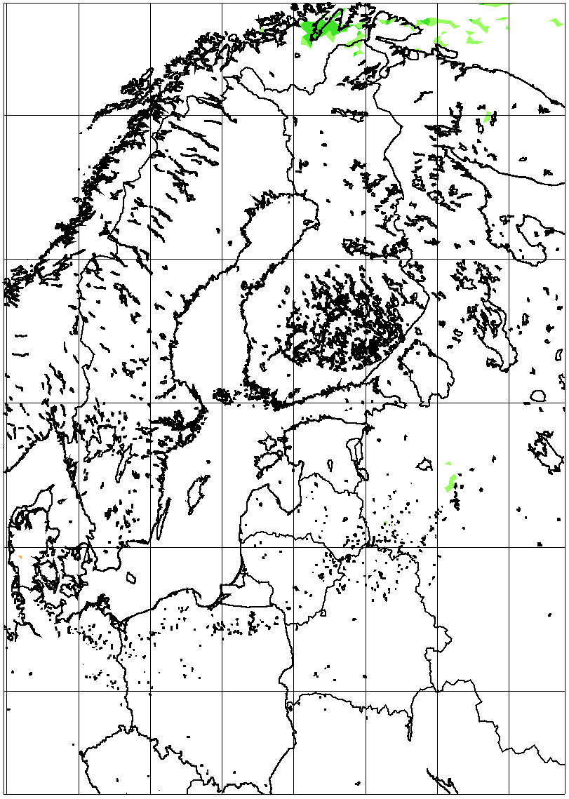 | 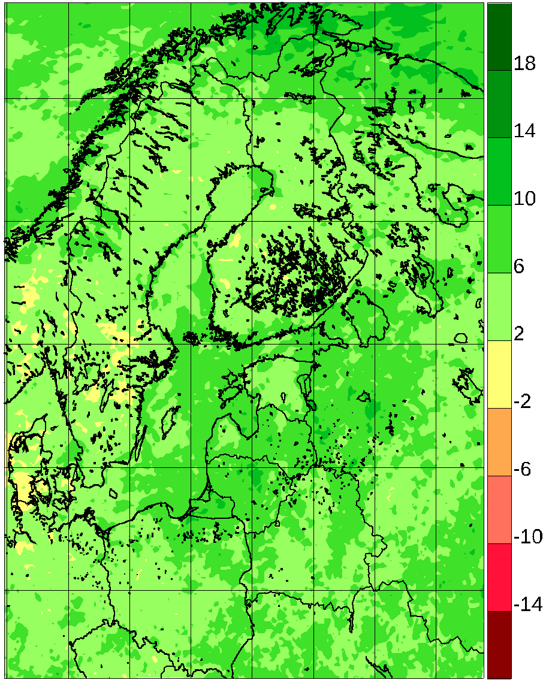
Figure 5 Change in 10-year return value of daily maximum wind speed relative change between 1971-2000 and 2071-2100 for 46 simulations from Euro-CORDEX according to the RCP8.5 scenario. Top row: Winter; bottom row: Summer. Left column: lowest quartile; mid column: median value; right column: higher quartile. For the medians, only points where 75% of models agree on the sign are shown.

Solar irradiation
In Fig. 6 we study the change in incoming solar radiation from the ensemble, where the pointwise two quartiles and the median are shown. In winter, most of the area shows a considerable relative reduction of the order of 10%. This is attributed to the higher modelled cloud cover (not shown) of most models in the future. This is frequently due to more zonal flow and goes alongside the increase in winter precipitation shown in Fig. 2.
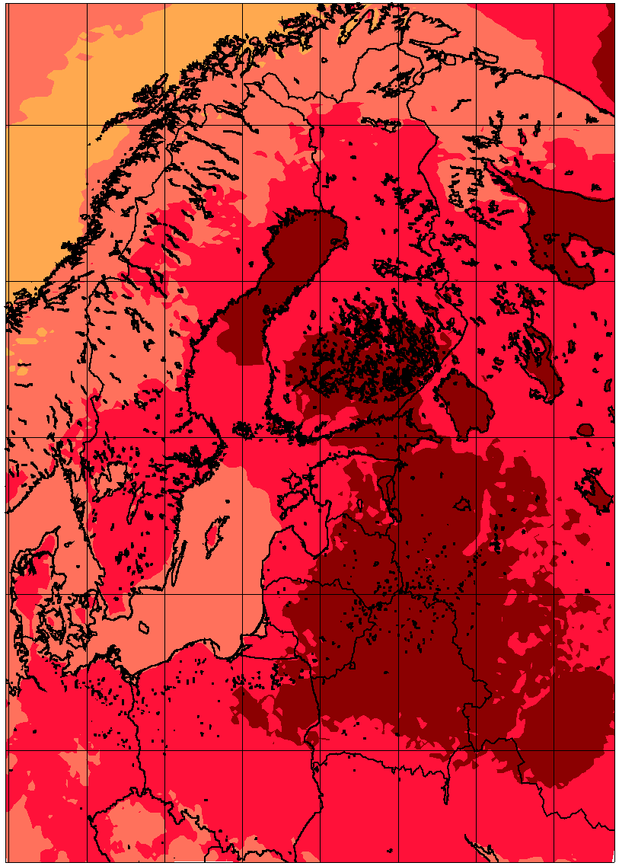 | 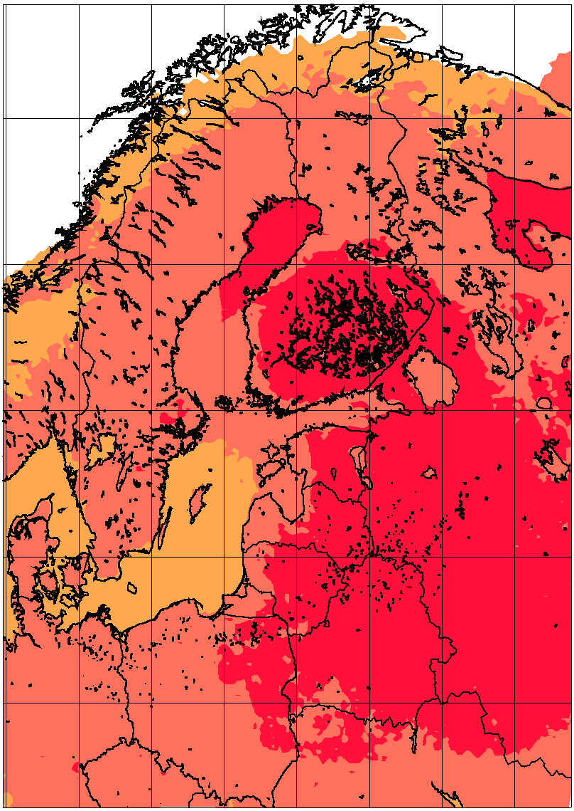 | 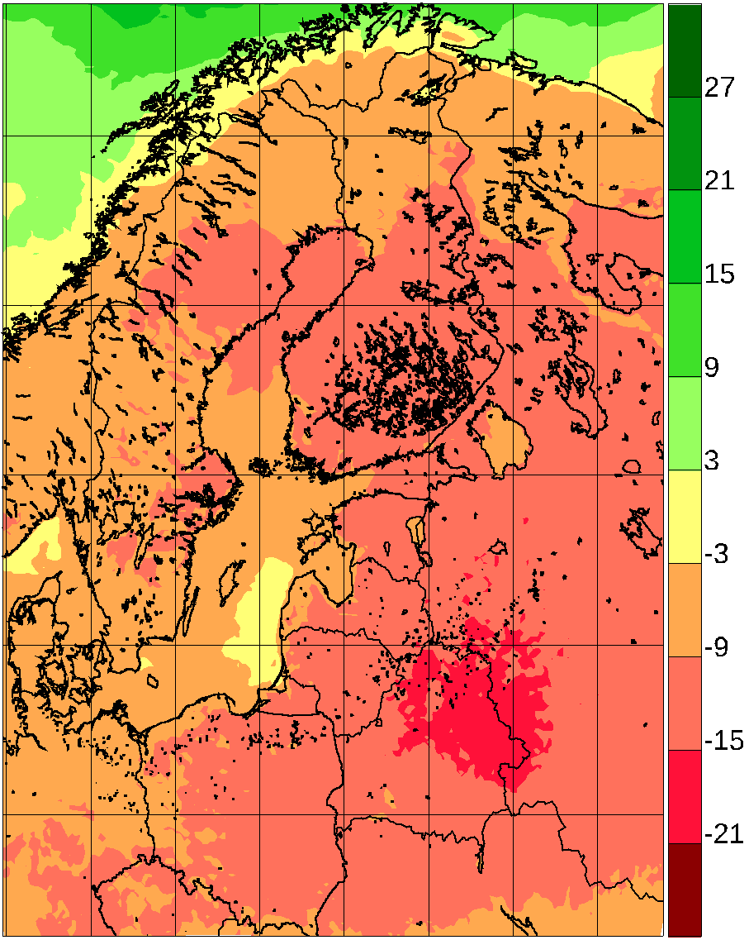
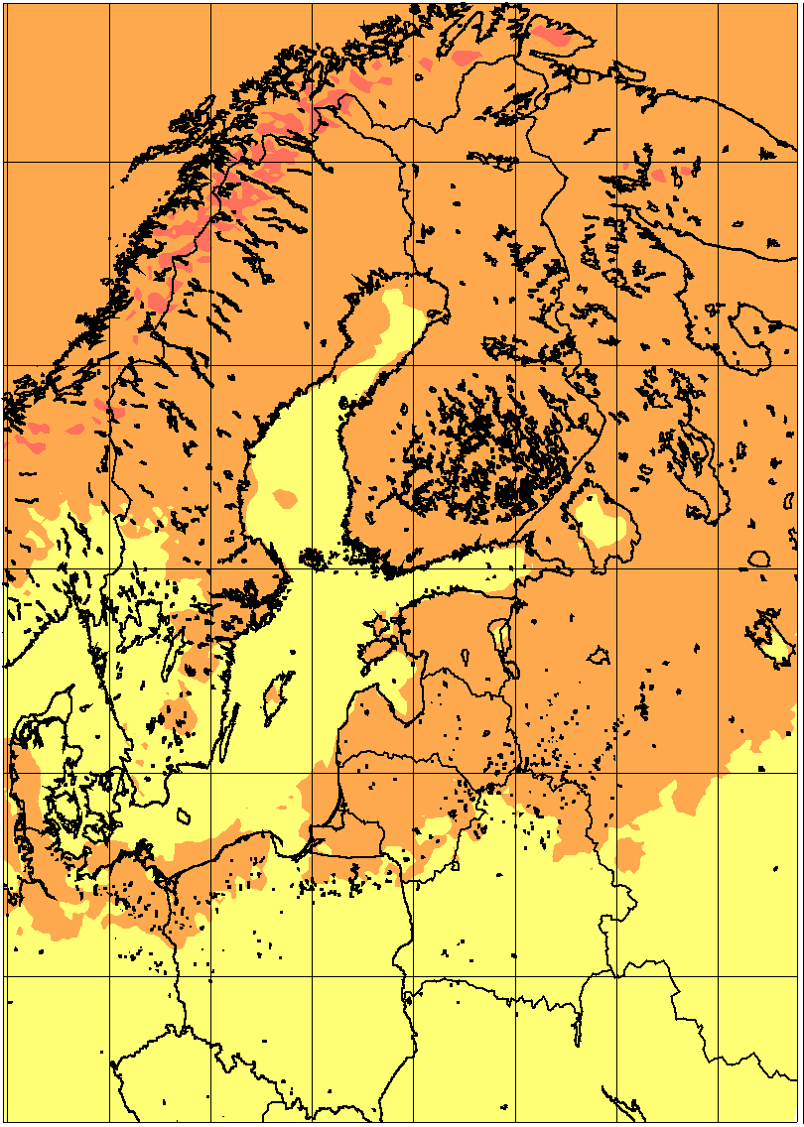 | 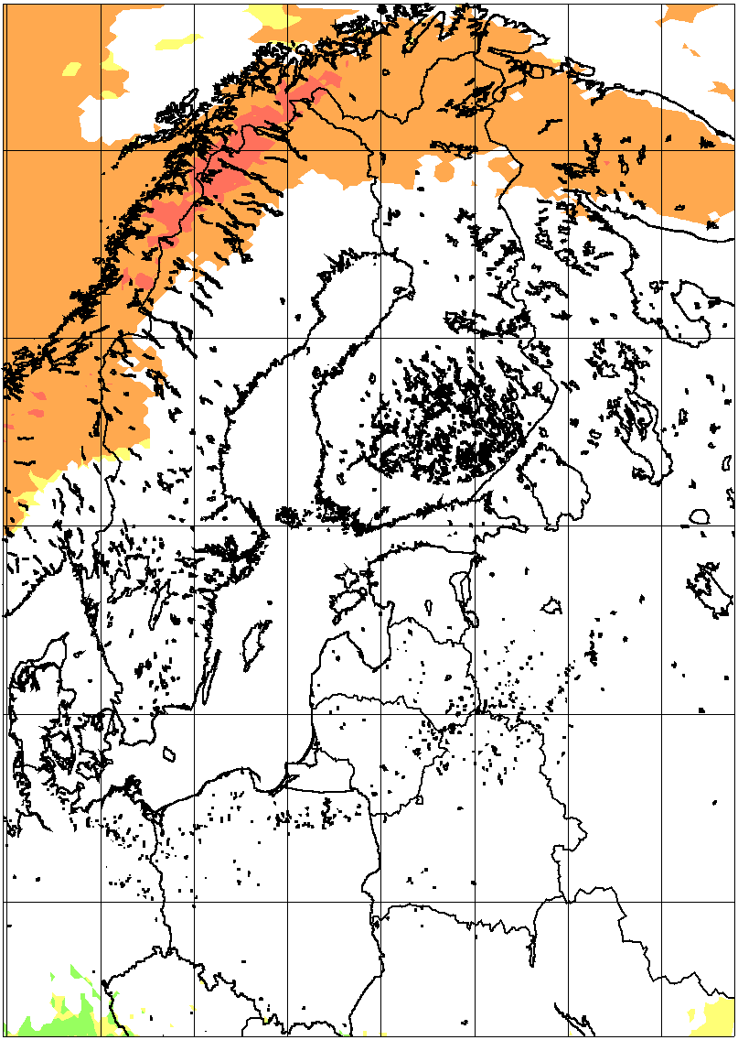 | 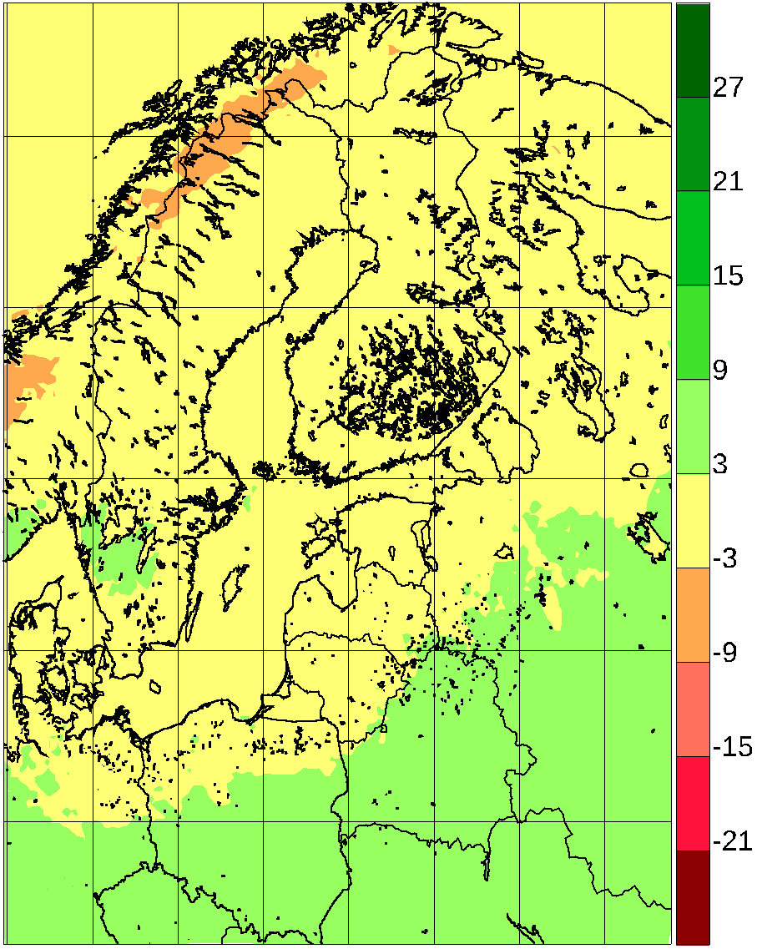
Figure 6. Average incoming surface solar radiation relative change between 1981-2010 and 2071-2100 for 48 simulations from Euro-CORDEX according to the RCP8.5 scenario. Top row: Winter; bottom row: Summer. Left column: lowest quartile; mid column: median value; right column: higher quartile. For the medians, only points where 75% of models agree on the sign are shown.

Snow and Ice
Rising temperatures are expected to lead to decreased snow cover, as more precipitation falls as rain and snow melt accelerates. There is an increase in winter precipitation in Scandinavia, which may partly compensate for these effects. Data from the ENSEMBLES project were analysed by Räisänen and Eklund (2011) who concluded that snow volume will decrease across Europe in the future, even though the Scandinavian mountain areas may experience a slight and statistically insignificant increase. Such an increase was also proposed by Schuler et al. (2006) in a detailed study for Norway based on two RCM scenarios forced with different GCMs. The authors also pointed out that in extreme years, the maximum amount of snow could be greater than in extreme years of the recent past, even if snow amount is reduced on average.
Winter snow cover is one of the most drastically changed climatological quantities (Fig. 7). There is agreement between models about a reduction of average winter-time snow amount of more 70% for most areas, with the exception of the high Scandinavian mountains, where the warming temperature does not reach the freezing point as frequently as in lower-lying regions. This reduction in snow amount is slightly larger than for maps shown in BACC2 (2013), consistent with the fact that the RCP8.5 scenario on average projects larger warming than the SRES A1B scenario used in BACC2.
It is only in high-altitude parts of central and northern Scandinavia that changes are limited with relatively large amounts of snow also in the future. In high altitude the increase of winter precipitation may be an effect compensating the increase in melting with higher temperature. Also the fact that increasing temperatures may not reach the melting point is significant.
Sea ice cover is not a product of the RCM, but rather an input originating from the driving coupled GCM. We will show the changes in interpolated sea ice field for the RCP8.5 scenario in Fig. 8, as these changes are large, and are decisive for the change in climate between the periods. To put the changes in context, we show in Fig. 9 the model-median mean sea ice cover in per cent for winter in the present-day period 1981-2010 as well as for the far-future period 2071-2100 according to the RCP8.5 scenario. It is seen that sea ice in the Baltic Sea is virtually absent in the future, while most models have up to 20% ice cover in seasonal mean for the Bothnic Bay.
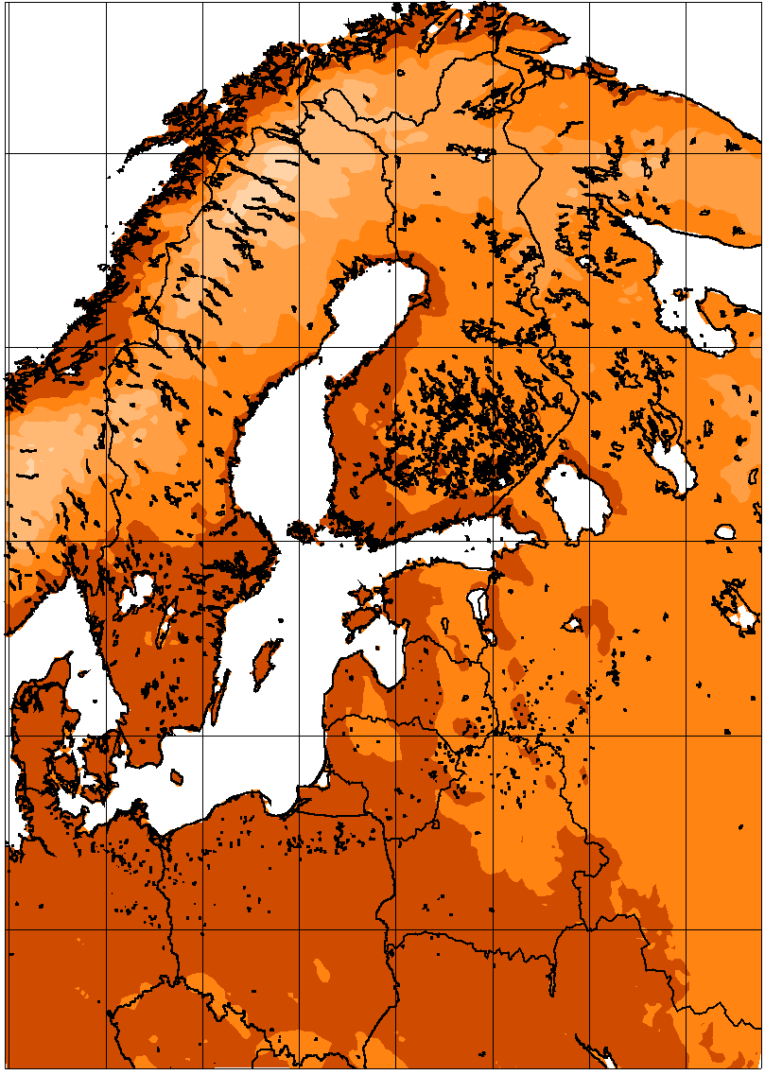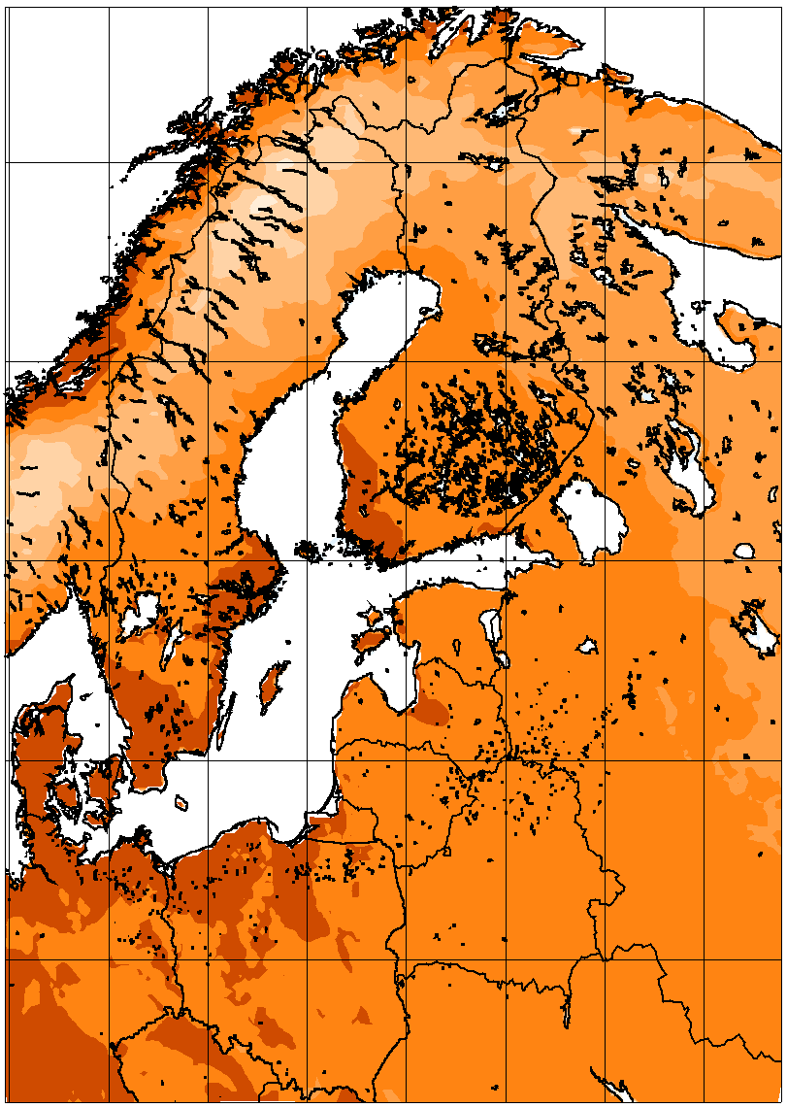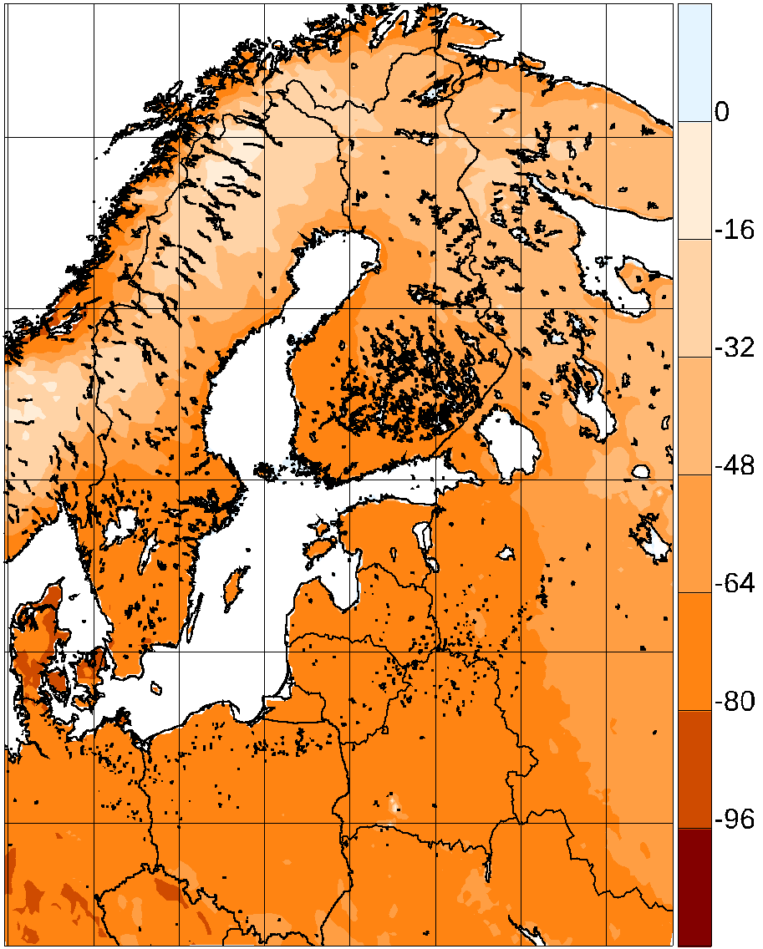
Figure 7. Average winter snow depth relative change between 1981-2010 and 2071-2100 for 45 simulations from Euro-CORDEX according to the RCP8.5 scenario. Left column: lowest quartile; mid column: median value; right column: higher quartile. For the medians, only points where 75% of models agree on the sign are shown.
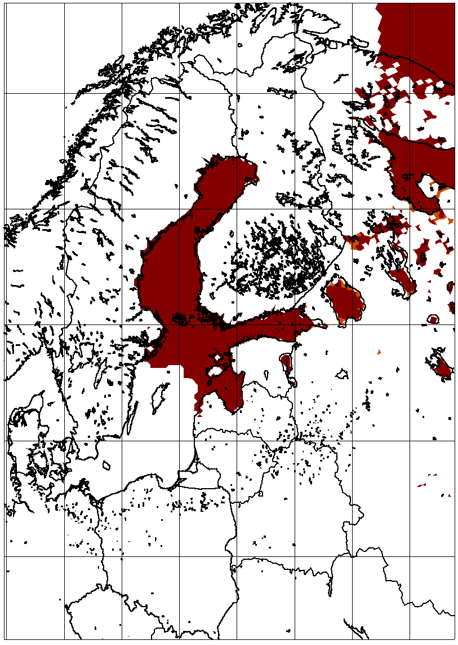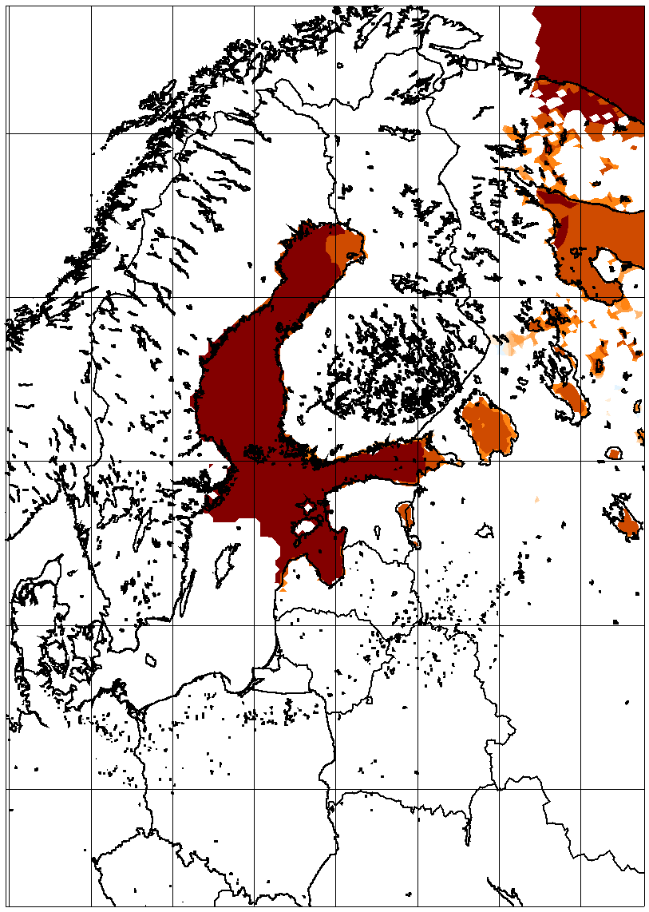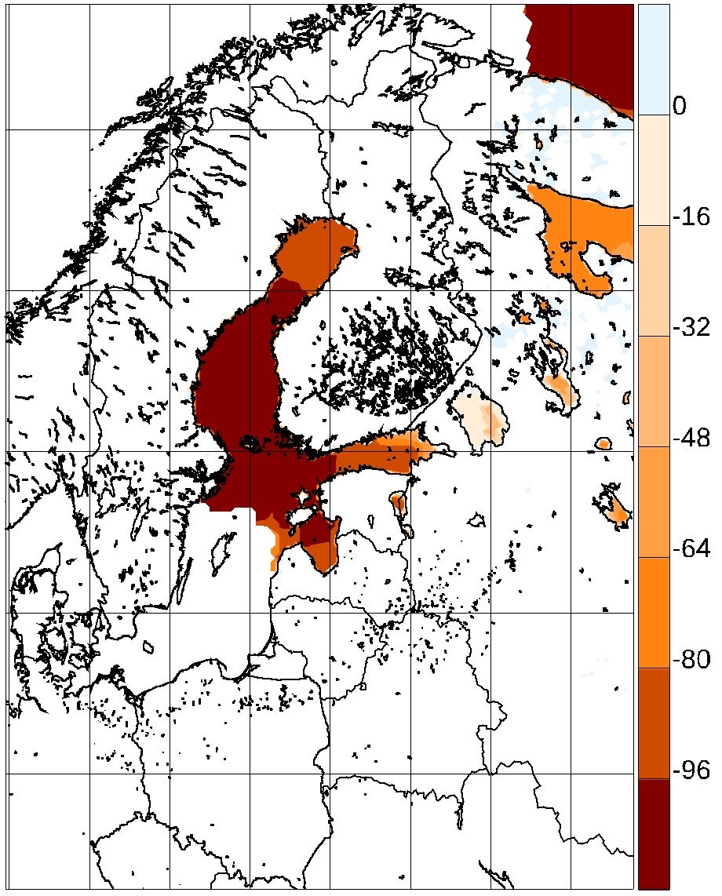
Figure 8. Average winter sea ice cover relative change between 1981-2010 and 2071-2100 for 40 simulations from Euro-CORDEX according to the RCP8.5 scenario; these values have been interpolated before the RCM simulations from the driving coupled GCM. Left column: lowest quartile; mid column: median value; right column: higher quartile. For the medians, only points where 75% of models agree on the sign are shown.
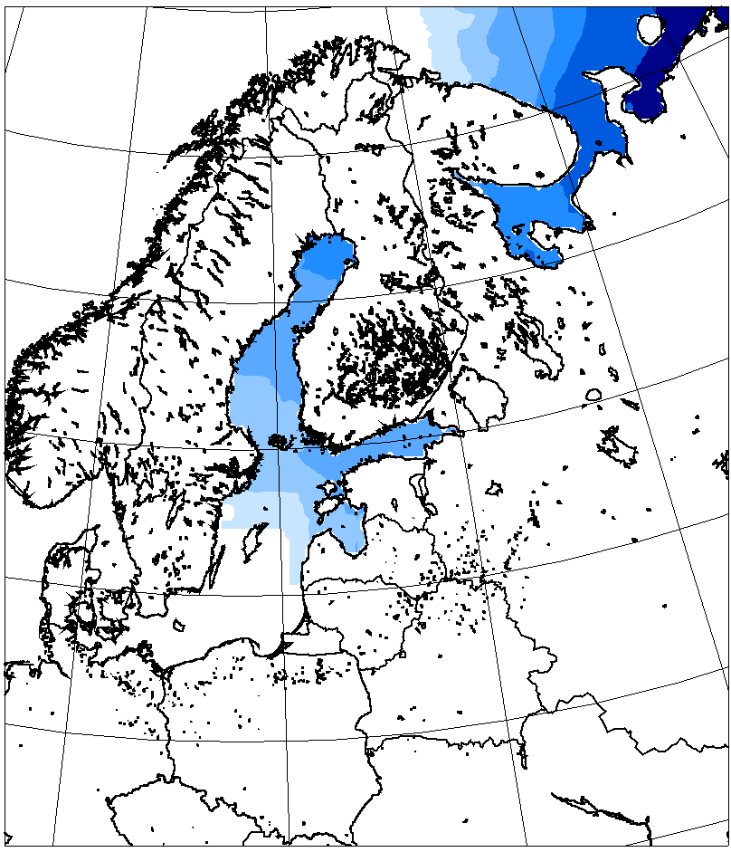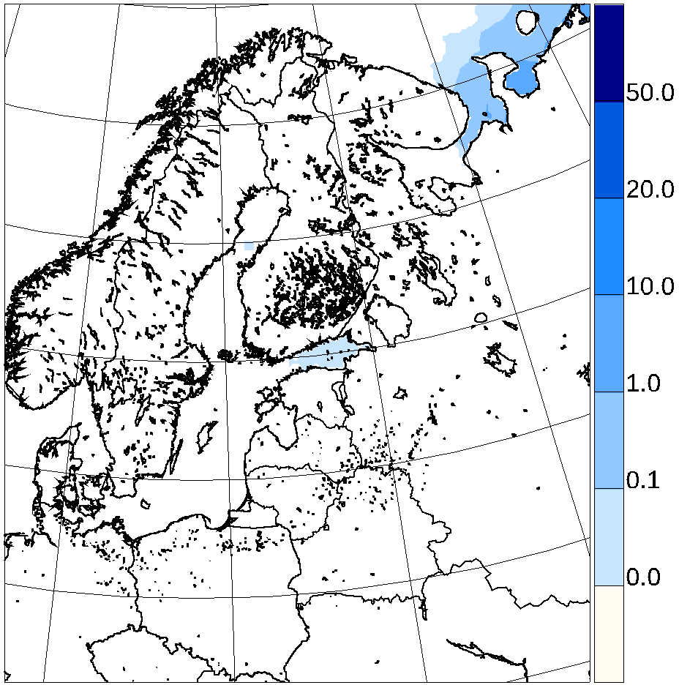
Figure 9. Average winter sea ice cover in per cent for 1981-2010 (left panel) and for 2071-2100 for 40 simulations from Euro-CORDEX according to the RCP8.5 scenario; these values have been interpolated before the RCM simulations from the driving coupled GCM.Note the non-linear scale.

Effects of model coupling
This text has not been completed yet, as the figures have just been made. Sorry!
At the moment we only look at the 6 boundary forcing GCMs, which have been applied both to the 12 km EURO-CORDEX ensemble and to theRCA-NEMO ensemble.
The single-model ocean-atmosphere regional ensemble RCA-NEMO shows a 0.5-1 degree larger warming, and as expected a much smaller spread than the EURO-CORDEX multi-GCM multi-RCM ensemble.
The coupled single-model ensemble has a smaller precipitation spread than the multi-model EURO-CORDEX ensemble, but the difference is considerably less than in the case of mean temperature, due to the larger interannual variability of precipitation. The signal for RCA4_NEMO is drier than for the entire EURO-CORDEX ensemble for both seasons depicted, leading to a smaller area of significant positive summer signal.
Wind reduction in summer (Fig. 12, rows 3 and 4) is a little bit smaller in the coupled ensemble than in the atmosphere-only ensemble. A notable exception is the increase in winter wind speed in the Bothnian Bay in the coupled model. This could be related to differences in sea ice changes between coupled and uncoupled models.
The incoming solar radiation is not reduced as much in the coupled ensemble, particularly during summer. This is most probably an effect of the coupling, and more realistic. In Bartók et al. (2016) it is shown that coupled GCMs tend to have increasing radiation in contrast to downscaled RCM results.
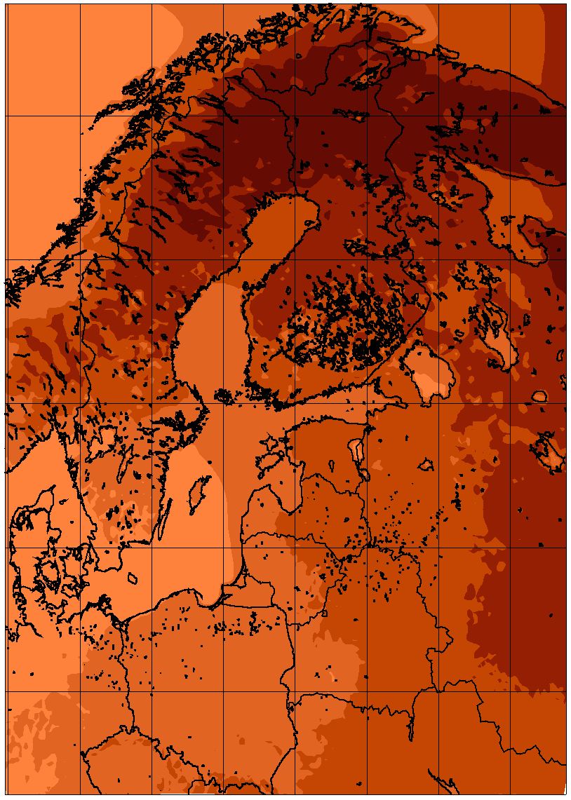 | 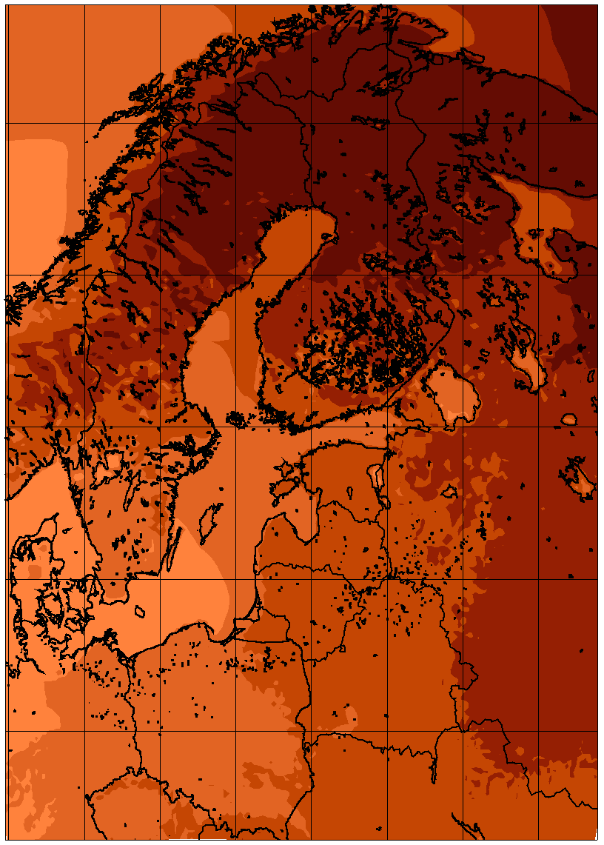 | 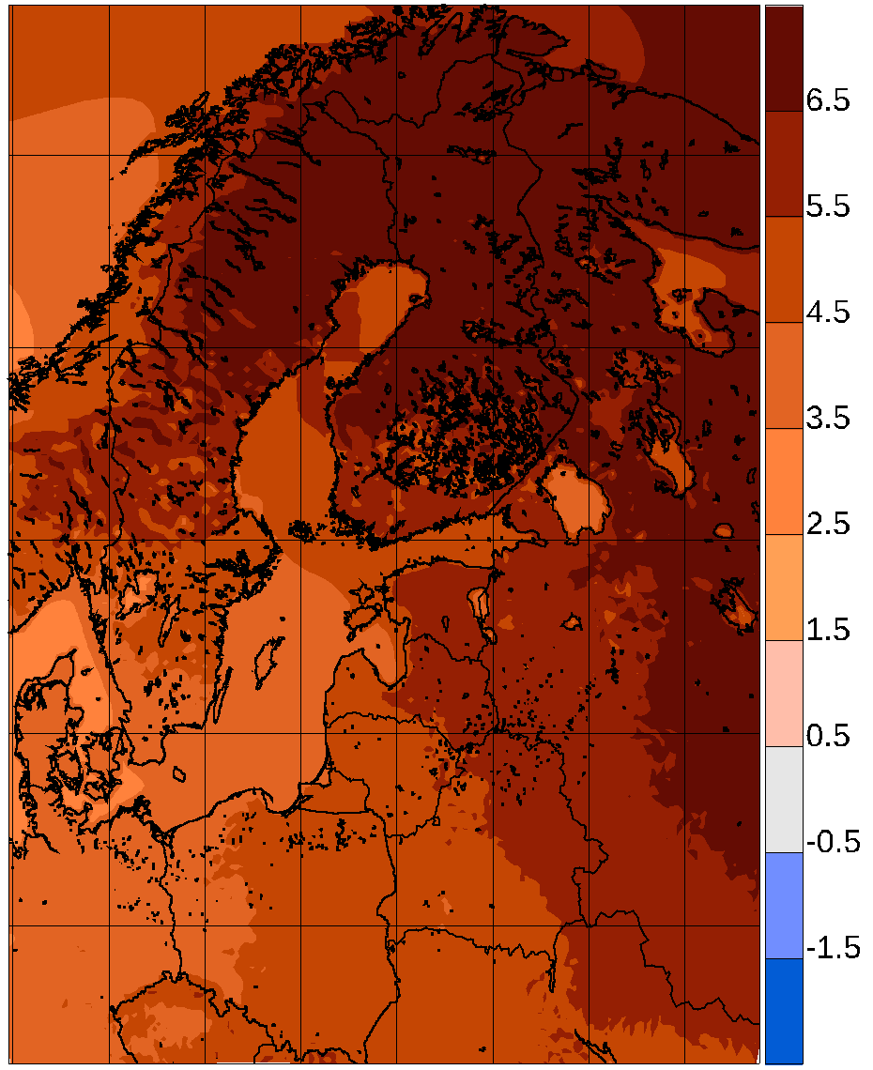
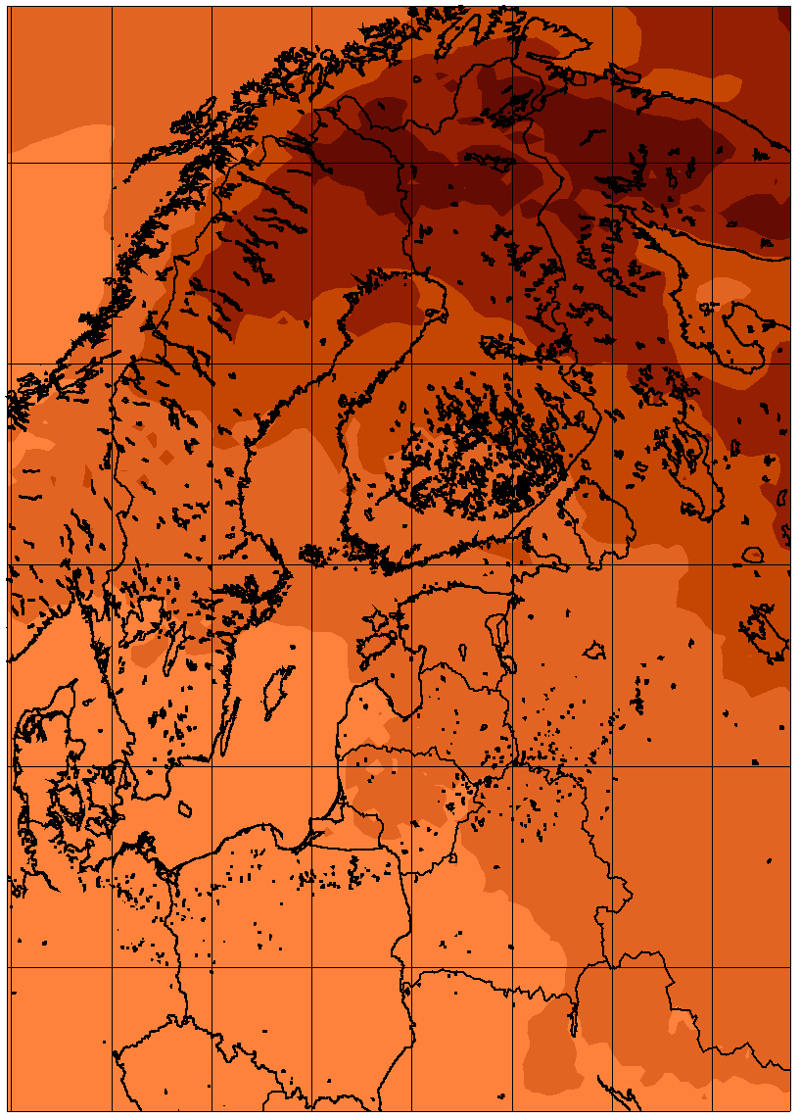 | 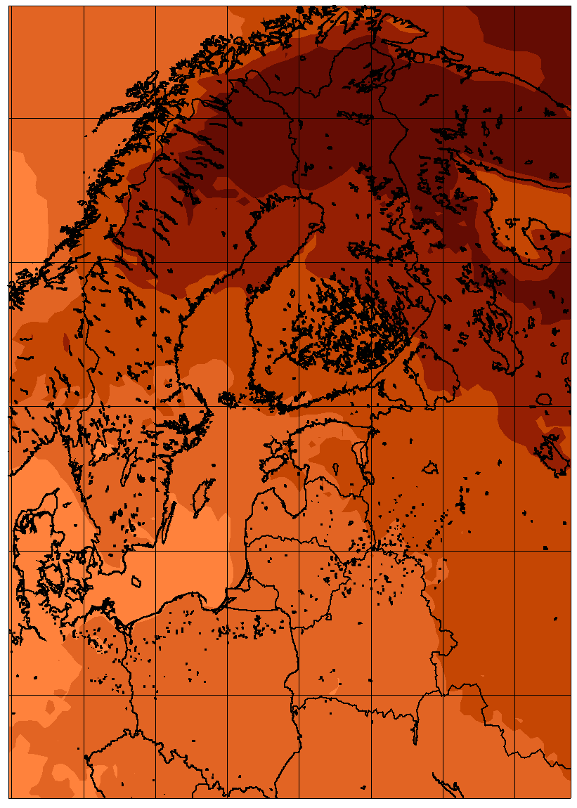 | 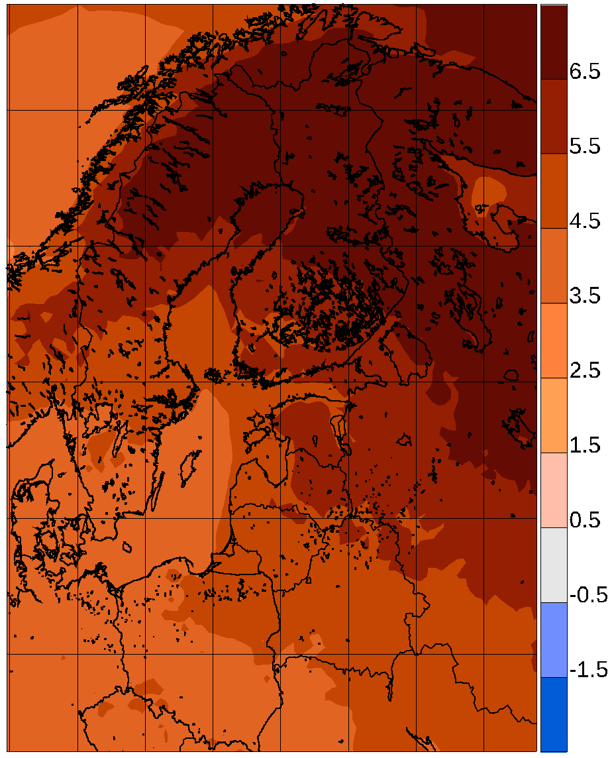
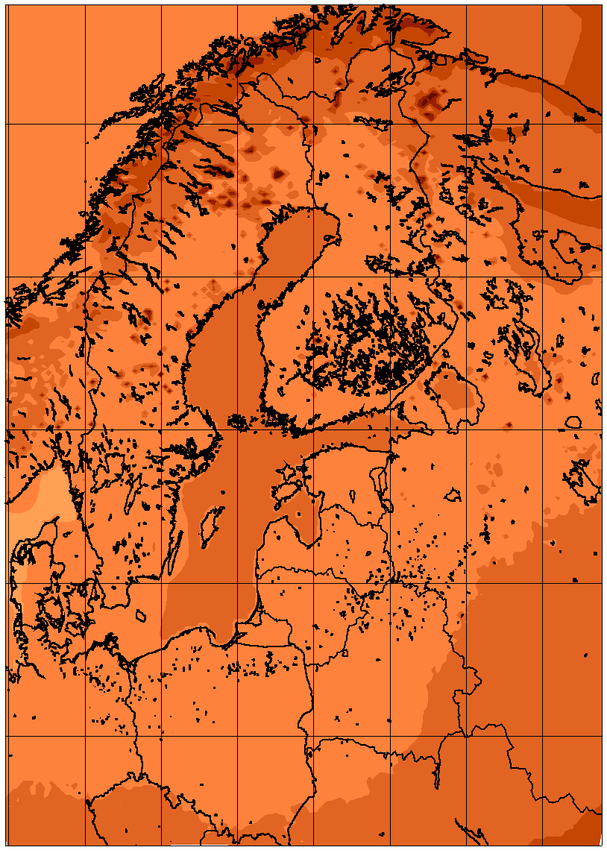 | 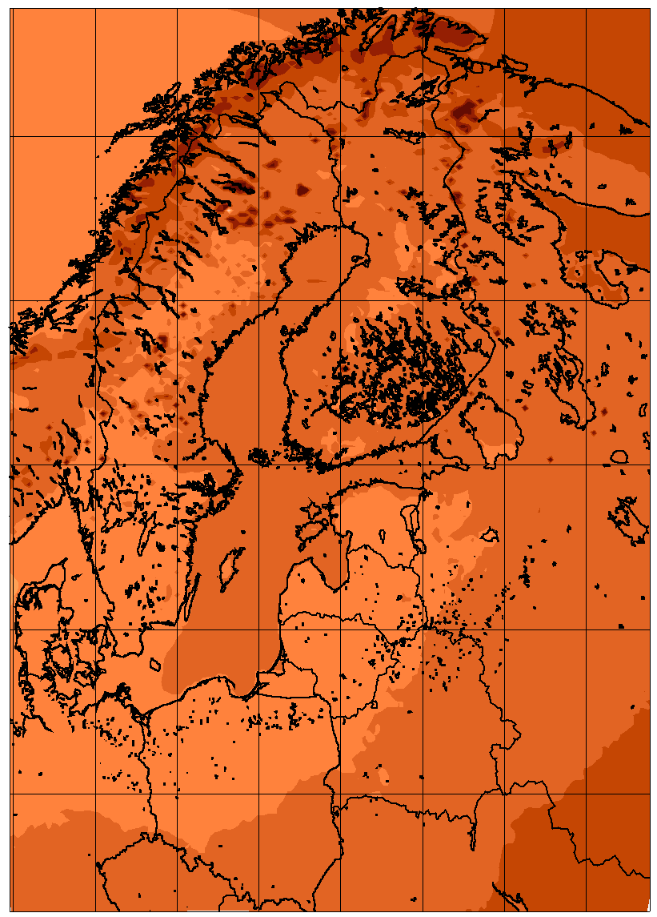 | 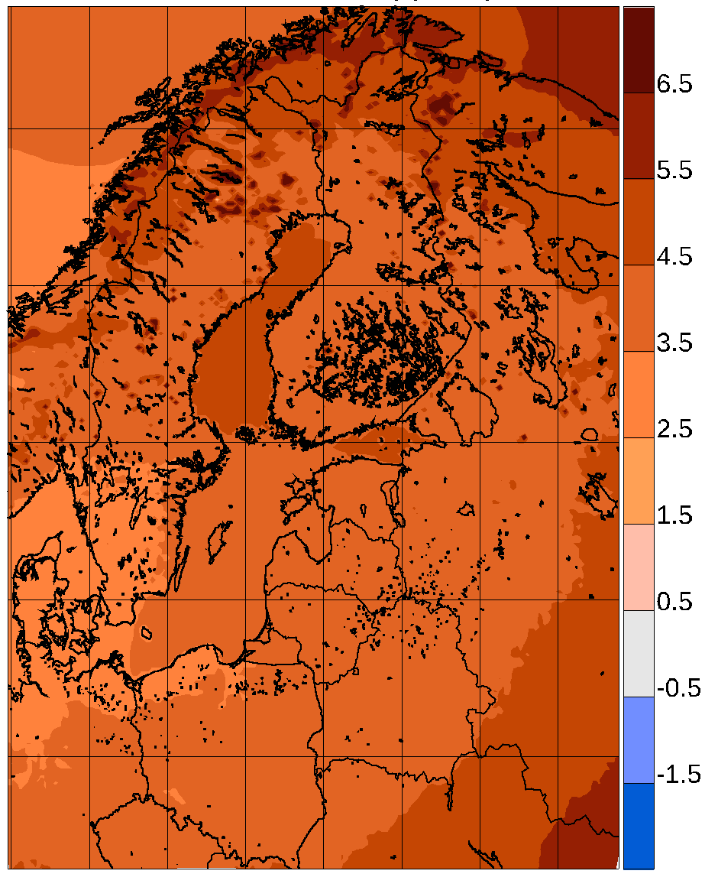
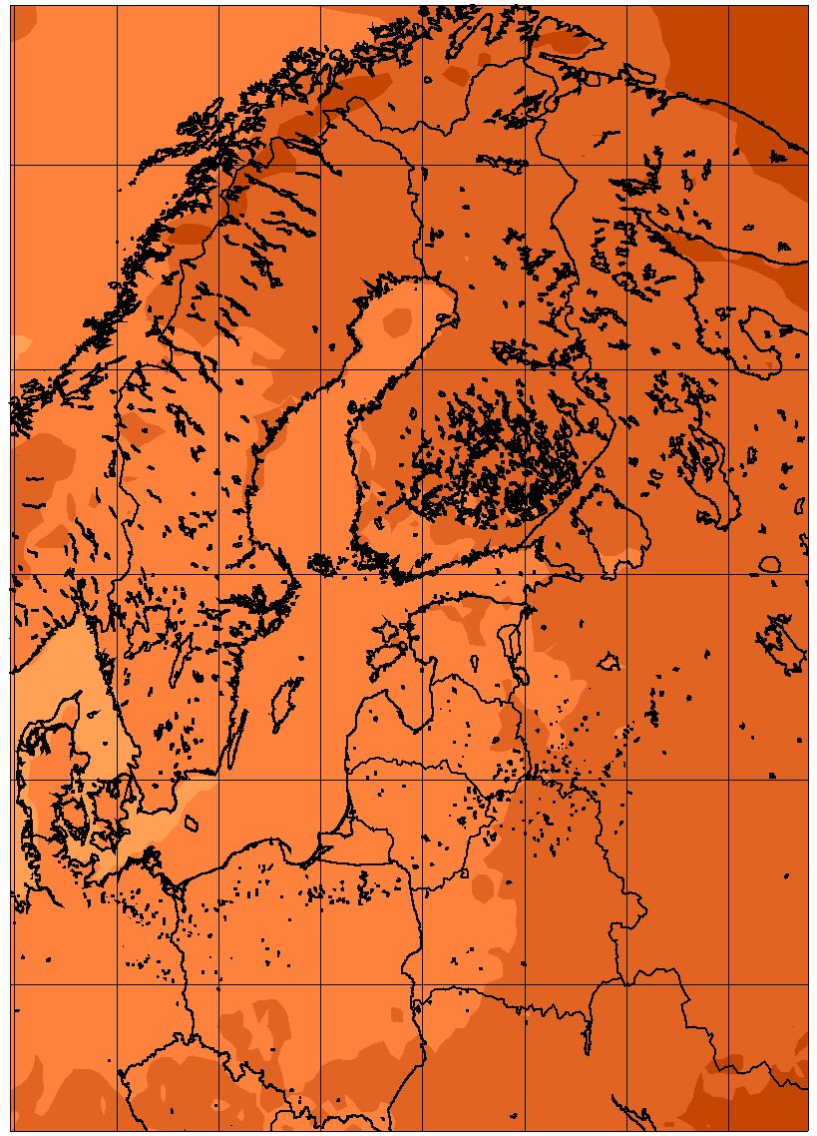 | 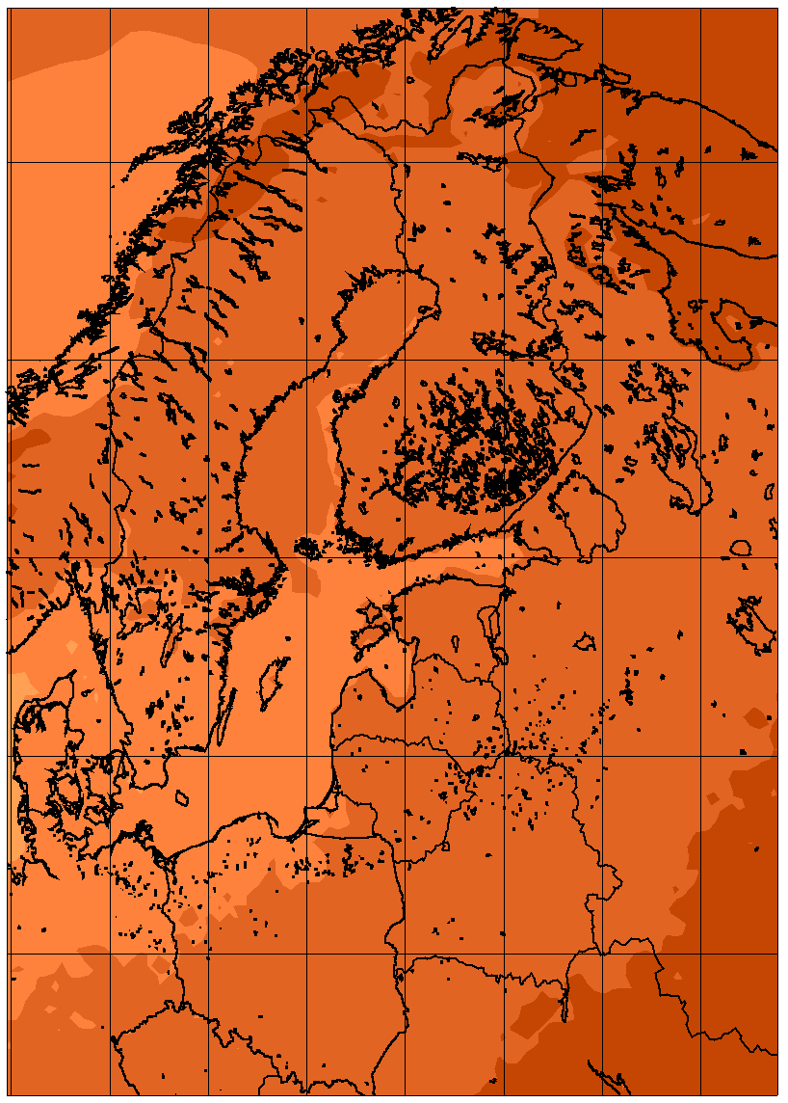 | 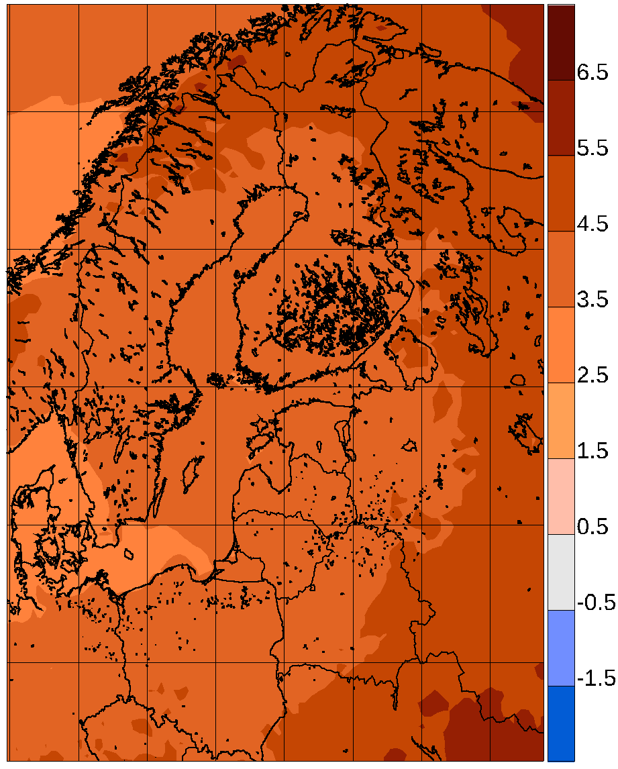
Figure 10. Temperature change between 1981-2010 and 2071-2100 for 6 atmosphere-only RCA4 simulations from Euro-CORDEX according to the RCP8.5 scenario and for the coupled single-model RCA-NEMO ensemble with the same driving GCMs. By row: Euro-CORDEX winter; RCA-NEMO winter; Euro-CORDEX summer; RCA-NEMO summer. Left column: lowest quartile; mid column: median value; right column: higher quartile. In all following figures, the mid column depicting pointwise median values is only coloured when 75% of simulations agree on the sign of the change.
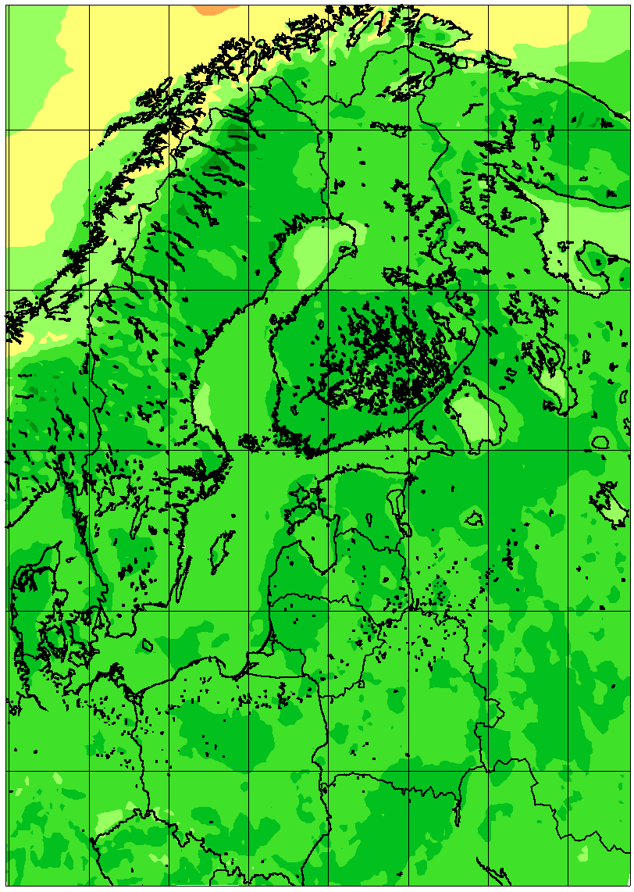 | 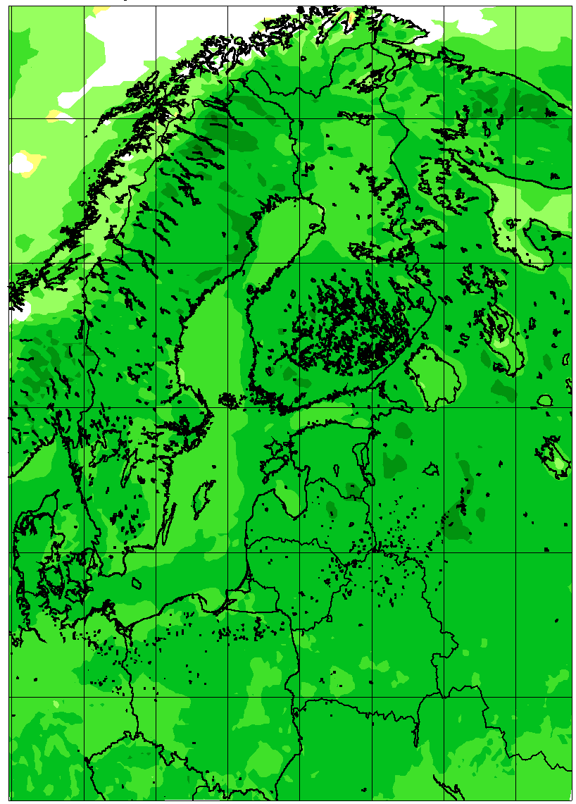 | 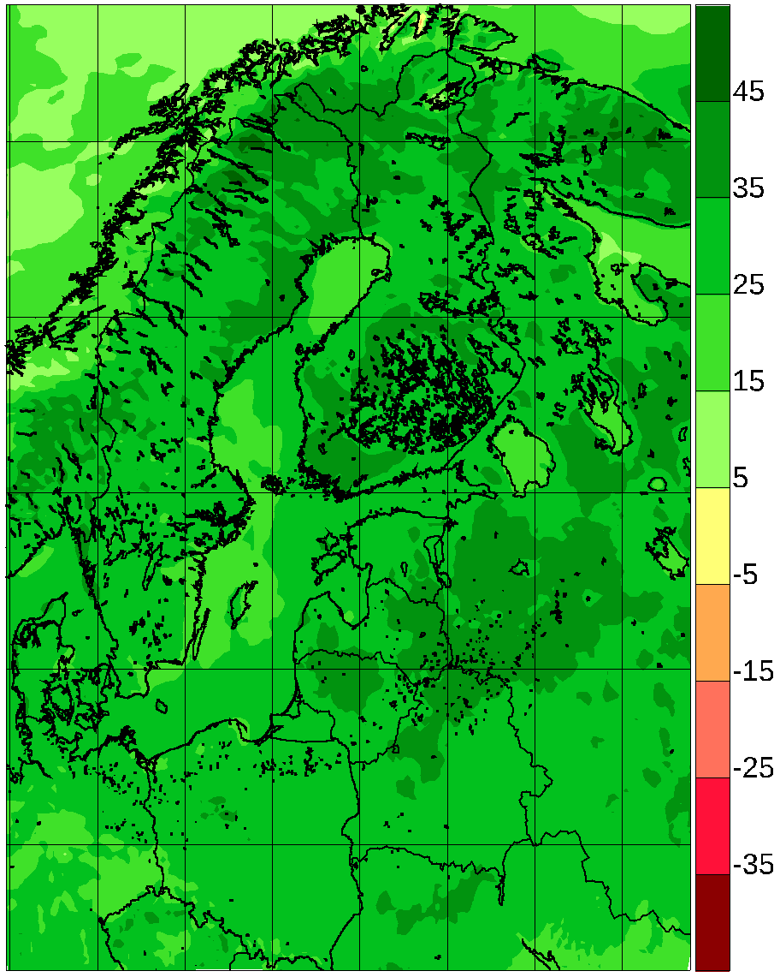
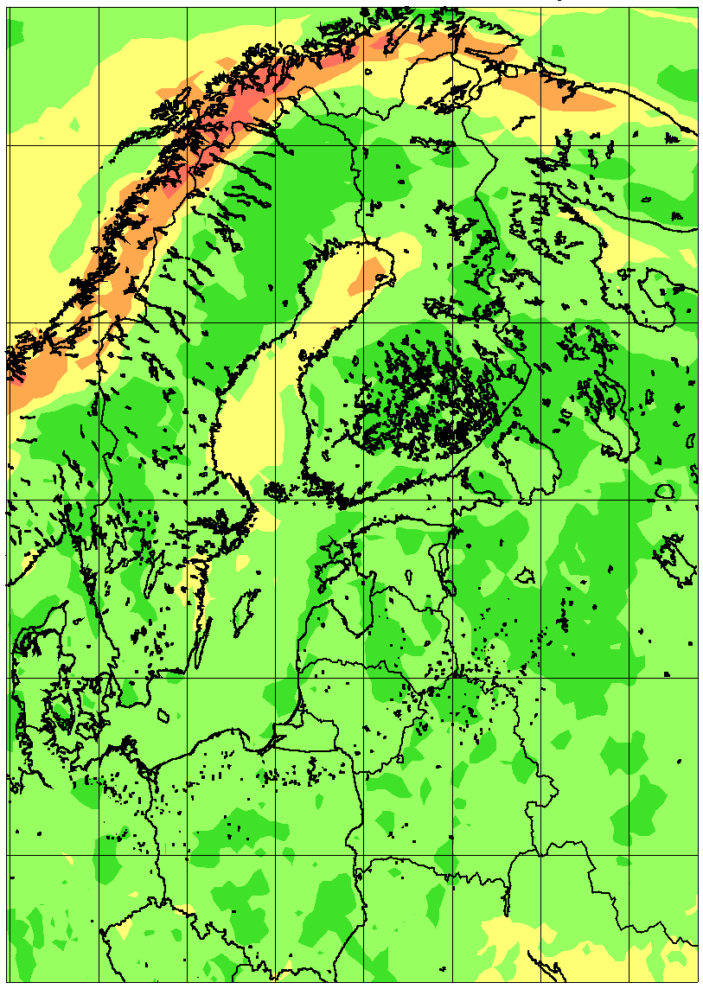 | 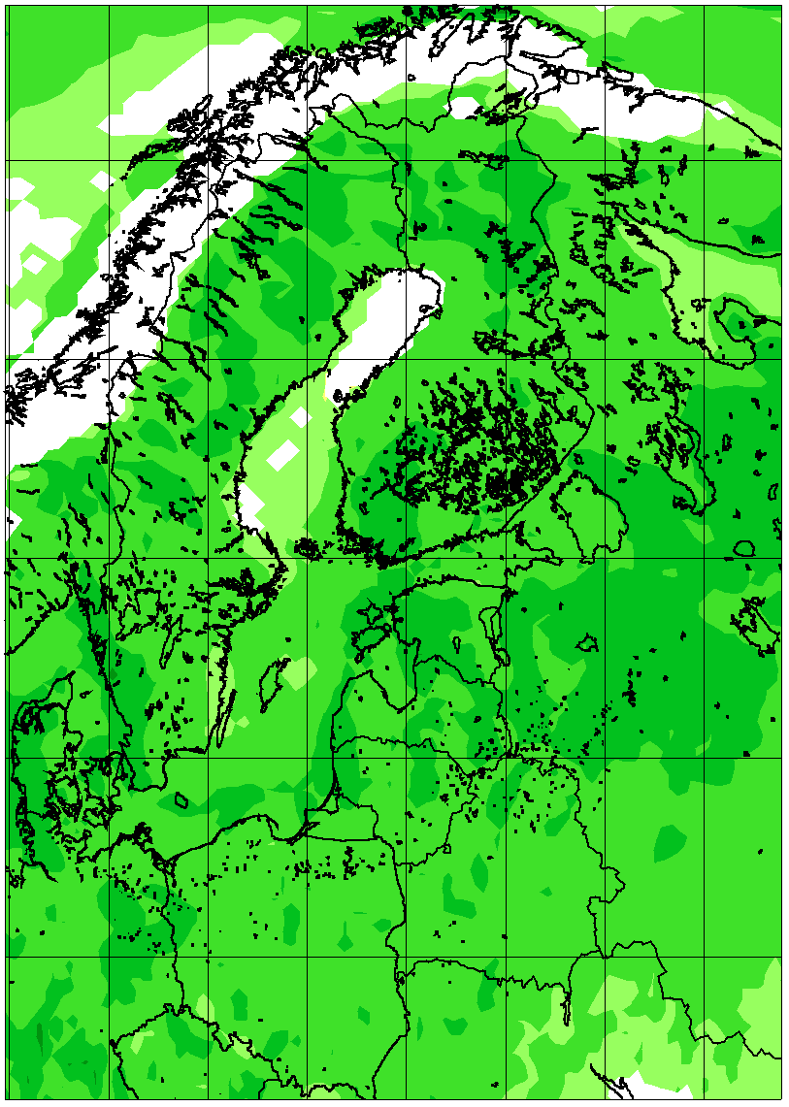 | 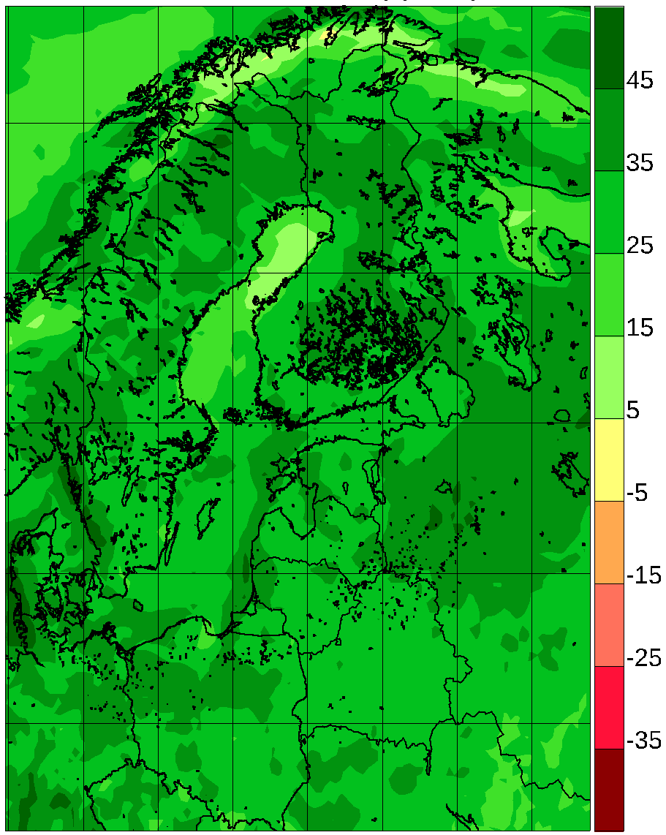
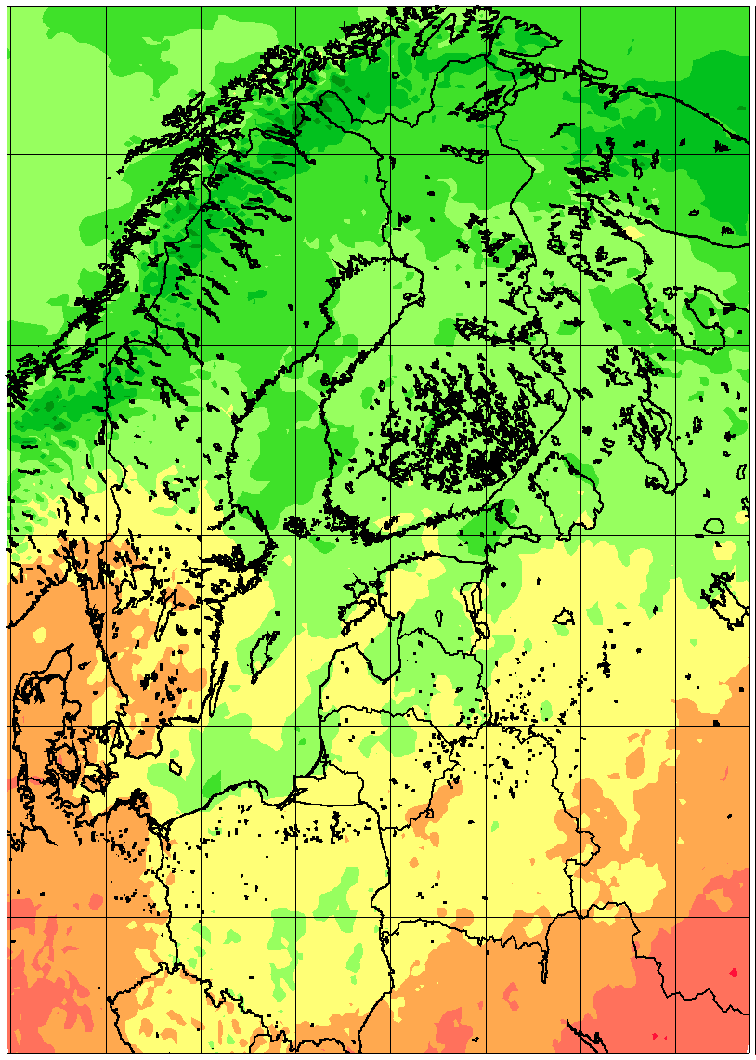 | 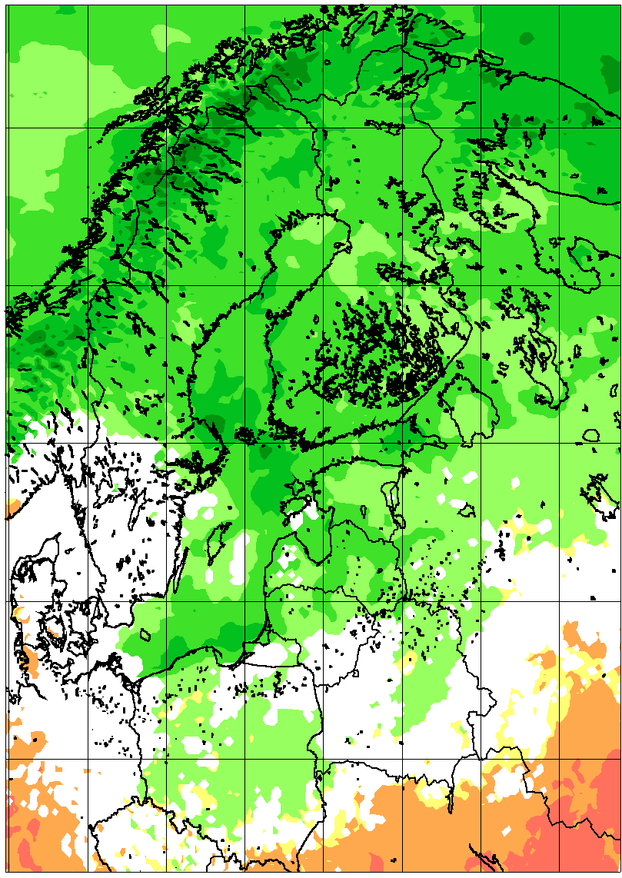 | 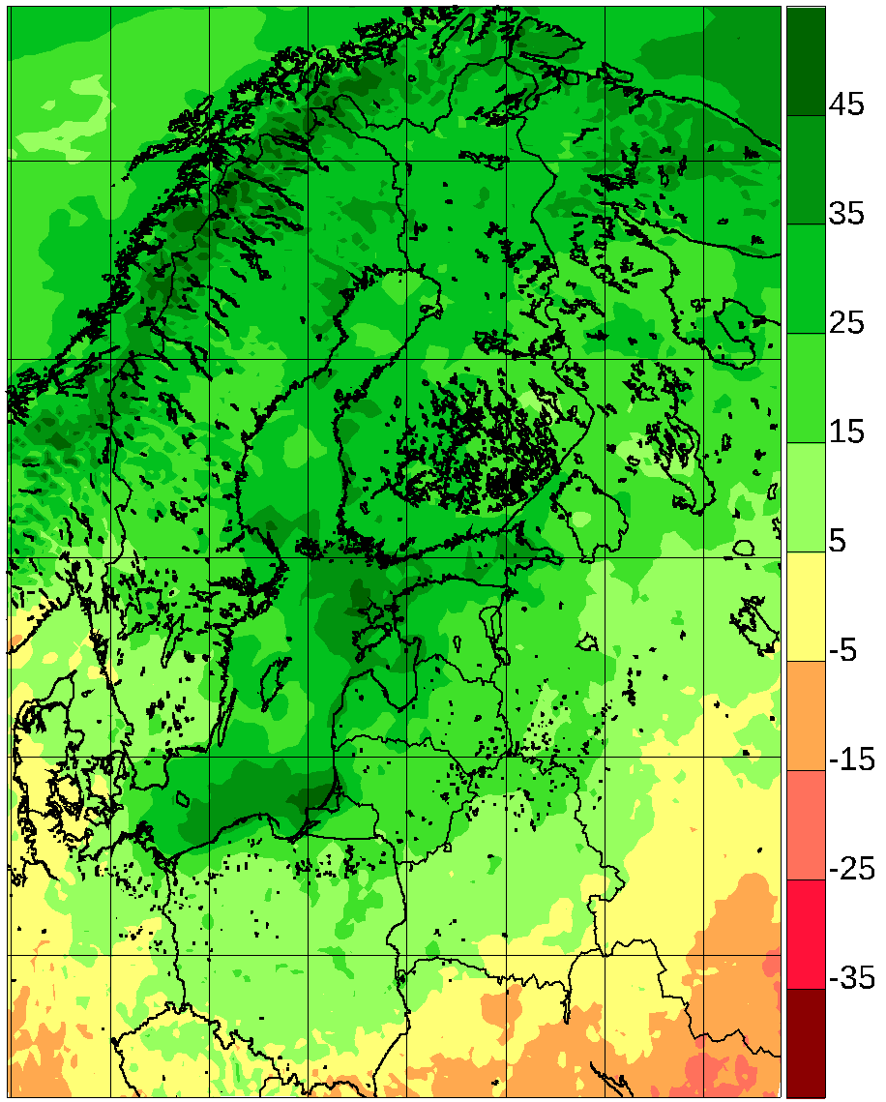
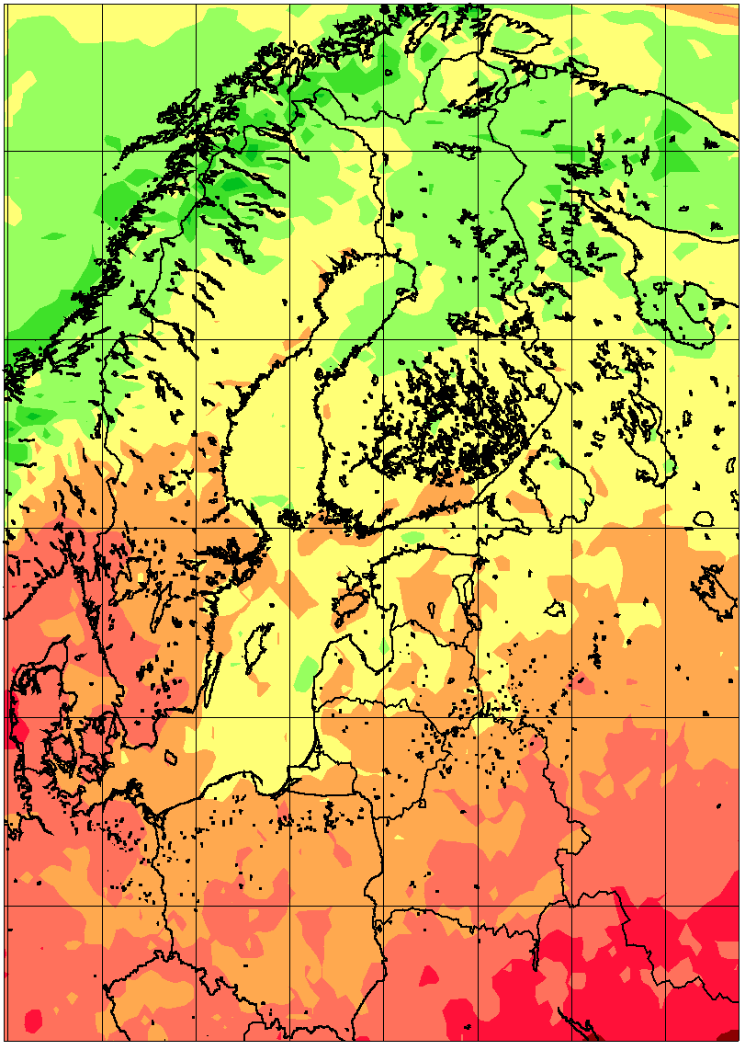 | 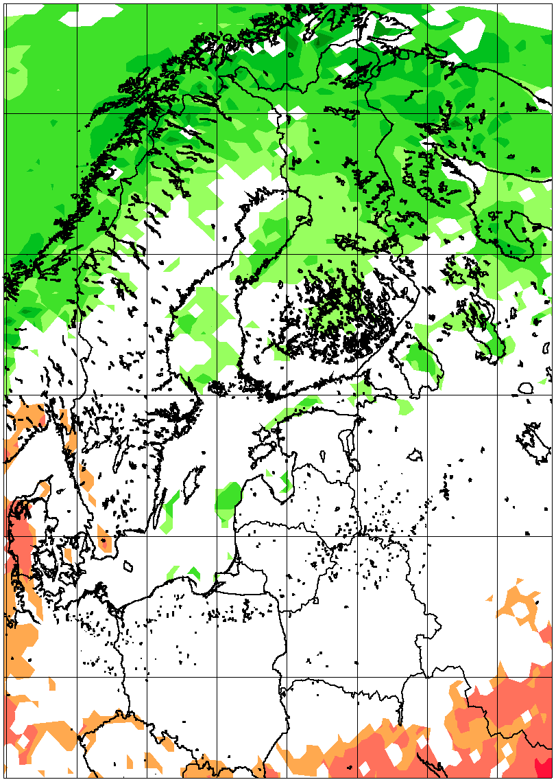 | 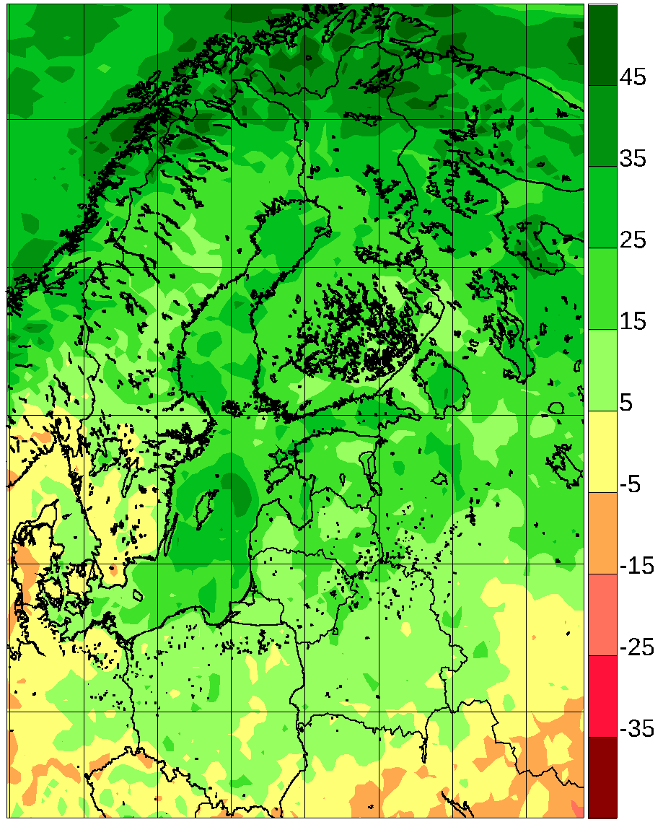
Figure 11. Precipitation relative change (%) between 1981-2010 and 2071-2100 for 6 atmosphere-only RCA4 simulations from Euro-CORDEX according to the RCP8.5 scenario and for the coupled single-model RCA-NEMO ensemble with the same driving GCMs. By row: Euro-CORDEX winter; RCA-NEMO winter; Euro-CORDEX summer; RCA-NEMO summer. Left column: lowest quartile; mid column: median value; right column: higher quartile. In all following figures, the mid column depicting pointwise median values is only coloured when 75% of simulations agree on the sign of the change.
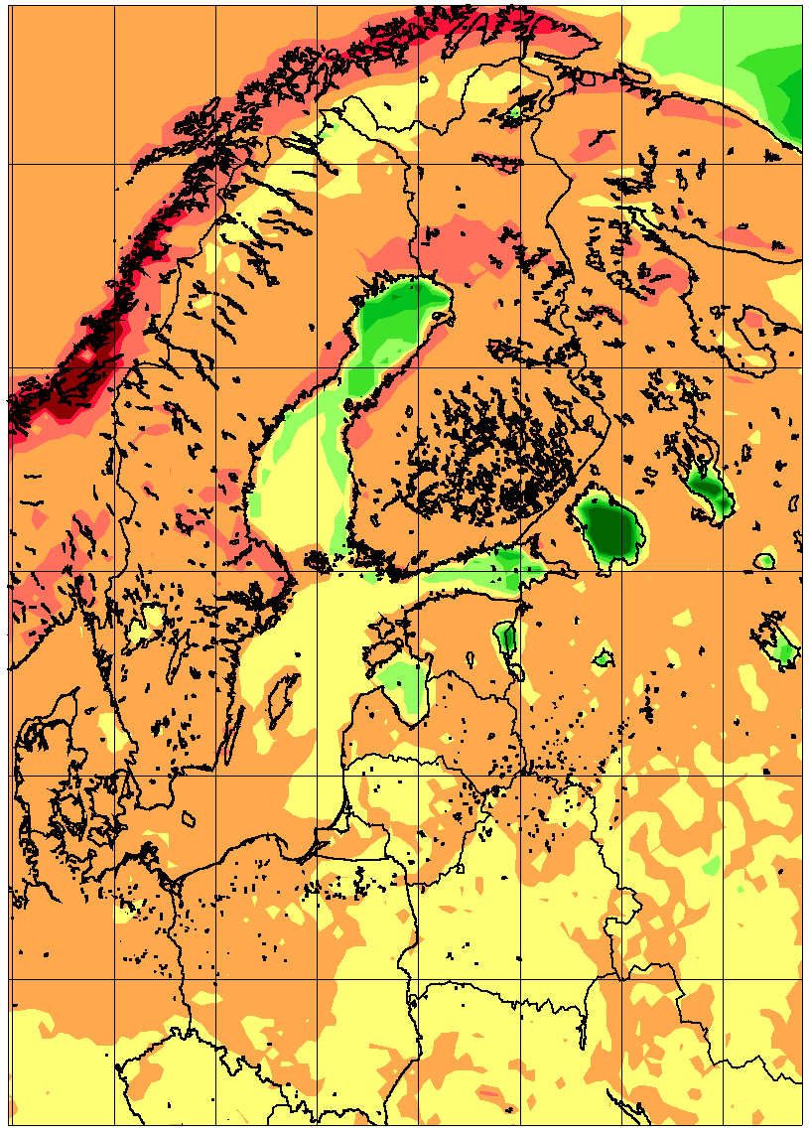 | 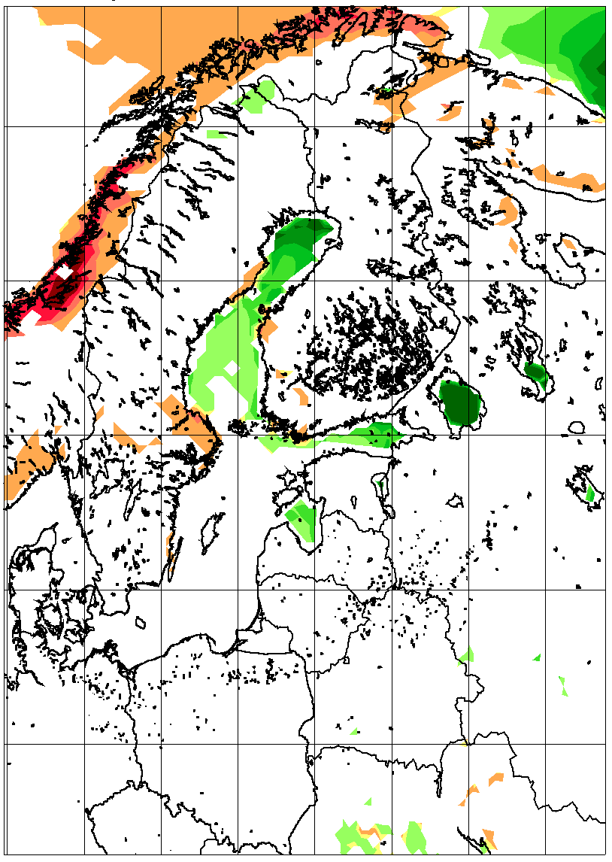 | 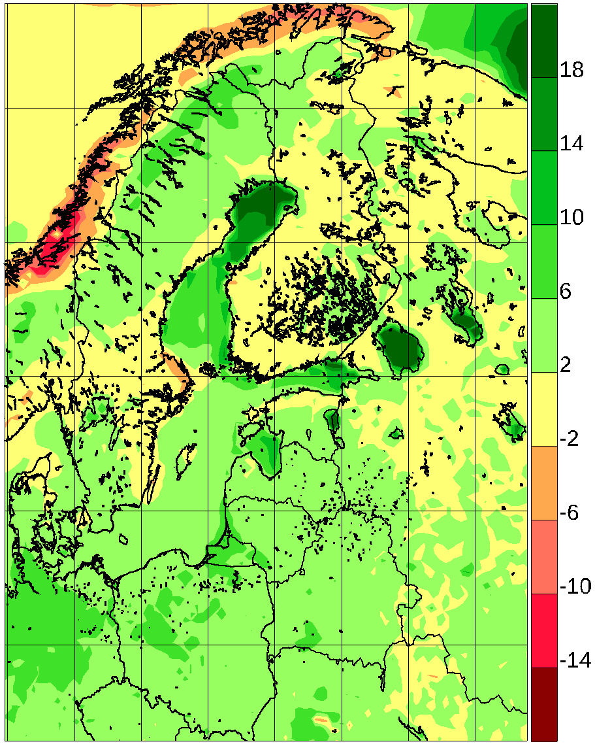
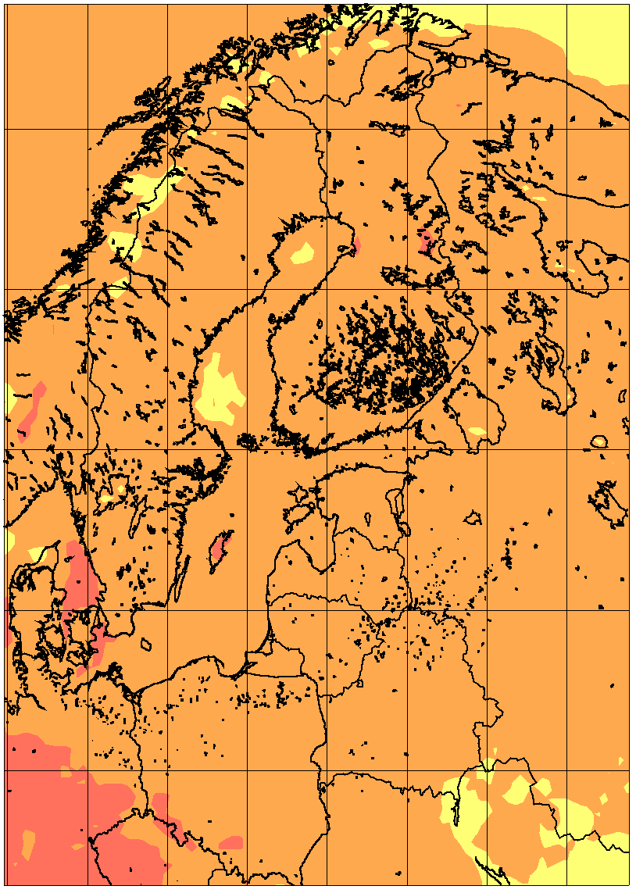 | 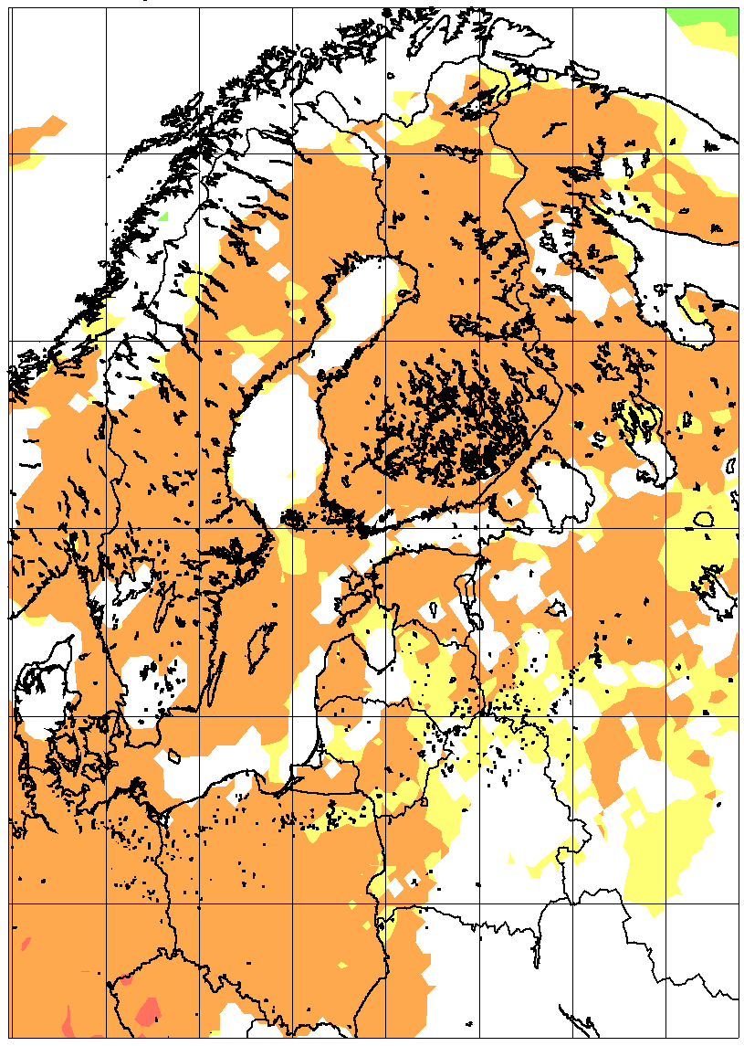 | 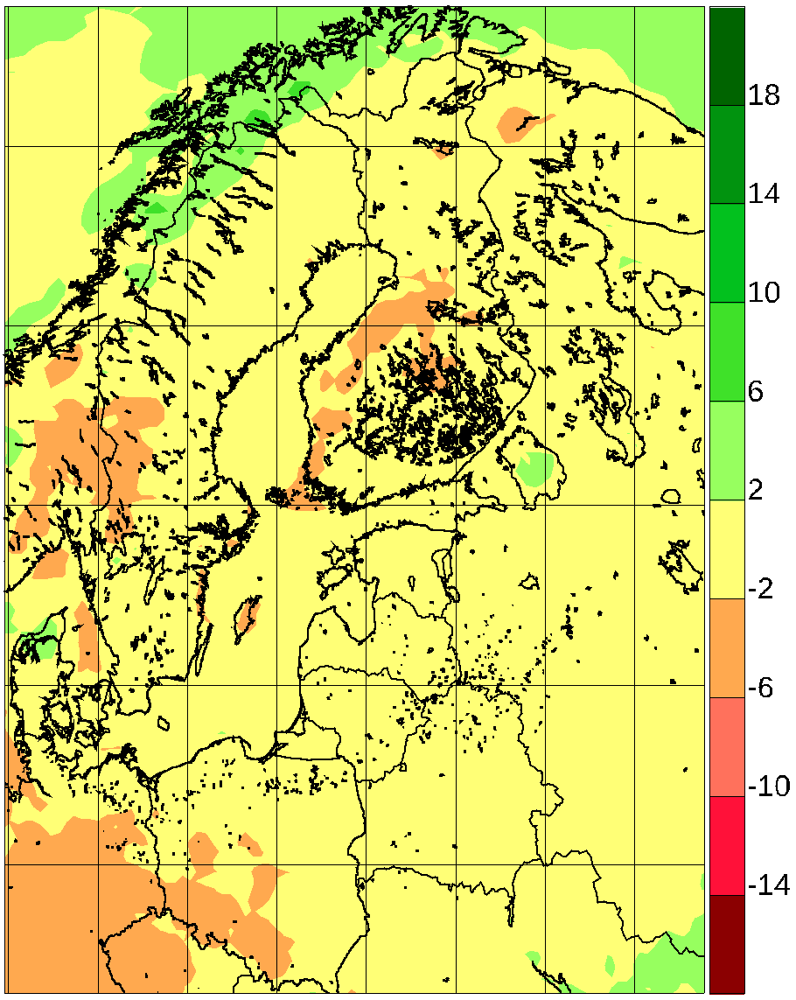
Figure 12. Average wind speed relative change (%) between 1981-2010 and 2071-2100 for 9 atmosphere-only RCA4 simulations from Euro-CORDEX according to the RCP8.5 scenario and for the coupled single-model RCA-NEMO ensemble with the same driving GCMs. By row: Euro-CORDEX winter; RCA-NEMO winter; Euro-CORDEX summer; RCA-NEMO summer. Left column: lowest quartile; mid column: median value; right column: higher quartile. In all following figures, the mid column depicting pointwise median values is only coloured when 75% of simulations agree on the sign of the change.
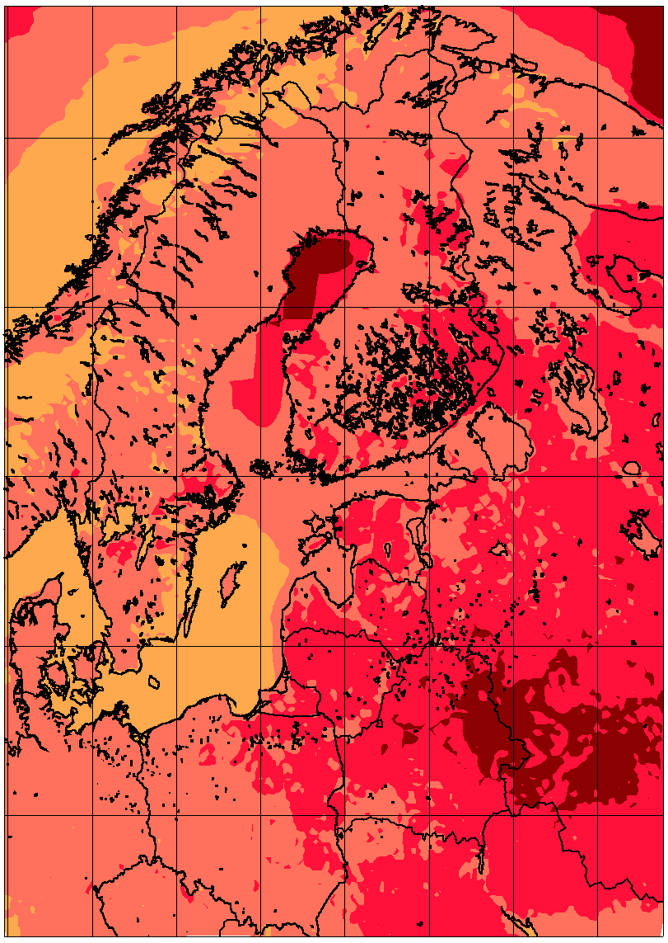 | 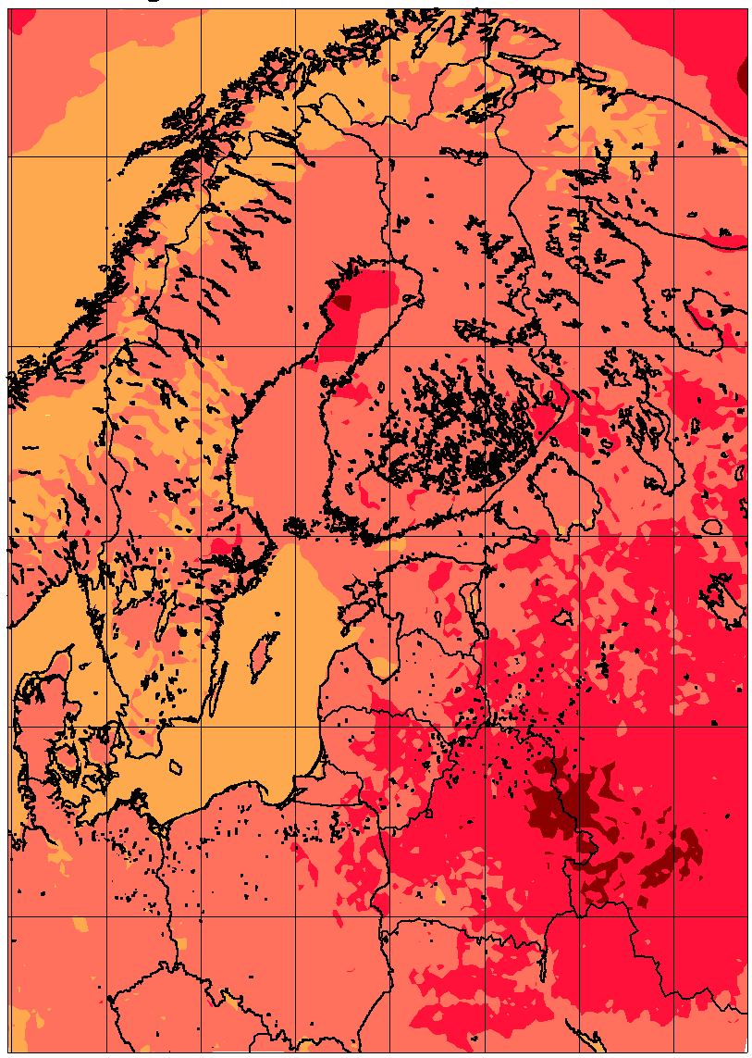 | 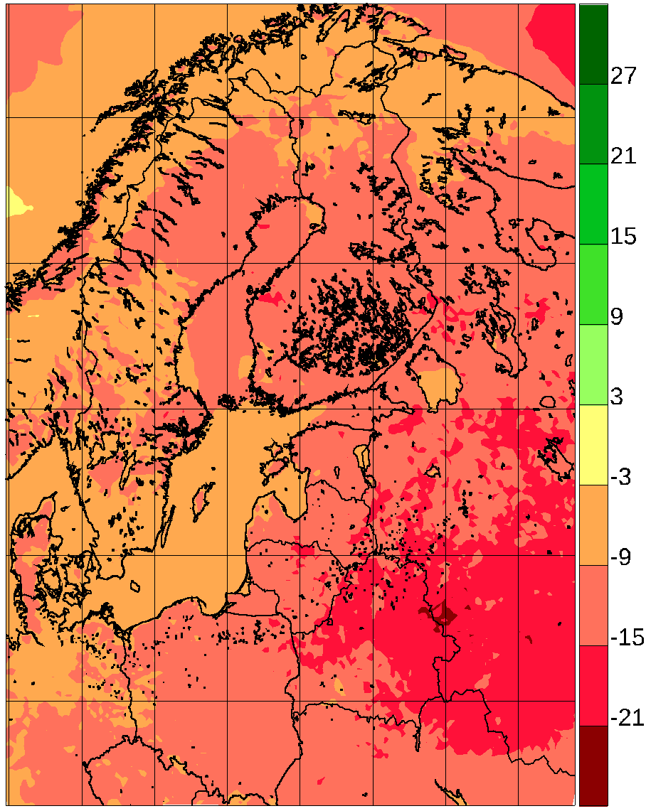
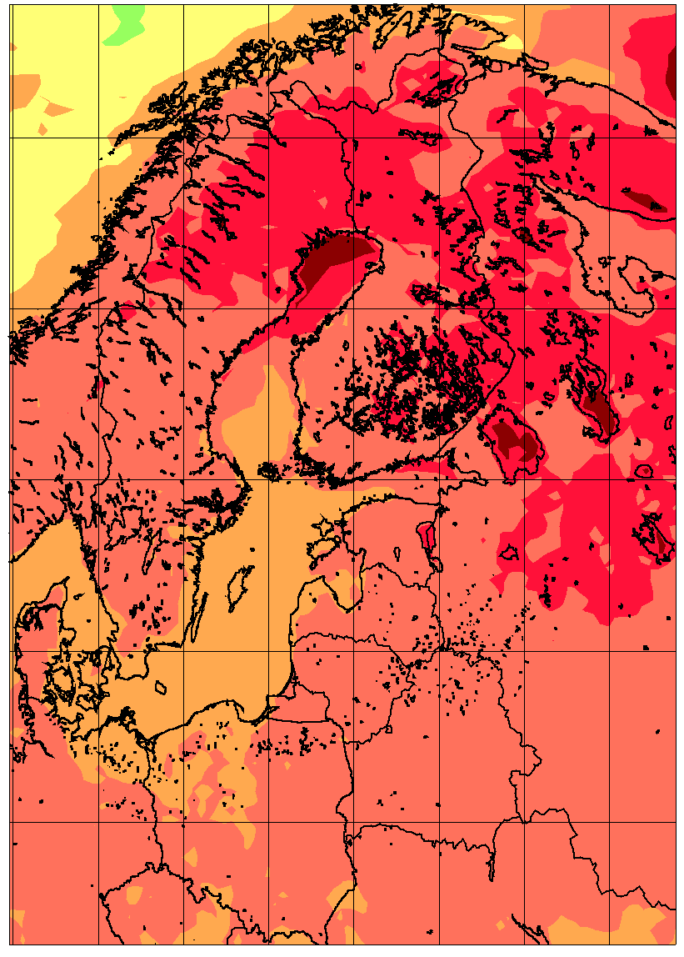 | 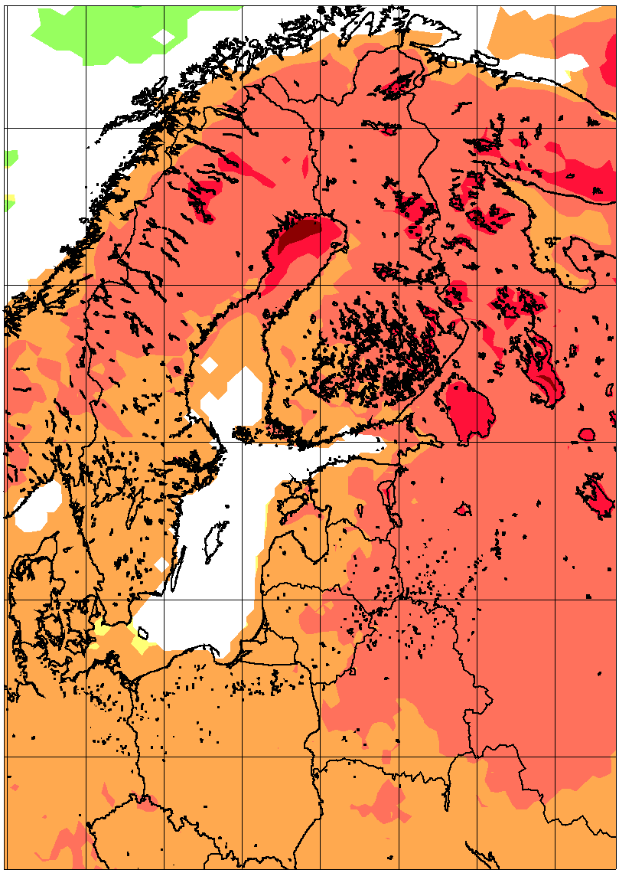 | 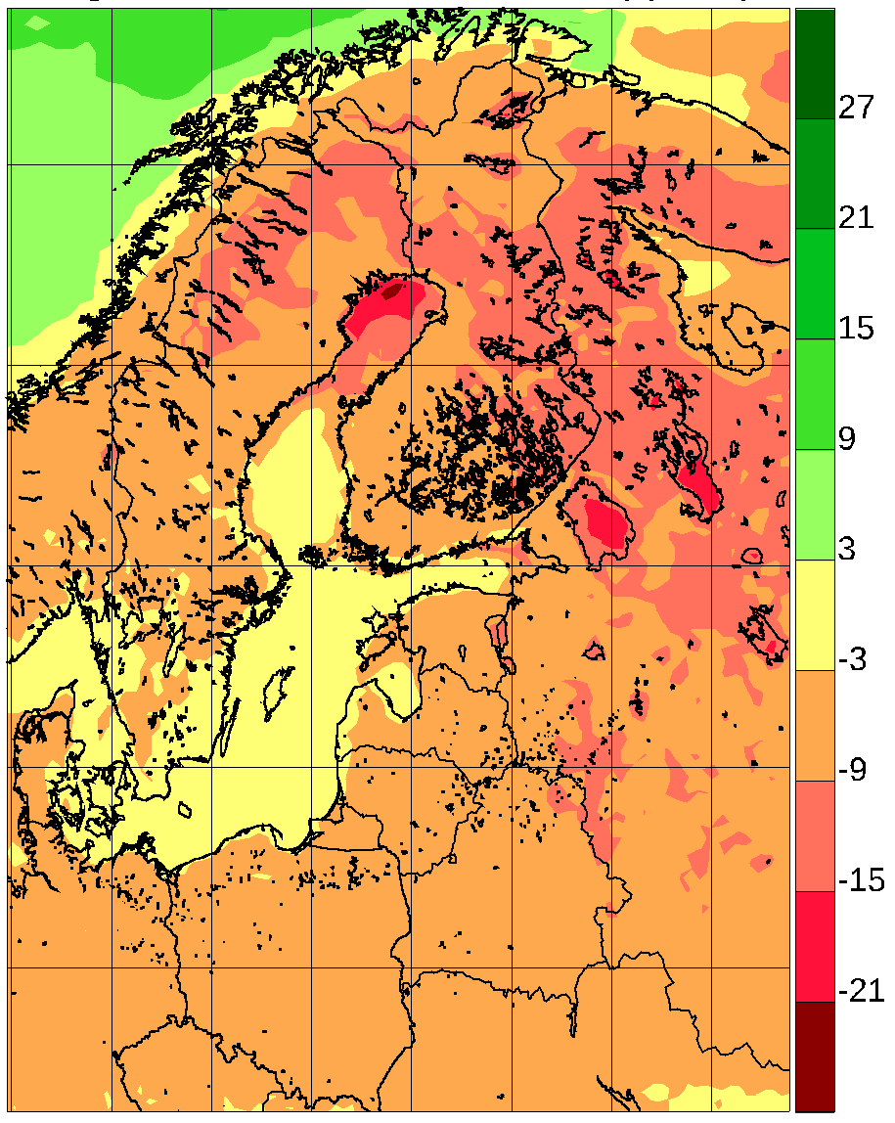
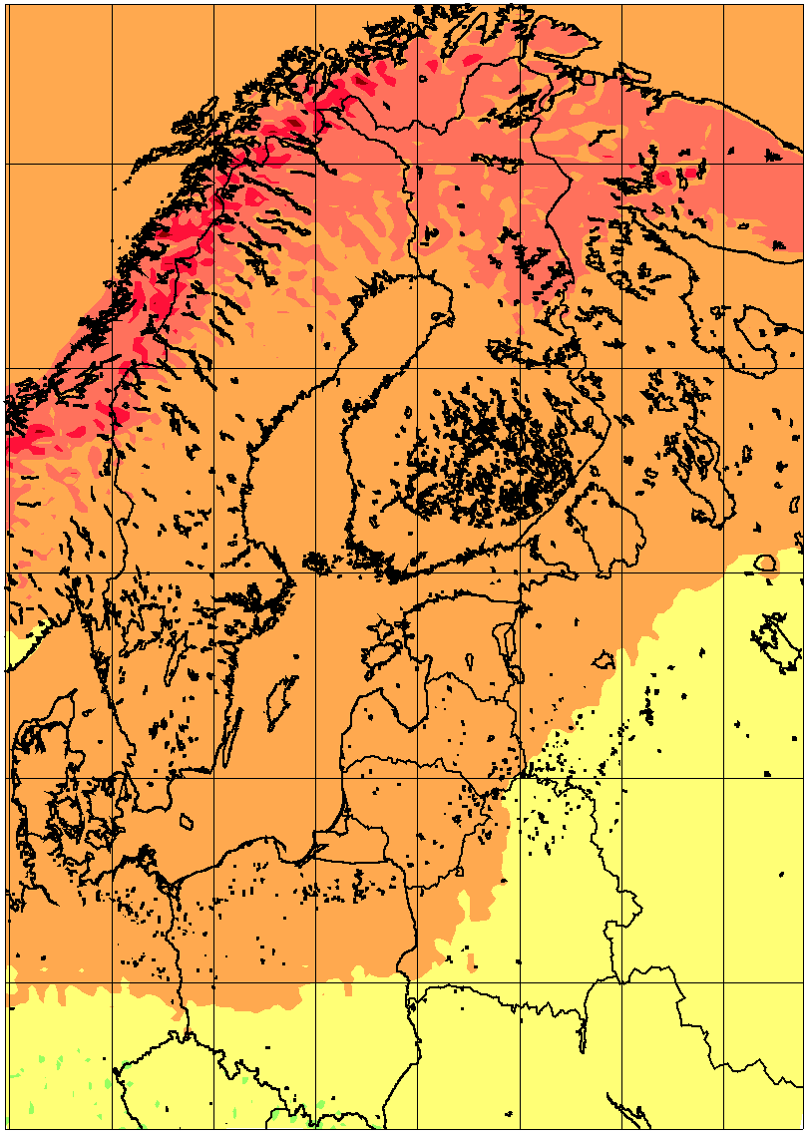 | 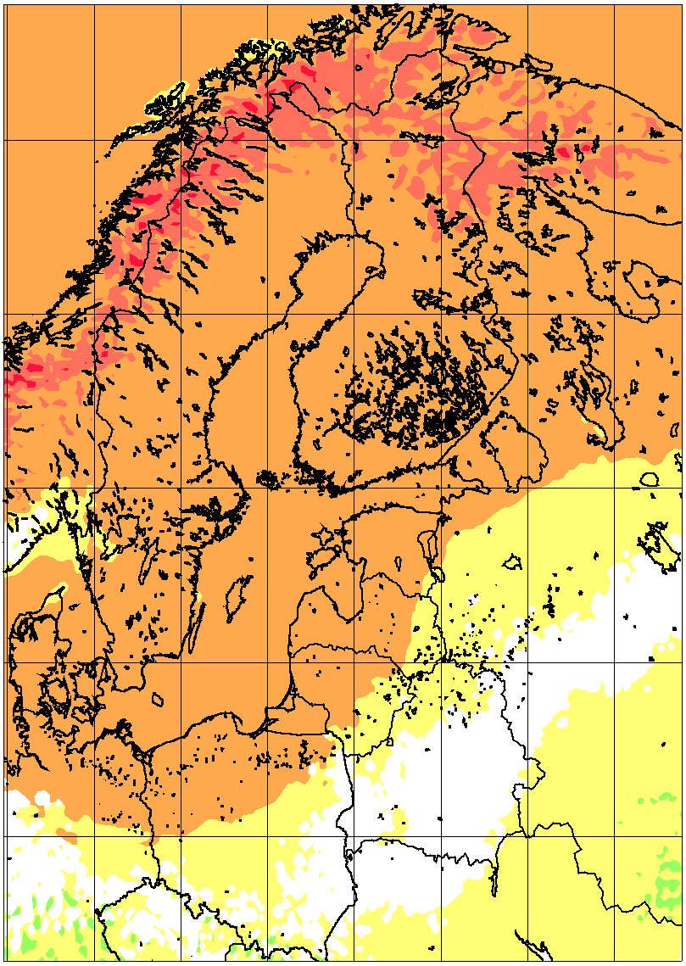 | 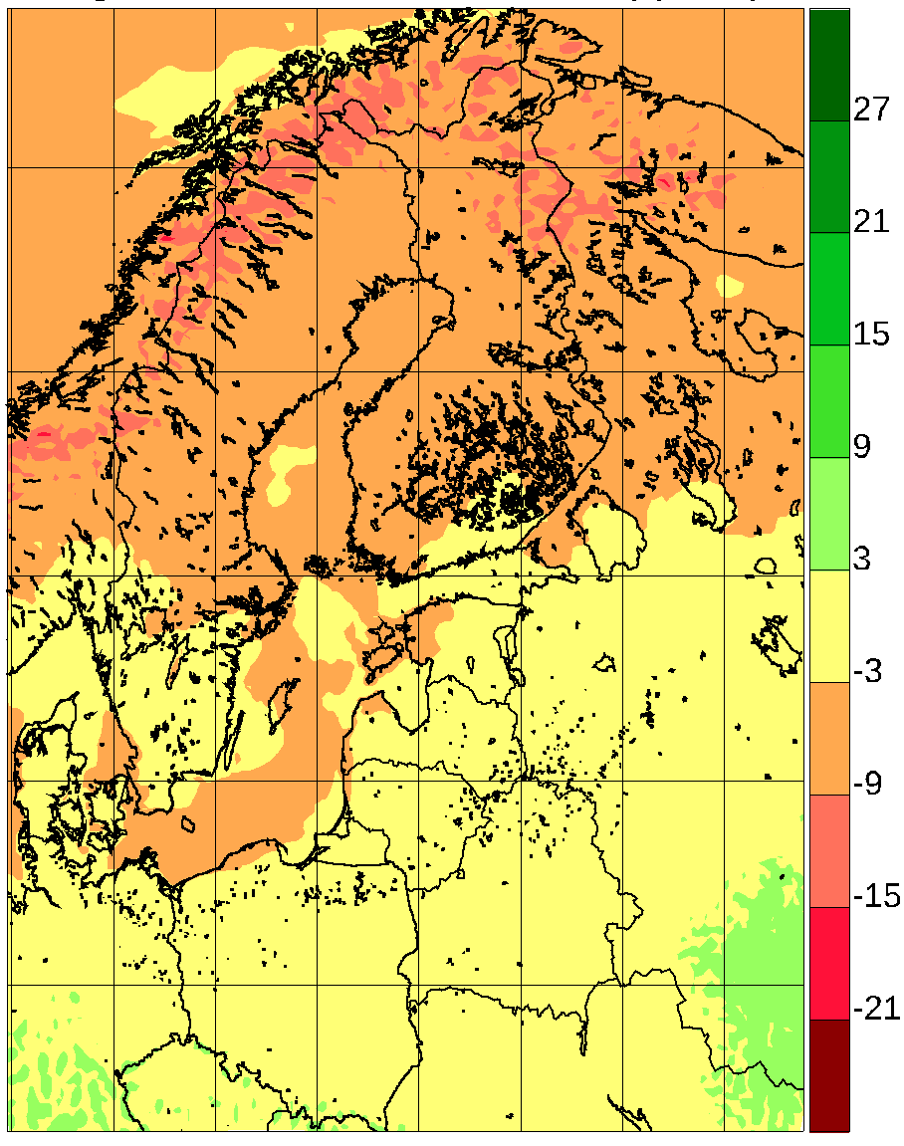
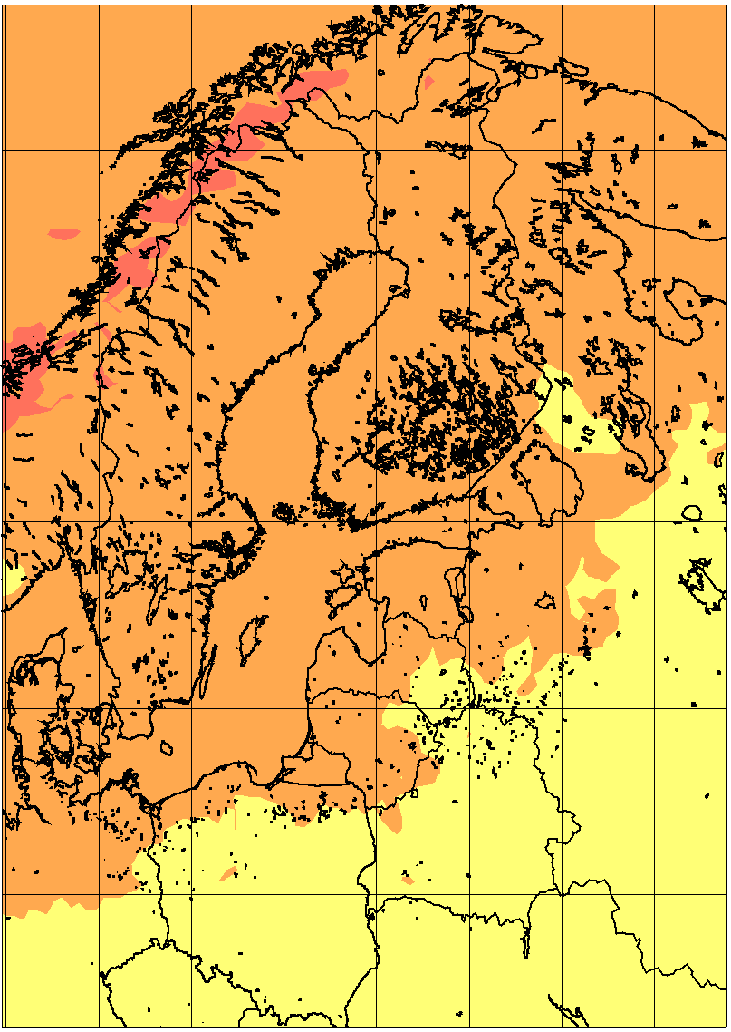 | 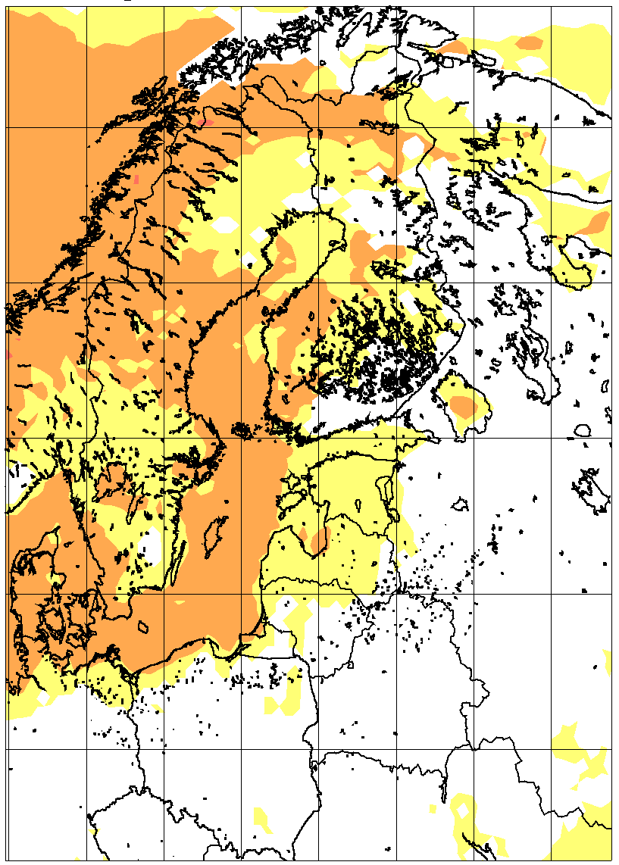 | 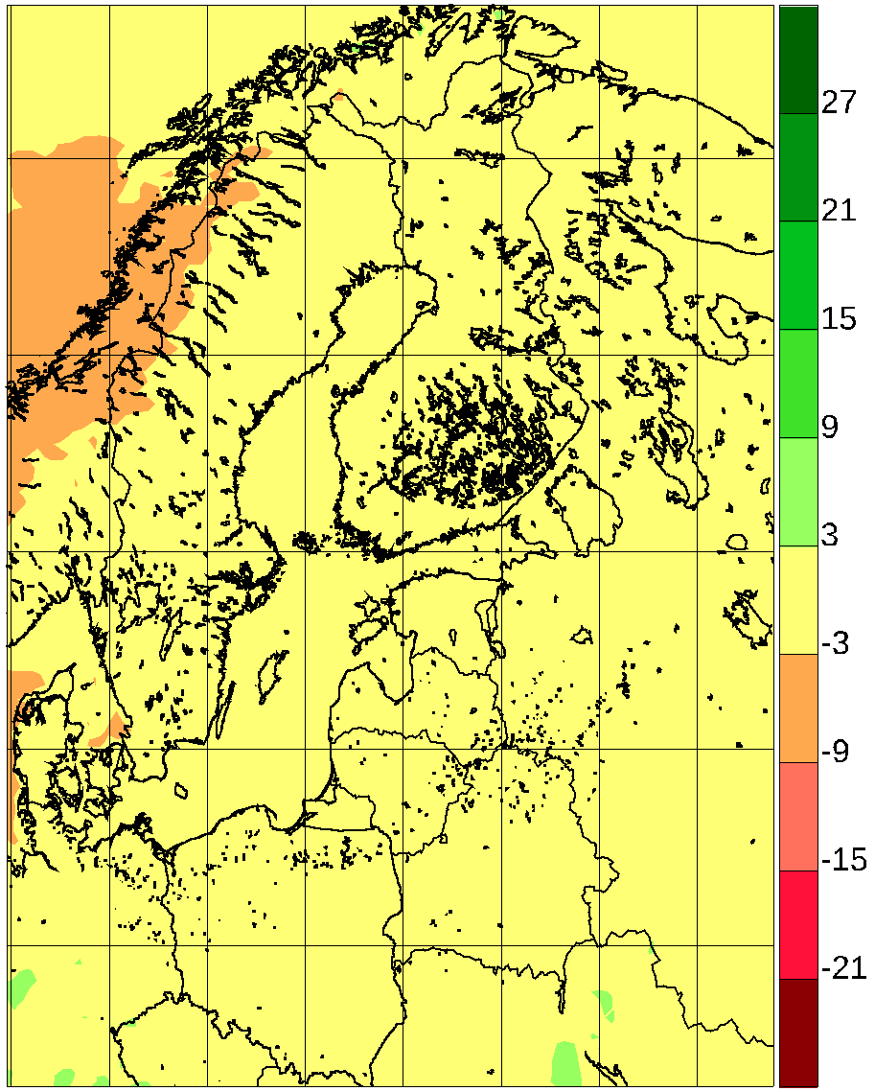
Figure 13. Average incoming solar radiation relative change (%) between 1981-2010 and 2071-2100 for 9 atmosphere-only RCA4 simulations from Euro-CORDEX according to the RCP8.5 scenario and for the coupled single-model RCA-NEMO ensemble with the same driving GCMs. By row: Euro-CORDEX winter; RCA-NEMO winter; Euro-CORDEX summer; RCA-NEMO summer. Left column: lowest quartile; mid column: median value; right column: higher quartile. In all following figures, the mid column depicting pointwise median values is only coloured when 75% of simulations agree on the sign of the change.

Conclusion

References
Akhtar, Naveed, Krug, Amelie, Brauch, Jennifer, Arsouze, Thomas, Dieterich, Christian, Ahrens, Bodo: European Marginal Seas in a regional atmosphere-ocean coupled model and their impact on Vb-cyclones and associated precipitation, Clim Dynam, 2019, 1-33, 10.1007/s00382-019-04906-x, 2019
BACC Author Team (2008) Assessment of Climate Change for the Baltic Sea Basin. Regional Climate Studies, Springer Verlag, Berlin, Heidelberg
BACC2 Author Team (2013) Second Assessment of Climate Change for the Baltic Sea Basin. Regional Climate Studies, Springer Verlag, Berlin, Heidelberg
Ban, N., J. Schmidli, and C. Schär (2015), Heavy precipitation in a changing climate: Does short-term summer precipitation increase faster?, Geophys. Res. Lett., 42, 1165–1172, doi:10.1002/2014GL062588.
Buser CM, Künsch HR, Schär C (2010) Bayesian multi-model projections of climate: generalization and application to ENSEMBLES results. Clim Res 4:227-241
Christensen OB (2011) Report on regional simulation of climate change according to an RCP8.5 scenario. Deliverable 1.3 of the FP7 ClimateCost project. Available by request from Ole B. Christensen, obc@dmi.dk
Christensen, O., & Kjellström, E. (2018, September 26). Projections for Temperature, Precipitation, Wind, and Snow in the Baltic Sea Region until 2100. Oxford Research Encyclopedia of Climate Science. https://oxfordre.com/climatescience/view/10.1093/acrefore/9780190228620.001.0001/acrefore-9780190228620-e-695. DOI: 10.1093/acrefore/9780190228620.013.695
Christensen JH, Christensen OB (2003) Severe summertime flooding in Europe. Nature 421:805-806
Christensen JH, Christensen OB (2007) A summary of the PRUDENCE model projections of changes in European climate by the end of the century. Climatic Change 81:7-30
Christensen JH, Hewitson B, Busuioc A, Chen A, Gao X, Held I, Jones R, Kolli RK, Kwon WT, Laprise R, Magaña Rueda V, Mearns L, Menéndez CG, Räisänen J, Rinke A, Sarr A,Whetton P (2007) Regional Climate Projections. In: Solomon S, Qin D, Manning M, Chen Z, Marquis M, Averyt KB, Tignor M, Miller HL (eds), Climate Change 2007: The Physical Science Basis. Contribution of Working Group I to the Fourth Assessment Report of the Intergovernmental Panel on Climate Change. Cambridge University Press, Cambridge, UK
Christensen JH, Kjellström E, Giorgi F, Lenderink G, Rummukainen M (2010) Weight assignment in regional climate models. Clim Res 44:179-194
Déqué M, Somot S, Sanchez-Gomez E, Goodess CM, Jacob D, Lendering G, Christensen OB (2012) The spread amongst ENSEMBLES regional scenarios: regional climate models, driving general circulation models and interannual variability. Clim Dynam 38:951-964
Dieterich, C., Wang, S., Schimanke, S., Gröger, M., Klein, B., Hordoir, R., Samuelsson, P., Liu, Y., Axell, L., Höglund, A., Meier, H.E.M. (2019): Surface heat budget over the North Sea in climate change simulations. Atmosphere, 10, 272. doi:10.3390/atmos10050272
Donat MG, Leckebusch GC, Wild S, Ulbrich U (2011) Future changes in European winter storm losses and extreme wind speeds inferred from GCM and RCM multi-model simulations. Nat Hazards Earth Syst Sci 11:1351-1370
Dosio A (2016) Projections of climate change indices of temperature and precipitation from an ensemble of bias-adjusted high-resolution Euro-CORDEX regional climate models, J. Geophys. Res. Atmos., 121, 5488–5511, doi:10.1002/2015JD024411.
Feser F, Weisse R, von Storch H (2001) Multi-decadal atmospheric modeling for Europe yields multipurpose data. EOS Trans 82:305-310
Giorgi F, Jones C, Asrar GR (2006) Addressing climate information needs at the regional level: the CORDEX framework. WMO Bull 58:175-183
Gröger M, Dieterich C, Meier HEM, Schimanke S (2015) Thermal air-sea coupling in hindcast simulations for the North Sea and Baltic Sea on the NW European shelf. Tellus A Dyn Meteorol Oceanogr 67(1):26911. doi: 10.3402/tellusa.v67.26911
Gröger, M., Arneborg, L., Dieterich, C., Höglund, A., and Meier, H.E.M. (2019), Summer hydrographic changes in the Baltic Sea, Kattegat and Skagerrak projected in an ensemble of climate scenarios downscaled with a coupled regional ocean–sea ice–atmosphere model. Clim Dyn 53, 5945–5966 doi:10.1007/s00382-019-04908-9
Gröger, M., Dieterich, C. & Meier, H.E.M (2020), Is interactive air sea coupling relevant for simulating the future climate of Europe?. Clim Dyn. https://doi.org/10.1007/s00382-020-05489-8
Hagemann S, Machenhauer B, Jones R, Christensen OB, Deque M, Vidale PL (2004) Evaluation of water and energy budgets in regional climate models applied over Europe. Clim Dynam 23:547-567
Hanel M, Buishand A (2011) Analysis of precipitation extremes in an ensemble of transient regional climate model simulations for the Rhine basin. Clim Dynam 36:1135-1153
Held I, Soden B (2006) Robust response of the hydrological cycle to global warming. J Clim 19:5686-5699
Ho-Hagemann HTM, Gröger M, Rockel B, Zahn M, Geyer B, Meier, HEM (2017) Effects of air-sea coupling over the North Sea and the Baltic Sea on simulated summer precipitation over Central EuropeClim Dyn 49: 3851. https://doi.org/10.1007/s00382-017-3546-8
IPCC (2001) Climate Change 2001: The Scientific Basis. Contribution from Working Group I to the Third Assessment Report of the Intergovernmental Panel on Climate Change. Houghton JT, Ding Y, Griggs DJ, Noguer M, van der Linden PJ, Dai X, Maskell K, Johnson CA (eds) Cambridge University Press, Cambridge, UK
IPCC (2007) Climate Change 2007: The Physical Science Basis. Solomon S, Qin D, Manning M, Marquis M, Averyt K, Tignor MMB, Miller HL, Chen Z (eds), Cambridge University Press, Cambridge, UK Iversen T (2008) Preface. Tellus A 60(3):395-397
IPCC (2013) Climate Change 2013: The Physical Science Basis. Contribution of Working Group I to the Fifth Assessment Report of the Intergovernmental Panel on Climate Change [Stocker, T.F., D. Qin, G.-K. Plattner, M. Tignor, S.K. Allen, J. Boschung, A. Nauels, Y. Xia, V. Bex and P.M. Midgley (eds.)]. Cambridge University Press, Cambridge, United Kingdom and New York, NY, USA, 1535 pp
Jacob, D., J. Petersen, B. Eggert, A. Alias, O. B. Christensen, L. M. Bouwer, A. Braun, A. Colette, M. Déqué, G. Georgievski, E. Georgopoulou, A. Gobiet, L. Menut, G. Nikulin, A. Haensler, N. Hempelmann, C. Jones, K. Keuler, S. Kovats, N. Kröner, S. Kotlarski, A. Kriegsmann, E. Martin, E. van Meijgaard, C. Moseley, S. Pfeifer, S. Preuschmann, C. Radermacher, K. Radtke, D. Rechid, M. Rounsevell, P. Samuelsson, S. Somot, J.-F. Soussana, C. Teichmann, R. Valentini, R. Vautard, B. Weber and Pascal Yiou, 2013: EURO-CORDEX: new high-resolution climate change projections for European impact research. Regional Environmental Change. doi: 10.1007/s10113-013-0499-2
Kelemen, F.D., Primo, C., Feldmann, H., Ahrens, B. (2019), Added Value of Atmosphere-Ocean Coupling in a Century-Long Regional Climate Simulation, Atmosphere, 10(9), 537; https://doi.org/10.3390/atmos10090537
Kendon, E., N.M. Roberts, H.J. Fowler, M.J. Roberts, S.C. Chan and C.A. Senior (2014) Heavier summer downpours with climate change revealed by weather forecast resolution model. Nature Climate Change 4, 570–576 doi:10.1038/nclimate2258
Kjellström E (2004) Recent and future signatures of climate change in Europe. Ambio 33:193-198
Kjellström E, and Ruosteenoja K (2007) Present-day and future precipitation in the Baltic Sea region as simulated in a suite of regional climate models. Climatic Change. 81 (Suppl. 1), 281-291. doi:10007/s10584-006-9219-y.
Kjellström E, Bärring L, Jacob D, Jones R, Lenderink G, Schär C (2007) Modelling daily temperature extremes: Recent climate and future changes over Europe. Climatic Change 81(S1):249-265
Kjellström E, Lind P (2009) Changes in the water budget in the Baltic Sea drainage basin in future warmer climates as simulated by the regional climate model RCA3. Boreal Environ Res 14:114-124
Kjellström E, Nikulin G, Hansson U, Strandberg G, Ullerstig A (2011a) 21st century changes in the European climate: uncertainties derived from an ensemble of regional climate model simulations. Tellus A 63:24-40
Kjellström E, Räisänen J, Skaugen TE, Rögnvaldsson O, Agustsson H, Olafsson H, Nawri N, Björnsson H, Ylhäisi J, Tietäväinen H, Gregow H, Jylhä K, Ruosteenoja K, Shkolnik I, Efimov S, Jokinen P, Benestad R (2011b) Climate scenarios. In: Thorsteinsson T, Björnsson H (eds). Climate Change and Energy Systems: Impacts, Risks and Adaptation in the Nordic and Baltic countries. TemaNord 2011:502
Kjellström E, Thejll P, Rummukainen M, Christensen JH, Boberg F, Christensen OB, Fox Maule C (2013) Emerging regional climate change signals for Europe under varying large-scale circulation conditions. Clim Res 56:103-119
Kjellström E, Bärring L, Nikulin G, Nilsson C, Persson G, and Strandberg G (2016) Production and use of regional climate model projections – a Swedish perspective on building climate services. Climate Services, 2-3, 15-29. Doi: 10.1016/j.cliser.2016.06.004.
Kjellström E, Nikulin G, Strandberg G, Christensen OB, Jacob D, Keuler K, Lenderink G, van Meijgaard E, Schär C, Somot S, Sørland SL, Teichmann C and Vautard R, (2017) European climate change at global mean temperature increases of 1.5 and 2°C above pre-industrial conditions as simulated by the EURO-CORDEX regional climate models. Earth Syst. Dynam. Discuss., https://doi.org/10.5194/esd-2017-104, in review.
Kotlarski S, Keuler K, Christensen OB, Colette A, Déqué M, Gobiet A, Goergen K, Jacob D, Lüthi D, vanMeijgaard E, Nikulin G, Schär C, Teichmann C, Vautard R, Warrach-Sagi K, and Wulfmeyer V (2014) Regional climate modeling on European scales: a joint standard evaluation of the EURO-CORDEX RCM ensemble, Geosci. Model Dev., 7, 1297-1333, https://doi.org/10.5194/gmd-7-1297-2014.
Kyselý J, Gaál L, Beranová R, Plavcová E (2011) Climate change scenarios of precipitation extremes in Central Europe from ENSEMBLES regional climate models. Theor Appl Climatol 104:529-542
Larsen AN, Gregersen IB, Christensen OB, Linde JJ, Mikkelsen PS (2009) Potential future increase in extreme one-hour precipitation events over Europe due to climate change. Water Sci Tech 60:2205-2216
Lenderink G, van Meijgaard E (2010) Linking increases in hourly precipitation extremes to atmospheric temperature and moisture changes. Environ Res Lett 5:025208. doi:10.1088/1748-9326/5/2/025208
Lind P, Kjellström E (2008) Temperature and precipitation changes in Sweden; a wide range of model-based projections for the 21st century. SMHI Reports Meteorology and Climatology, 113
Lind, P., Belušić, D., Christensen, O.B. et al. Benefits and added value of convection-permitting climate modeling over Fenno-Scandinavia. Clim Dyn 55, 1893–1912 (2020). https://doi.org/10.1007/s00382-020-05359-3
Meier HEM, Höglund A, Döscher R, Andersson H, Löptien U,Kjellström E (2011) Quality assessment of atmospheric surface fields over the Baltic Sea from an ensemble of regional climate model simulations with respect to ocean dynamics. Oceanologia 53:193-227
Nikulin G, Kjellström E, Hansson U, Jones C, Strandberg G, Ullerstig A (2011) Evaluation and future projections of temperature, precipitation and wind extremes over Europe in an ensemble of regional climate simulations. Tellus A 63:41-55
Prein AF, Gobiet A, Truehetz H, Keuler K, Goergen K, Teichmann C, Fox Maule C, van Meijgaard E, Déqué M, Nikulin G, Vautard R, Colette A, Kjellström E and Jacob D (2015) Precipitation in the EURO-CORDEX 0.11˚ and 0.44˚ simulations: high resolution, high beneﬁts? Clim. Dyn., doi: 10.1007/s00382-015-2589-y.
Primo, C., Kelemen, F. D., Feldmann, H., Ahrens, B. (2019): A regional atmosphere-ocean climate system model (CCLMv5.0clm7-NEMOv3.3-NEMOv3.6) over Europe including three marginal seas: on its stability and performance, Geoscientific Model Development Discussions, 2019, 1-33, doi:10.5194/gmd-2019-73
Räisänen J (2010) Probabilistic projections of temperature and precipitation change for the period 2021- 2050, In: Proc. Future Climate and Renewable Energy: Impacts, Risks and Adaptation, 31 May - 2 June 2010, Oslo, p 78-79
Räisänen J, Eklund J (2011) 21st century changes in snow climate in northern Europe: a high-resolution view from ENSEMBLES regional climate models. Clim Dynam 38:2575-2591
Samuelsson P, Jones C, Willén U, Ullerstig A, Gollvik S, Hansson U, Kjellström E, Nikulin G, Wyser K (2011) The Rossby Centre Regional Climate Model RCA3: Model description and performance. Tellus A 63:4-23
Schuler DV, Beldring S, Førland EJ, Roald LA, Engen-Skaugen T (2006) Snow cover and snow water equivalent in Norway: current conditions (1961-1990) and scenarios for the future (2071-2100). Met No Report no. 01/2006 Climate. Oslo, Norway
Sein, D.V, Gröger, M., Cabos, W., Alvarez, F., Hagemann, S., de la Vara, A., Pinto, J.G., Izquierdo, A., Koldunov, N.V., Dvornikov, A. Y., Limareva, N., Martinez, B., Jacob, D. (2020a), Regionally coupled atmosphere - ocean - marine biogeochemistry model ROM: 2. Studying the climate change signal in the North Atlantic and Europe J. Adv. Model. Earth Syst., https://doi.org/10.1029/2019MS001646
Seneviratne, S.I., N. Nicholls, D. Easterling, C.M. Goodess, S. Kanae, J. Kossin, Y. Luo, J. Marengo, K. McInnes, M. Rahimi, M. Reichstein, A. Sorteberg, C. Vera, and X. Zhang, 2012: Changes in climate extremes and their impacts on the natural physical environment. In: Managing the Risks of Extreme Events and Disasters to Advance Climate Change Adaptation [Field, C.B., V. Barros, T.F. Stocker, D. Qin, D.J. Dokken, K.L. Ebi, M.D. Mastrandrea, K.J. Mach, G.-K. Plattner, S.K. Allen, M. Tignor, and P.M. Midgley (eds.)]. A Special Report of Working Groups I and II of the Intergovernmental Panel on Climate Change (IPCC). Cambridge University Press, Cambridge, UK, and New York, NY, USA, pp. 109-230.
Strandberg G, Bärring L, Hansson U, Jansson C, Jones C, Kjellström E, Kolax M, Kupiainen M, Nikulin G, Samuelsson P, Ullerstig A and Wang S, (2014) CORDEX scenarios for Europe from the Rossby Centre regional climate model RCA4. Reports Meteorology and Climatology, 116, SMHI, SE-60176 Norrköping, Sverige.
Taylor, KE, Stouffer, RJ, Meehl, GA (2012) An overview of CMIP5 and the experiment design. Bull. Am. Meteorol. Soc. 93, 485–498. http://dx.doi.org/ 10.1175/BAMS-D-11-00094.1.
Tian Tian, F. Boberg, O. B. Christensen, J. H. Christensen, J. She and T. Vihma, Resolved complex coastlines and land sea contrasts in a high-resolution regional climate model: a comparative study using prescribed and modelled SSTs. Tellus A 2013, 65, 19951, http://dx.doi.org/10.3402/tellusa.v65i0.19951
Tobin I, Jerez S, Vautard R, Thais F, Déqué M, Kotlarski S, Maule CF, van Meijgaard E, Nikulin G, Noël T, Prein A & Teichmann C (2016) Climate change impacts on the power generation potential of a European mid-century wind farms scenario, Environmental Research Letters, 11, 034013, doi: 10.1088/1748-9326/11/3/034013.
van der Linden P, Mitchell JFB (eds) (2009) ENSEMBLES: climate change and its impacts: summary of research and results from the ENSEMBLES project. Met Office, Hadley Centre, Exeter, UK
van Vuuren DP, Edmonds JA, Kainuma M, Riahi,K, Weyant J (2011) A special issue on the RCPs. Climatic Change 109:1-4
Vautard R, Gobiet A, Sobolowski S, Kjellström E, Stegehuis A, Watkiss P, Mendlik T, Landgren O, Nikulin G, Teichmann C and Jacob D (2014) The European climate under a 2°C global warming. Environ. Res. Lett. 9, 034006, doi:10.1088/1748-9326/9/3/034006.
Wang S, Dieterich C, Döscher R, Höglund A, Hordoir R, Meier H, Samuelsson P and Schimanke S (2015) Development and evaluation of a new regional coupled atmosphere ocean model in the North Sea and Baltic Sea, Tellus A, 67, 24284. doi:10.3402/tellusa.v67.24284

Recommended Readings
BACC2 Author Team (2013) Second Assessment of Climate Change for the Baltic Sea Basin. Regional Climate Studies, Springer Verlag, Berlin, Heidelberg

